GHS classification and labelling of Chlordecone, DDT, Endosulfan, Lindane, OctaBDE, PentaBDE, Pentachlorobenzene, PFOS and its salts by the European Community
With explanations of hazard classes, hazard statements, and label information

July 2012

Disclaimer
The views expressed in this paper do not necessarily reflect the views of the Secretariat of the Stockholm Convention (SSC), the United Nations Environment Programme (UNEP), the United Nations Industrial Development Organization (UNIDO), the United Nations Institute for Training and Research (UNITAR), the United Nations (UN) or other contributory organizations. SSC, UNEP, UNIDO, UNITAR or the UN do not accept responsibility for the accuracy or completeness of the contents and shall not be liable for any loss or damage that may be occasioned, directly or indirectly, through the use of, or reliance on, the contents of this paper.

The following data is available at: http://esis.jrc.ec.europa.eu/index.php?PGM=cla

1.4.10.5.2 Information required on a GHS label
(d) Product identifier
(ii) The label for a substance should include the chemical identity of the substance. For mixtures or alloys, the label should include the chemical identities of all ingredients or alloying elements that contribute to acute toxicity, skin corrosion or serious eye damage, germ cell mutagenicity, carcinogenicity, reproductive toxicity, skin or respiratory sensitization, or specific target organ toxicity (STOT), when these hazards appear on the label. Alternatively, the competent authority may require the inclusion of all ingredients or alloying elements that contribute to the hazard of the mixture or alloy;
The chemical identities of all POPs: Chlordecone, DDT, Endosulfan, Lindane, OctaBDE, PentaBDE, Pentachlorobenzene, PFOS and its salts in mixtures with a concentration larger than the GHS relevant mixture concentration cut off of 0.1 % (except for lindane with 0,01%) have to appear on the label of the mixtures.
Note: The EU's classifications are based on the EU implementation of the GHS and are not globally agreed classifications. They are presented here to indicate that for most POPs it is likely that the cut-off levels are 0.1%.

Chlordecone
Name: 1,1a,3,3a,4,5,5,5a,5b,6-decachloro-octahydro-1,3,4-metheno-2H-cyclobuta-[cd]-pentalen-2-one
CAS number: 143-50-0
GHS relevant mixture concentration cut off: 0.1 % Carc. 2, Aquatic Acute 1
Aquatic Chronic 1
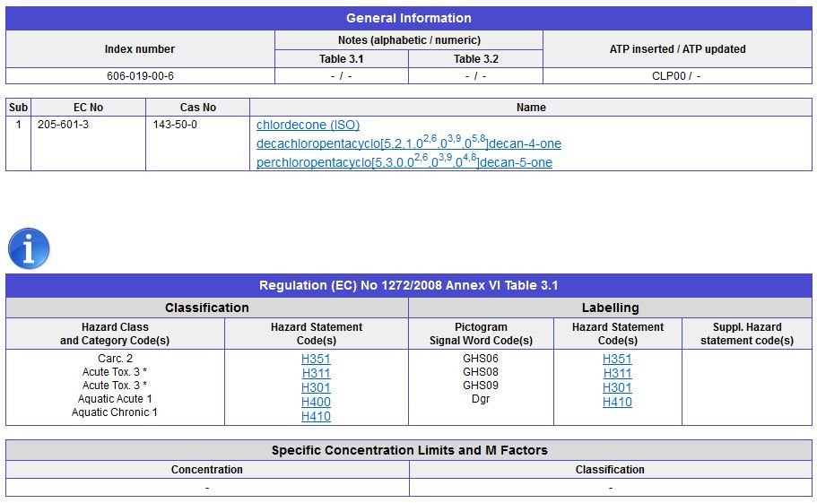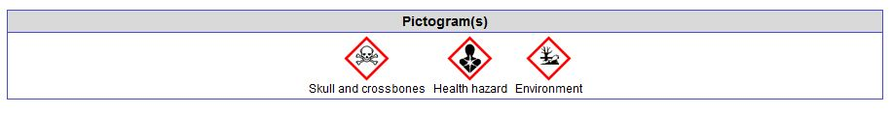

DDT
Name: 1,1,1-trichloro-2,2-bis (4-chlorophenyl) ethane
CAS number: 50-29-3
GHS relevant mixture concentration cut off: 0.1 % Carc. 2, Aquatic Acute 1
Aquatic Chronic 1

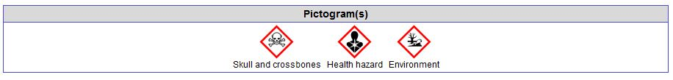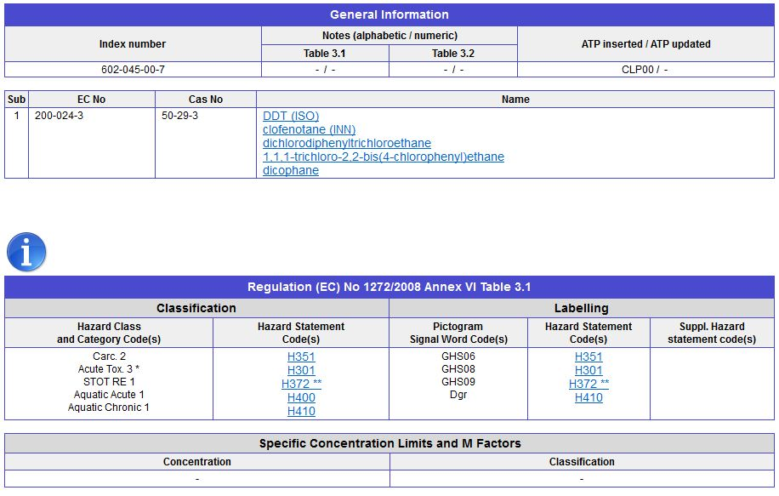

Endosulfan
Name: 6,7,8,9,10,10-hexachloro-1,5,5a,6,9,9a-hexahydro-6,9-methano-2,4,3-benzodioxathiepin-3-oxide
CAS number: technical endosulfan 115-29-7, alpha endosulfan 959-98-8, beta endosulfan 33213-
65-9
GHS relevant mixture concentration cut off: 0.1 % Aquatic Acute 1
Aquatic Chronic 1

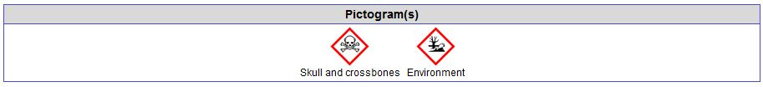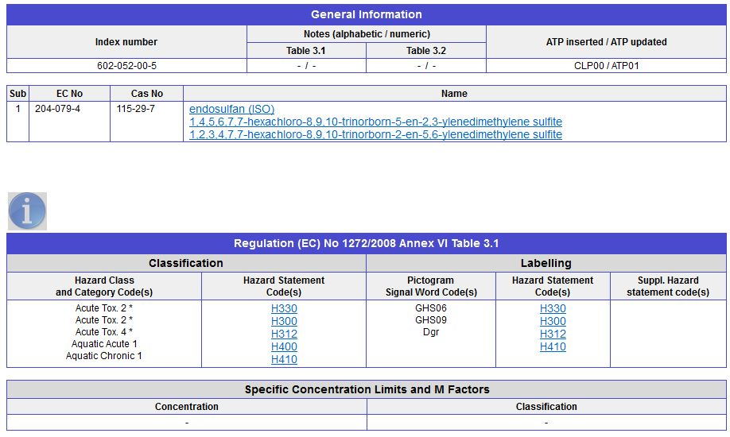
Lindane
Name: gamma 1,2,3,4,5,6-hexachlorocyclohexane
CAS number: 58-89-9
GHS relevant mixture concentration cut off: 0.1 % /10 =0.01% Aquatic Acute 1,
Aquatic Chronic 1
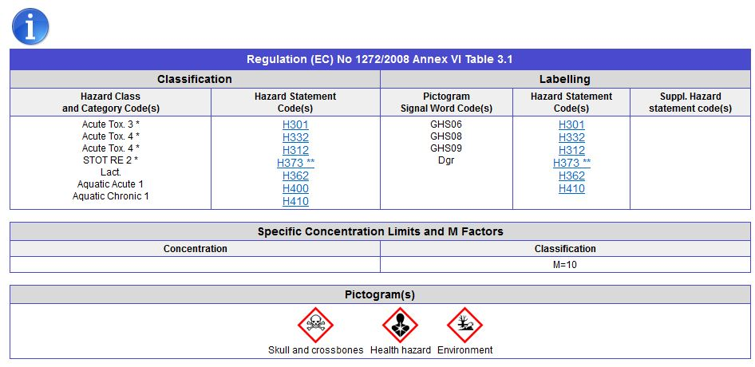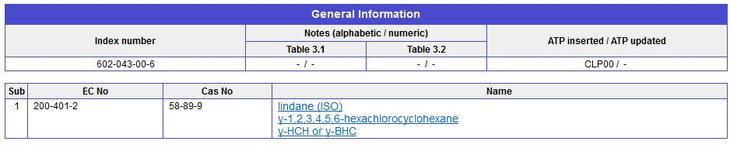

OctaBDE
CAS number: 32536-52-0
Name: Hexabromodiphenyl ether and heptabromodiphenyl ether
CAS numbers: 2,2’,4,4’,5,5’-hexabromodiphenyl ether (BDE-153, CAS No: 68631-49-2), 2,2’,4,4’,5,6’-hexabromodiphenyl ether (BDE-154, CAS No: 207122-15-4), 2,2’,3,3’,4,5’,6-heptabromodiphenyl ether (BDE-175, CAS No: 446255- 22-7), 2,2’,3,4,4’,5’,6-heptabromodiphenyl ether (BDE-183, CAS No: 207122-16-5) and other hexa- and heptabromodiphenyl ethers present in commercial octabromodiphenyl ether
GHS relevant mixture concentration cut off: 0.1 % Repr. 1B
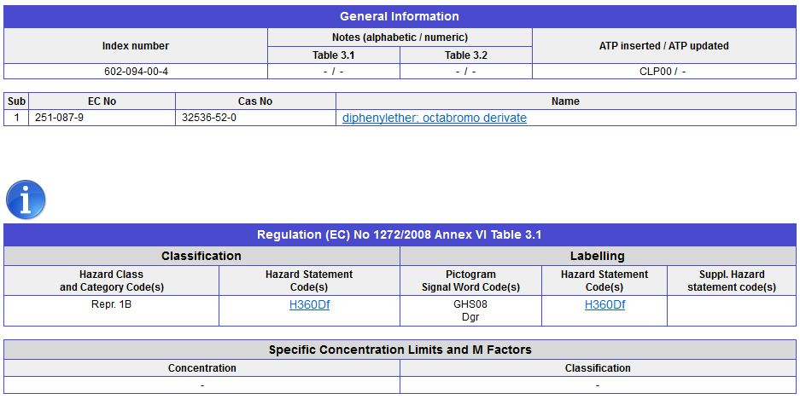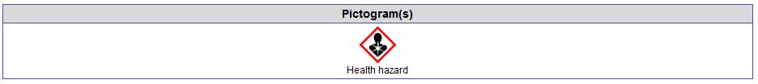
PentaBDE
CAS number: 32534-81-9
Name: Tetrabromodiphenyl ether and pentabromodiphenyl ether
CAS number: 2,2’,4,4’-tetrabromodiphenyl ether (BDE-47, CAS No: 5436-43-1) and 2,2’,4,4’,5- entabromodiphenyl ether (BDE-99, CAS No: 60348-60-9) and other tetra- and pentabromodiphenyl ethers present in commercial pentabromodiphenyl ether
GHS relevant mixture concentration cut off: 0.1 % Aquatic Acute 1
Aquatic Chronic 1
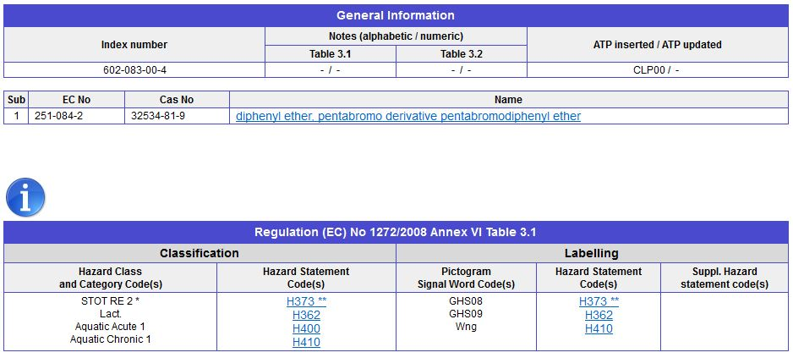
Pentachlorobenzene
Name: benzene, pentachloro-
CAS number: 608-93-5
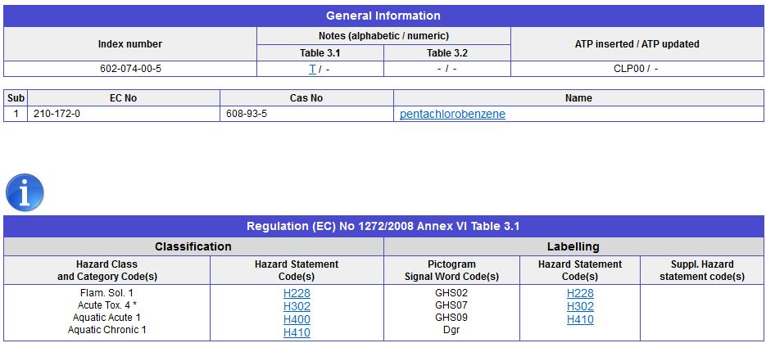GHS relevant mixture concentration cut off: 0.1 % Aquatic Acute 1
Aquatic Chronic 1

PFOS and its salts
Names: Perfluorooctanesulfonic acid, PFOS related chemicals
CAS number: Perfluorooctane sulfonic acid (CAS No: 1763-23-1), its salts and perfluorooctane sulfonyl fluoride (CAS No: 307-35-7), potassium perfluorooctane sulfonate (CAS No: 2795-39-3); lithium perfluorooctane sulfonate (CAS No: 29457- 72-5); ammonium perfluorooctane sulfonate (CAS No: 29081-56-9); diethanolammonium perfluorooctane sulfonate (CAS No: 70225-14-8); tetraethylammonium perfluorooctane sulfonate (CAS No: 56773-42-3); didecyldimethylammonium perfl uorooctane sulfonate (CAS No: 251099-16-8)
GHS relevant mixture concentration cut off: 0.1 % Carc. 2, Rep 1B
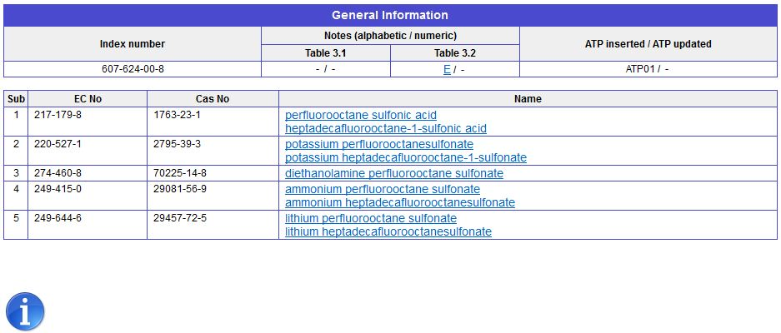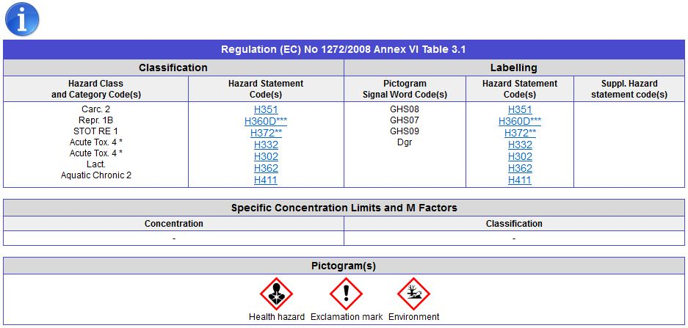

Explanations of hazard class, hazard statement codes, and label information
Classification/Labelling
Hazard Class and Category Code(s)
Flam. Sol. 1 Flammable solid
Acute Tox. 2 Acute toxicity, Category 2
Acute Tox. 3 Acute toxicity, Category 3
Acute Tox. 4 Acute toxicity, Category 4
STOT RE 1 Specific Target Organ Toxicity, Repeated Exposure, Category 1
STOT RE 2 Specific Target Organ Toxicity, Repeated Exposure, Category 2
Lact. Effects on or via lactation (breast feeding)
Carc. 2 Carcinogenicity, Category 2
Repr. 1B Reproductive Toxicity, Category 1B
Aquatic Acute 1 Aquatic Hazard, Acute toxicity category 1
Aquatic Chronic 1 Aquatic Hazard, Chronic toxicity category 1
Aquatic Chronic 2 Aquatic Hazard, Chronic toxicity category 2
Classification/Labelling
Hazard Statement Codes
H228 Flammable solid
H300 Fatal if swallowed
H301 Toxic if swallowed
H302 Harmful if swallowed
H311 Toxic in contact with skin
H312 Harmful in contact with skin
H330 Fatal if inhaled
H332 Harmful if inhaled
H351 Suspected of causing cancer
H360 May damage fertility or the unborn child
H362 May cause harm to breast-fed children
H372 Causes damage to organs ….through prolonged or repeated exposure
H373 May cause damage to organs….through prolonged or repeated exposure
H400 Very toxic to aquatic life
H410 Very toxic to aquatic life with long lasting effectsi
H411 Toxic to aquatic life with long lasting effects
Labelling
Pictogram, Signal Word Code(s)
GHS02 pictogram: flame
GHS06 pictogram: scull and crosbone
GHS07 pictogram: exclamation mark
GHS08 pictogram : health hazard
GHS09 pictogram: environment
Dgr signal word: Danger
Wng signal word: Warning

