UNITED  NATIONS |  |  | EP
 | United Nations  Environment  Programme | Distr.  GENERAL  UNEP/POPS/INC.6/INF/16  12 April 2002  ENGLISH ONLY

INTERGOVERNMENTAL NEGOTIATING COMMITTEE FOR AN
INTERNATIONAL LEGALLY BINDING INSTRUMENT
FOR IMPLEMENTING INTERNATIONAL ACTION ON
CERTAIN PERSISTENT ORGANIC POLLUTANTS
Sixth session
Geneva, 17-21 June 2002
Item 5 of the provisional agenda*

PREPARATION FOR THE CONFERENCE OF THE PARTIES

Report of the meeting of the expanded Inter-Organization Programme for the

Sound Management of Chemicals on national implementation plans for

persistent organic pollutants, held in Montreux, Switzerland from

28 to 30 January 2002**

Note by the secretariat

Attached to the present note is information provided by the secretariat of the Inter-Organization Programme for the Sound Management of Chemicals (IOMC). The information has been circulated as submitted and has not been formally edited.

Attachment

REPORT OF AN
EXPANDED IOMC MEETING ON NATIONAL IMPLEMENTATION PLANS (NIPs) FOR PERSISTENT ORGANIC POLLUTANTS (POPs)

Hotel Victoria, Glion-sur-Montreux, Switzerland
28-29 January 2002

Item 1: Adoption of draft agenda

1. Mr J Buccini opened the Meeting and welcomed participants. The adopted agenda for the meeting is given at Annex I.

2. A list of participants is given at Annex II. Mr J Buccini acted as facilitator and the IOMC Secretariat as rapporteur. In addition, he represented the Intergovernmental Negotiating Committee (INC) for an International Legally Binding Instrument for Implementing International Action on certain Persistent Organic Pollutants (POPs) (INC).

Item 2: Meeting goals and outcomes

3. The participants reviewed nine goals for the meeting proposed by the facilitator and agreed on goals related to:

- National Implementation Plans (NIPs) (goals i to iii);
- Guidance (goals iv and v); and
- IGOs (goals vi to ix).

4. With regard to NIPs, the goals were (i) to take measures to ensure that NIPs will meet the needs of the Parties in implementing the Convention and the future needs of the Conference of Parties (COP); (ii) to address the issues of consistency of design, approach, content, etc. in developing NIPs; and (iii) to reach a common understanding of the possible inclusion of elements within NIPs that are not required by the Stockholm Convention.

5. With regard to relevant Guidance, the goals were (iv) to identify, in at least a preliminary way, where gaps or weaknesses exist in guidance materials and where synergies may be effective in developing common guidance to ensure a consistent approach to NIPs development; and (v) to ensure that consistent guidance materials for developing NIPs are available to and used, as appropriate, by all IGOs.

6. With regard to IGOs, the goals were (vi) to acquire a thorough understanding of the NIPs-related activities of each participating IGO; (vii) in cases where an IGO possesses considerable in-house expertise in an element of a NIP, to discuss modalities for accessing such expertise; (viii) to identify appropriate models for collaboration by participating IGOs to achieve closer coordination in their approaches to developing NIPs; and (ix) to review the IGO reporting obligations and opportunities at INC6.

Item 3: The Stockholm Convention and NIPs

7. The Secretariat gave a PowerPoint presentation on the Stockholm Convention that was being used in the GEF/UNEP regional workshops (Annex III). In discussing the provisions on unintentionally produced POPs, it was pointed out that reducing releases of these materials may also reduce greenhouse gas emissions (and vice-versa). POPs proposals in this area should highlight the benefits under both POPs and climate change.

Item 4: Review on Guidance on NIPs

8. GEF Initial Guidelines for Enabling Activities for the Stockholm Convention on Persistent Organic Pollutants represent an early response by the GEF to assist eligible developing countries to implement the Convention. They are initial guidelines that will be revised, as needed, and it was mentioned that they are scheduled for a review in the first quarter of 2002. The main focus of the guidelines is the preparation of NIPs and a five-step process is presented: Step 1: Determination of coordinating mechanisms and organization of process; Step 2: Establishment of POPs inventory and assessment of national infrastructure and capacity; Step 3: Setting of priorities and determination of objectives; Step 4: Formulation of a NIP, and specific Action Plans on POPs; and Step 5: Endorsement of NIP by stakeholders. It was recognised that the current GEF Initial Guidelines go beyond the NIP needs required by the Stockholm Convention.

9. Other existing and planned guidance material relevant to NIPs. The World Bank is currently developing detailed guidance material on NIPs in cooperation with UNEP and DANCED. Rather than providing technical details, the World Bank document instead points to existing reference material (e.g. on inventories). It was recognised, however, that sufficient guidance is not available in all areas and that there is a need to fill guideline gaps.

10. UNDP has developed a GEF POPs Resource Kit (available at www.undp.org/gef).

11. Additional existing guidelines which are potentially useful in supporting NIPs are e.g. on Preparing a National Profile to Assess the National Infrastructure for Management of Chemicals (UNITAR), Organising a National (Priority-Setting) Workshop on Chemicals Management and Safety (UNITAR), Implementing a National PRTR Design Project (UNITAR), Guidance on Action Plan Development for Sound Chemicals Management (UNITAR), Developing a Risk Management Plan for a Priority Chemical (UNITAR), Identification of PCBs and Materials Containing PCBs (UNEP), technical issues of the Basel and Rotterdam Convention (UNEP), Inventory of World-wide PCB Destruction Capacity (UNEP), PRTR inventories (OECD), termite control (FAO/UNEP), alternative pest control technology (FAO/UNEP), and PCBs (Canada). Guidelines developed in the context of the Biodiversity, Climate Change and Aarhus Conventions provide valuable information on processes (e.g. access to information, participation in the decision-making process, risk management), but less on technical POP issues.

12. There was general agreement that the two basic types of guidance address either technical or process aspects of POPs, and that in each case there was existing guidance that may be applied directly, existing guidance that might need to be adapted, and gaps in the guidance that needed to be filled.

13. With regard to the GEF Initial Guidelines, it was recognised that the current Guidelines would likely be subject to review at INC6.

14. With regard to guidelines other than the GEF Initial Guidelines, it was agreed that each IGO should report its available guidance to the Interim Secretariat of the Stockholm Convention. Such guidance should include existing technical and process-related guidelines on POPs and those guidelines which are planned to be developed in the future. Perceived gaps in guidelines should be indicated also. The POPs Secretariat will then post the information on its website with hyperlinks to the relevant documents.

15. With regard to new guidelines and those which need revision, it was agreed that there is a need for developing the best possible guidelines for countries to meet the requirements of the POPs convention covering medium- and long-term activities and that INC6 should request their development. It was also agreed that there is a need for funding to develop these guidelines.

Item 5: What is an acceptable NIP? Is a common approach possible?

16. Article 7 of the Stockholm Convention requires Parties to develop plans for the implementation of their obligations under the Convention (NIPs). Until now, however, insufficient INC guidance has been given to Parties on how to develop NIPs (including aspects of communication, coordination, etc.) or on what is considered to be an acceptable NIP (e.g., contents, core elements, format, etc).

17. It was agreed that, in the current situation, it is important to improve the consistency of NIPs development rather than to let the process develop in a random fashion. In other words, there is a desire for the greatest degree of consistency attainable in developing NIPs, recognizing that there will be variability between Parties (e.g. according to country size, development stage, geography etc.). It was expected that INC6 would discuss the needs for more guidance.

18. In order to start the process of defining a consistent approach towards developing NIPs, the Convention Interim Secretariat was asked to identify NIP-relevant provisions of the Stockholm Convention and the essential or ‘core’ elements from the GEF Initial Guidelines. This is not to be seen as a final list or an end in itself, rather it is the starting point for further exchange of information, review and development.

Item 6: Roles of respective organizations in supporting NIP development

19. The facilitator proposed and the participants agreed that IGOs can be divided into two tiers with regard to the development of NIPs. Tier I comprises UNEP, UNDP, World Bank, FAO, UNIDO and Regional Development Banks (RDBs). These IGOs are active in pursuing/signing agreements on NIPs for POPs. Table 1 provides an overview of the involvement and roles of Tier 1 IGOs in 4 areas related to NIPs (development, capacity building, guidance and post-NIP activities). A ‘+’ means that the IGO in question has a role; a ‘-‘ means that the IGO in question does not have a role.

Table 1. Role of Tier 1 IGOs relevant to NIPs
Roles | World Bank | UNDP | UNEP | UNIDO | FAO | RDBs
Development | + | + | + | + | -* | -
Capacity building | + | + | + | + | + | +
Guidance | + | - | + | - | + | -
Post-NIP activities | + | + | + | + | + | +
*with reservations

20. Tier II IGOs comprise ILO, UNITAR, WHO, and OECD. In principle, these IGOs could act as Executing Agencies under the GEF procedure. However, provision of available guidelines and general Programme outputs are likely to be the main contributions to the development of NIPs by these IGOs.

21. In order to improve technical coordination on POPs-related activities among IGOs, it was agreed to establish an IOMC coordinating group on POPs implementation plans. The seven IOMC POs are the core participants of this Group. The World Bank, UNDP and GEF are invited to become members. The Terms of Reference (TOR) will be drafted at its first meeting.

Item 7: What are the models for IGO cooperation and collaboration?

22. Three financial cooperation models under the GEF procedure were discussed based on the experience of UNDP. The three models were the Co-implementation Model (Model ‘a’); the Multiple Execution Model (Model ‘b’); and the Inter-agency Agreements Model (IAA) (Model ‘c’). It was agreed that these are basic models and they might need amendments, adaptation etc.. In addition, it was recognised that there are other possible funding mechanisms.

23. Model ‘a’ comprises more than one Implementing Agency (IA). An Executing Agency (EA) might receive funding from more than one IA. This model demands separate project protocols, activities and budgets. It also involves a high level of administration and was mainly designed for very big projects (more than several million dollars). It was, therefore, considered to be relatively unpractical in the context of NIP development.

24. Model ‘b’ involves only one IA but it may involve several EAs. This model demands separate project protocols, activities and budgets. Model ‘b’ can be understood as an intermediate model between Models ‘a’ and ‘c’.

25. Model ‘c’ involves only one IA and one EA. The EA, however, then subcontracts to other EAs through ‘Inter-Agency Agreements (IAA). This model needs a single budget line and TOR. It has proven to be effective and administratively simple. It can be applied to small as well as big projects. It was agreed that model ‘c’ is the preferred model for coordination among the IGOs, but it was noted that there may be special cases, such as large countries, where another model may be more appropriate. UNDP offered to broker the services and expertise (via IAAs) of the other specialized IGOs to client countries with UNDP-implemented POPs Enabling Activities.

26. It was pointed out that there were other models such as the ones used in the World Bank/WHO Roll Back Malaria programme and the recent African Stockpiles programme. It was also pointed out that while the GEF is the principal entity of the interim financial mechanism of the Convention, other sources of funds can be used.

27. It was recognised, however, that it is the client country which finally decides the model and which IGO(s) it wants to work with on a special subject. The chosen IGO(s), however, can then ask other IGOs for assistance and expertise through IOMC. It was also recognised that IGOs have within their mandates strong links to certain countries (e.g. through ongoing projects).

Item 8: What is possible beyond the core elements of a NIP? How to provide support?

28. It was recognised that some countries might develop NIPs covering only the core elements required by the Convention, while other countries might see advantages in going beyond these elements and include aspects which are not dealt with in the Convention (e.g. institutional strengthening, capacity building, the development of inventories on chemicals, and rehabilitation of contaminated sites).

29. It was also recognised that existing projects might already have POP components. The African Stockpile Programme, for example, which is mainly dealing with organophosphorus pesticides, also covers POPs pesticides. Furthermore, unwanted by-product POPs might be produced due to inappropriate incineration of pesticide wastes.

30. It was agreed that under the GEF funding procedure, countries should address themselves to the core elements of the Convention although, in certain cases, it is advantageous to go beyond the core elements (e.g. some CEE countries accessing the EU which are preparing plans in line with the Aarhus Protocol on POPs).

Item 9: NIP knowledge sharing and information clearinghouse mechanism.

31. Paragraph 4 of Article 9 of the Convention tasks the secretariat with providing a clearinghouse mechanism. The Secretariat will maintain the clearinghouse as defined by the Convention. Relevant information will be made available on the World-wide Web on the POPs Convention Website (http://www.chem.unep.ch/sc), on CD-ROM and in hard copy.

32. It was recommended to develop an interactive web-based database for fast access to information and guidance that supports enabling activities.

Item 10: What happens after NIPs have been developed?

33. Once NIPs have been developed, countries should be in a position to implement them. In particular, in order to allow developing countries and countries with economies in transition to do so, INC (and later COP) should adopt a financial framework and agree upon arrangements (paragraphs 2 and 7 of Article 13 of the Convention). In addition, countries might look into alternative lending mechanisms for projects which are indirectly linked to POPs (e.g. power generation, agriculture). It was agreed that this issue would rank third in priority, after NIPs development and preparations for COP1.

Item 11: Status of IGO efforts to support countries.

34. Requests for assistance so far received and approved by the GEF Secretariat:

EAs (expedited procedures) approved as of January 2002
UNIDO: Algeria, Armenia, Croatia, Czech Republic, Ghana, Hungary, Indonesia, Nigeria, Macedonia, Poland, Romania, Togo.
UNEP: Cote d’Ivoire, Fiji, Kenya, Mauritania, Tunisia.
UNDP: Kazakhstan, Philippines, Samoa, Slovak Republic, Vietnam
Presently under review: UNDP: Bangladesh, Iran

EAs (normal processing procedures) approved as of January 2002
UNIDO: China (PDF-B)

Countries part of the Project on “Development of National Implementation Plans for the Management of POPs” Approved in May 2001
UNEP: Barbados, Bulgaria, Chile, Ecuador, Guinea, Lebanon, Malaysia, Mali, Micronesia, Papua New Guinea, Slovenia, Zambia.

35. Eight months after the adoption of the Convention, 37 countries have requested and obtained funding for the preparation of NIPs. IAs have already received some of the relevant funds and have been requested to release immediately 15% of the total to the country in question to facilitate start-up work. Implementation has already started in few cases (Poland, Czech Republic, Hungary). The total GEF funding so far is approximately $18 million. It is expected that within the next three years, all eligible countries will have initiated their work on NIPs, and that a few of the NIPs will have been completed by then.

36. All the requests received so far by GEF follow the GEF Initial Guidelines approved in May 2001, with minor adaptations to the specific needs/size of the country concerned. As recommended by the GEF Council, all proposals attempt to introduce the broader vision of “management of chemicals” and of compliance with related conventions into each country’s policy framework.

37. It was noted that significant impacts were being felt by IGOs as a result of some countries approaching more than one IGO to seek assistance in developing their GEF NIP proposals. To minimize the impacts on each other, it was agreed that once a proposal is submitted that endorses an IGO by the GEF focal point of that country, that IGO will inform the others so that they may make any necessary adjustments in their activities with that particular country.

38. Coordination and Capacity Building Support – Collaboration with UNEP: The key action undertaken by GEF, intended to encourage coordination of efforts among agencies/countries, is represented by the project on “Development of NIPs for the Management of POPs” to be executed by UNEP Chemicals. The 12 countries involved ensure geographic representation and diversity of characteristics. Each of the participating “pilot” countries is supposed to become a regional center for capacity building and exchange of experience. To this end, funds have been allocated specifically to involve in the project all neighbouring countries. GEF attaches great importance to this project and is anxious to see it moving rapidly to CEO endorsement and implementation. The project should become the “engine” for enhanced coordination, Convention ratification, and quality of NIPs. UNEP Chemicals, being also the interim secretariat of the Convention, is uniquely positioned to execute it. UNITAR is planning to assist UNEP with implementation
of this project through joint participation in a series of planning and training workshops and development of related guidance and training materials in the 12 project countries.

39. A second initiative is the project on ”Support for the Implementation of the Stockholm Convention on POPs” approved September 2001, also executed by UNEP Chemicals. Its objective is to promote the signature/ratification of the Convention and to facilitate access to GEF funding for EAs. This is being achieved through eight regional one-week workshops.

40. Annex IV provides a summary of UNDP-GEF POPs enabling activities.

Item 12: Reporting to INC6.

41. The report of this meeting will be presented to INC6. The IGOs were encouraged to report on their POPs activities under Agenda Item 3 of INC6 on June 17.

Item 13: Timing and path forward beyond Montreux

42. It was agreed to hold the next expanded IOMC meeting on POPs in connection with the GEF Council meeting in Washington, 15-17 May 2002, to be hosted by the World Bank. The agenda will include terms of reference for an IOMC Group on POPs.

43. After the Washington meeting, follow-up will take place at the regular IOMC/IOCC meeting, Geneva, 27-28 June 2002.

= = =
ANNEX I: AGENDA

EXPANDED IOMC MEETING ON NATIONAL IMPLEMENTATION PLANS (NIPs) FOR PERSISTENT ORGANIC POLLUTANTS (POPs),
Hotel Victoria, Glion-sur-Montreux, Switzerland, 28-29 January 2002

1. Adoption of draft agenda. (All)

2. Meeting goals and outcomes

a) Meeting Report (IOMC Secretariat)

b) Goals (All)

3. The Stockholm Convention and NIPs (UNEP)

4. Review of guidance on NIPs:

a) GEF Initial Guidelines and process (UNEP)

b) Other existing guidance material relevant to NIPs: (All)

c) Planned additional guidance materials relevant to NIPs (All)

5. What is an acceptable NIP? Is a common approach possible? (All)

6. Roles of respective organizations in supporting NIP development. (All)

7. What are the models for IGO cooperation and collaboration? (All)

8. What is possible beyond the core elements of a NIP? How to support? (All)

9. NIP knowledge sharing and information clearinghouse mechanism. (UNDP, UNIDO)

10. What happens after NIPs have been developed? (World Bank)

11. Status of IGO efforts to support countries. (All)

12. Reporting to INC6. (All)

13. Timing and path forward beyond Montreux. (All)

14. Closure of the meeting.
ANNEX II: LIST OF PARTICIPANTS

EXPANDED IOMC MEETING ON NATIONAL IMPLEMENTATION PLANS (NIPs) FOR PERSISTENT ORGANIC POLLUTANTS (POPs),
Hotel Victoria, Glion-sur-Montreux, Switzerland, 28-29 January 2002

Mr Craig BOLJKOVAC
Deputy Programme Coordinator
Chemicals and Waste Management Programme
UNITAR
MIE B.510
Palais des Nations
CH-1211 Genève
Suisse
Tel: 41 22 917 84 71
Fax: 41 22 917 80 47
E-mail: craig.boljkovac@unitar.org

Dr John BUCCINI
31 Sycamore Drive
Nepean, Ontario K2H 6R4
Canada
Tel: (613) 828-7667
Fax: (815) 352-4253
E-mail: jbuccini@sympatico.ca

Dr Zoltan CSIZER
Director, Cleaner Production and Environmental Management Branch
United Nations Industrial Development Organization
Wagramer Str.5
A-1400 Vienna
Autriche
Tel: 43 1 260 26 38 95
Fax: 43 1 260 26 68 19
E-mail: zcsizer@unido.org

Mr Steve GORMAN
World Bank
1818 H Street, NW
Washington, DC 20433
USA
Tel:1 202 473 5865
Fax: 1 202 -522 3258
E-mail: sgorman@worldbank.org

Dr Kersten GUTSCHMIDT
International Programme on Chemical Safety (IPCS)
World Health Organization
20 Avenue Appia
1211 Geneva 27
Switzerland
Tel:41-22-7913731
Fax: 41-22-7914848
E-mail: gutschmidtk@who.int

Mr Andrew HUDSON
Principal Technical Advisor, International Waters/POPs
UNDP-GEF
FF-1076
One United Nations Plaza
New York, NY 10017
USA
Tel: 1 212 906 6228
Fax: 1 212 906 6998
E-mail: andrew.hudson@undp.org

Dr Tim MEREDITH
Coordinator
International Programme on Chemical Safety (IPCS)
World Health Organization
20 Avenue Appia
1211 Geneva 27
Switzerland
Tel:41-22-7914348
Fax: 41-22-7914848
E-mail: mereditht@who.int

Mr Isaac OBADIA
Coordinator, Occupational Health and Environmenrt Cluster,
SafeWork Programme,
International Labour Office
4 route des Morillons
1211 Geneva 22
Suisse
Tel: 41 22 7996746
Fax: 41 22 7996878
E-mail: obadia@ilo.org

Ms F. Ouane
UNEP Chemicals
11-13, chemin des Anémones
1219 Châtelaine
Suisse
Fax: 41 22 797 34 60
E-mail: fouane@chemicals.unep.ch

Dr N.A. VAN DER GRAAFF
Chief, Plant Protection and Protection Division
Food and Agriculture Organization
Via delle Terme di Caracalla
00100 Rome
Italie
Tel: 39 06 5705 34 41
Fax: 39 06 5705 63 47
E-mail: niek.vandergraaff@fao.org

Dr R. VISSER
Head, Environment, Health and Safety Division
Environment Directorate
Organisation for Economic Cooperation and Development
2, rue André-Pascal
75775 Paris Cedex 16
France
Tel: 33 1 45 24 93 15
Fax: 33 1 45 24 16 75
E-mail: robert.VISSER@oecd.org

Mr John WHITELAW
Deputy Director
UNEP Chemicals
11-13, chemin des Anémones
1219 Châtelaine
Suisse
Tel: 41 22 917 83 60
Fax: 41 22 797 34 60
E-mail: jwhitelaw@unep.ch

Mr J. WILLIS
Director, Chemicals
United Nations Environment Programme
International Environment House
11-13 chemin des Anémones
1219 Geneva
Suisse
Tel: 41 22 917 81 83
Fax: 41 22 797 34 60
E-mail: jwillis@unep.ch
ANNEX III: OVERVIEW OF STOCKHOLM CONVENTION

Slide 1

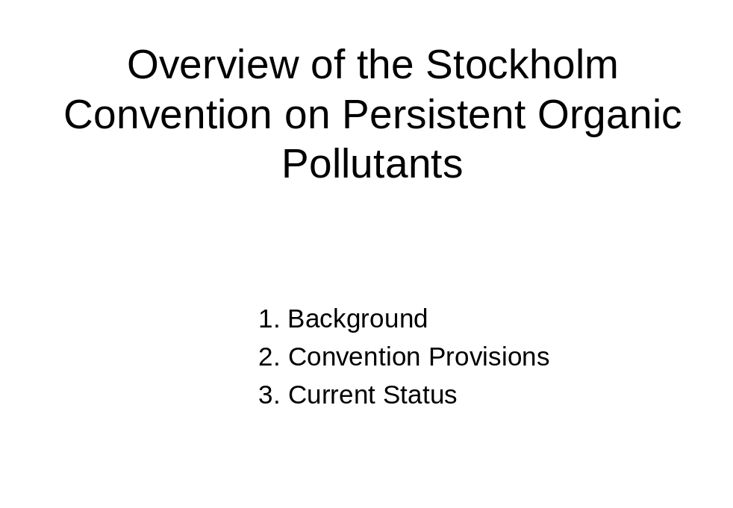

Slide 2

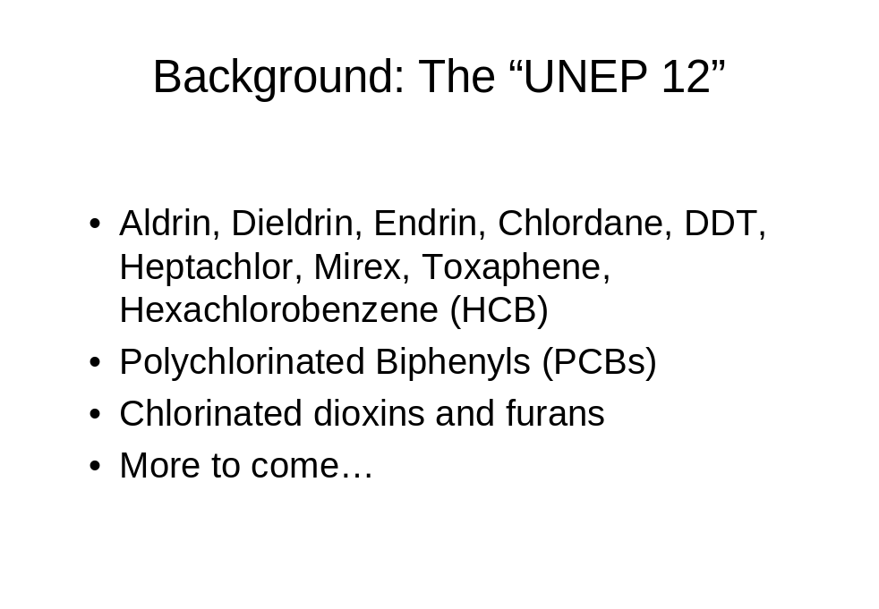

Slide 3

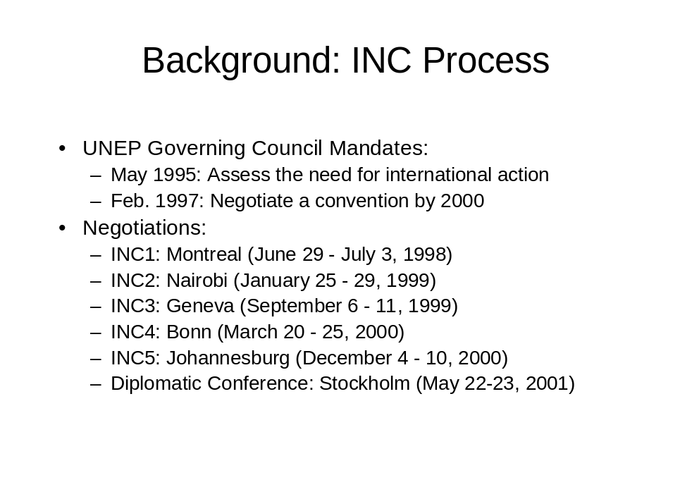

Slide 4

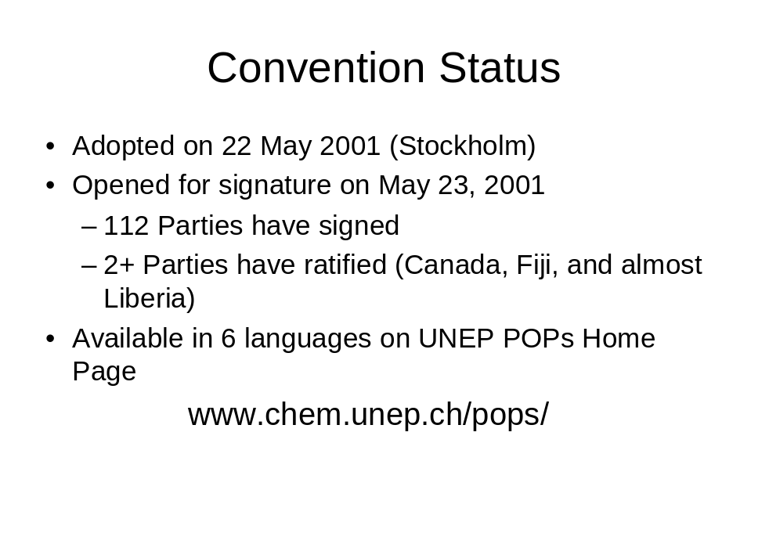

Slide 5

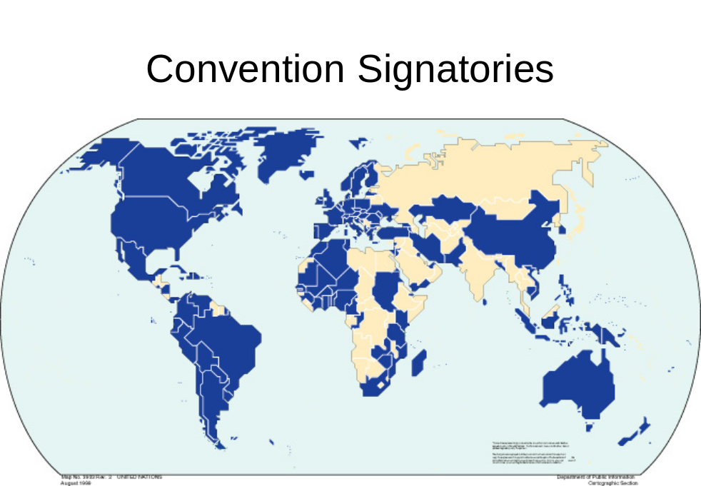

Slide 6

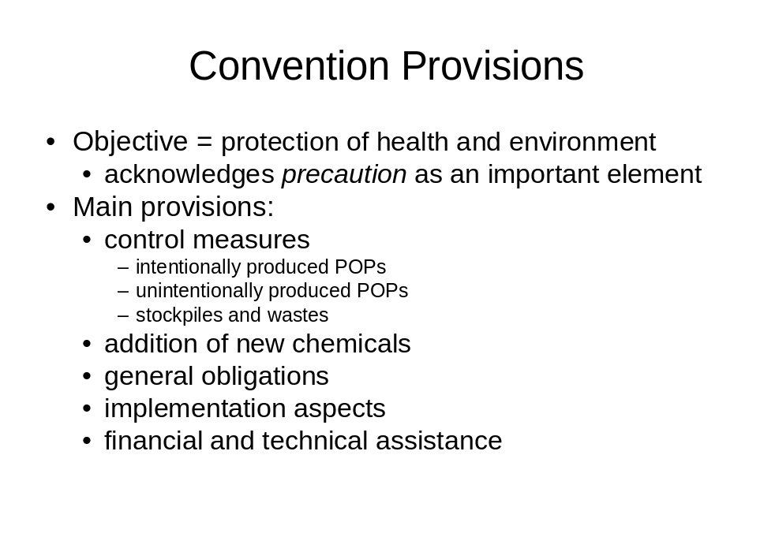

Slide 7

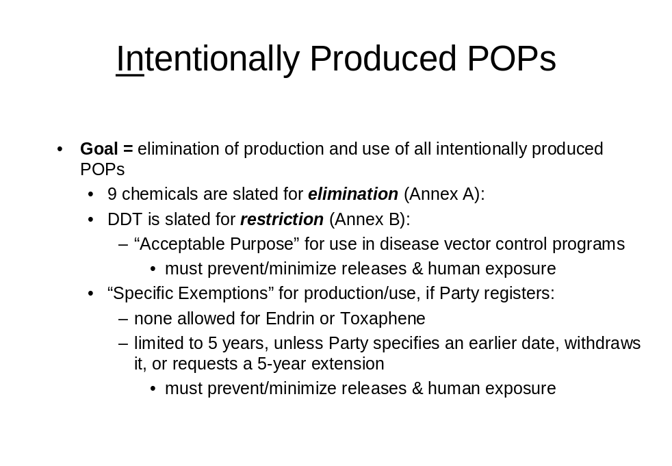

Slide 8

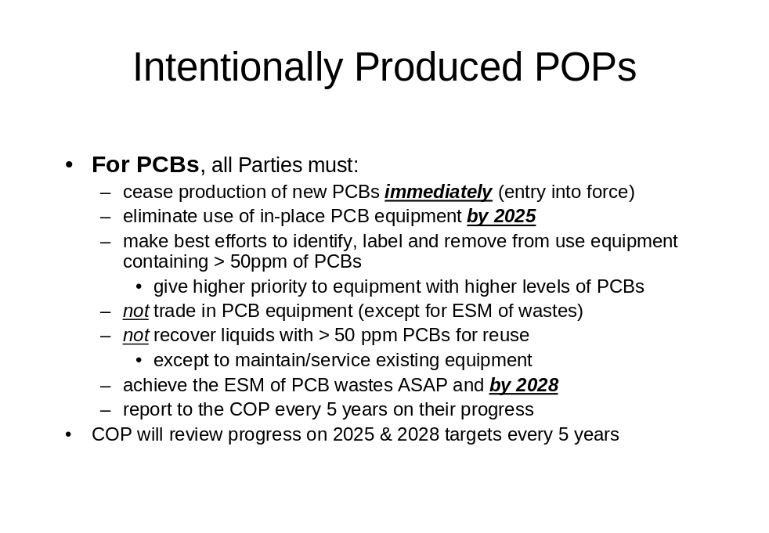

Slide 9

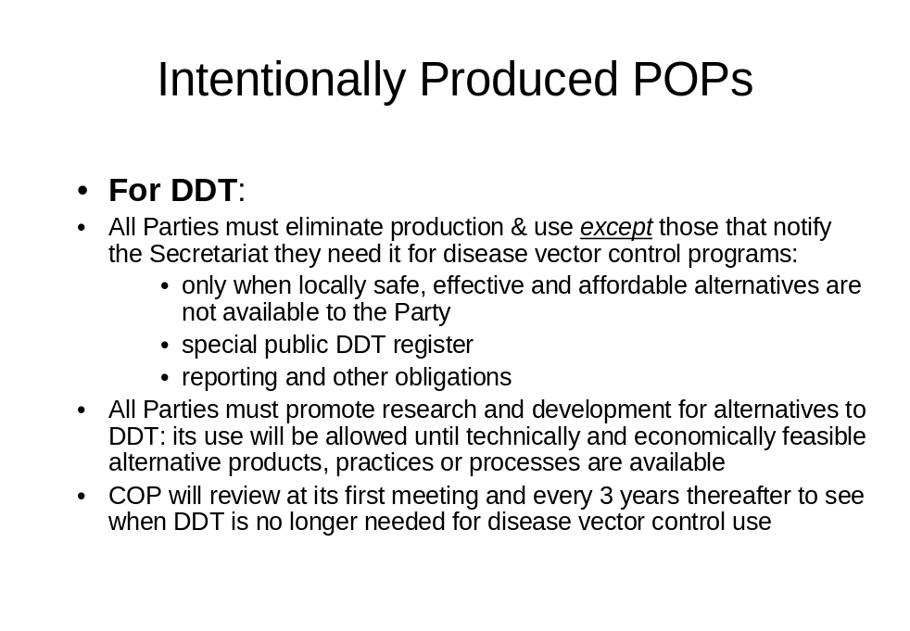

Slide 10

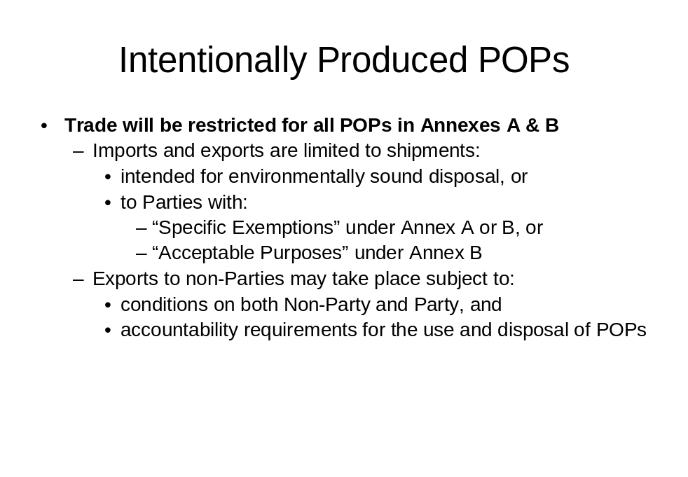

Slide 11

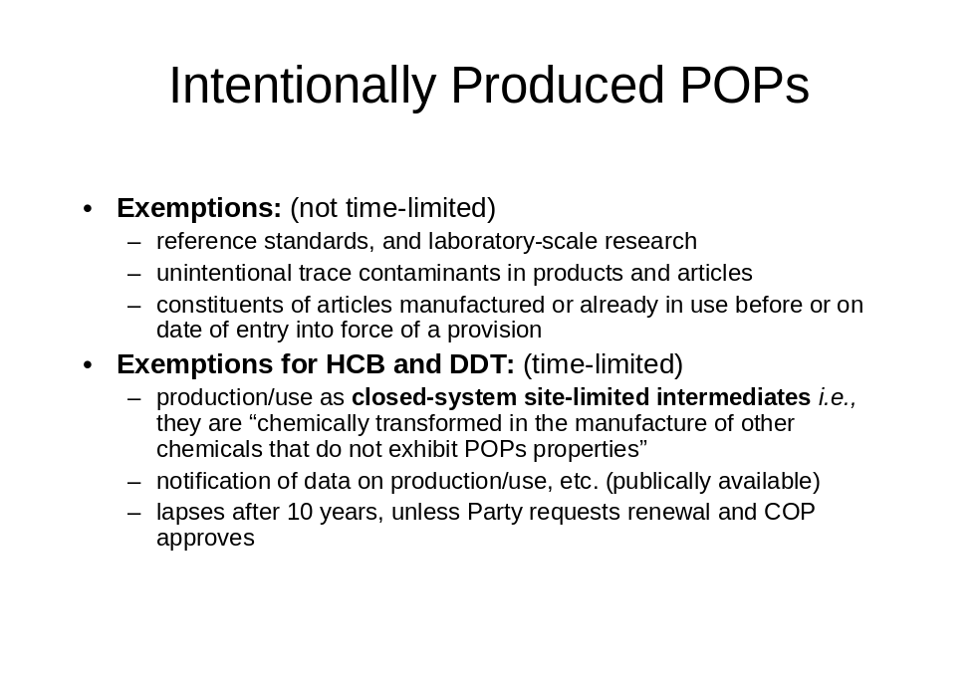

Slide 12

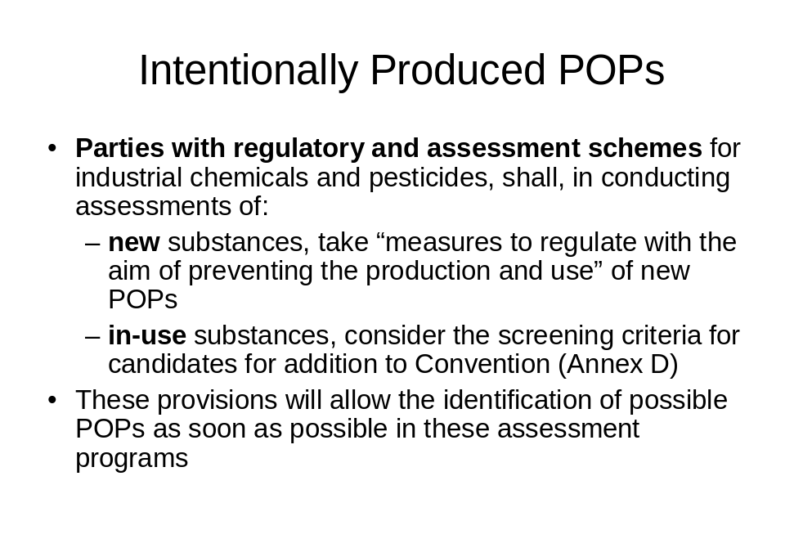

Slide 13

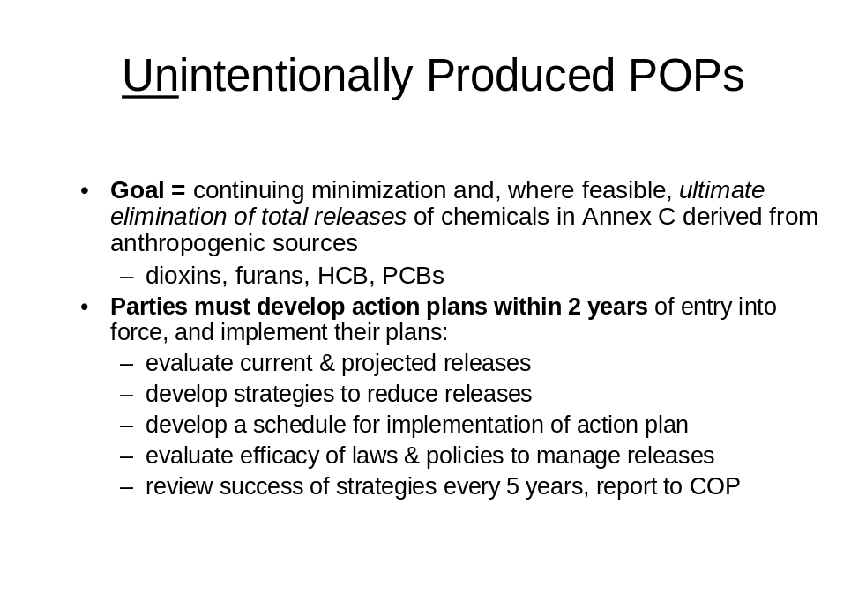

Slide 14

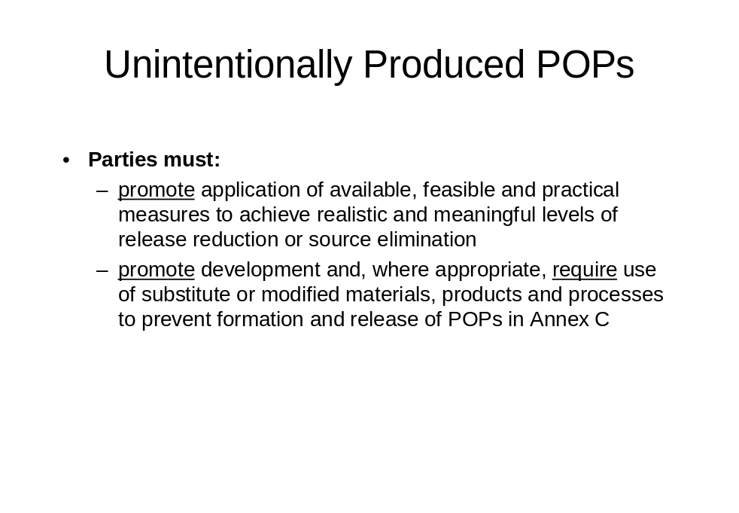

Slide 15

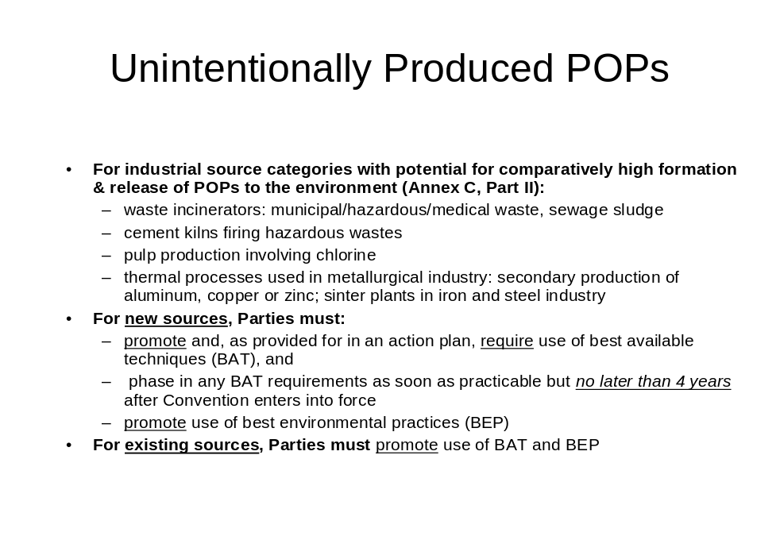

Slide 16

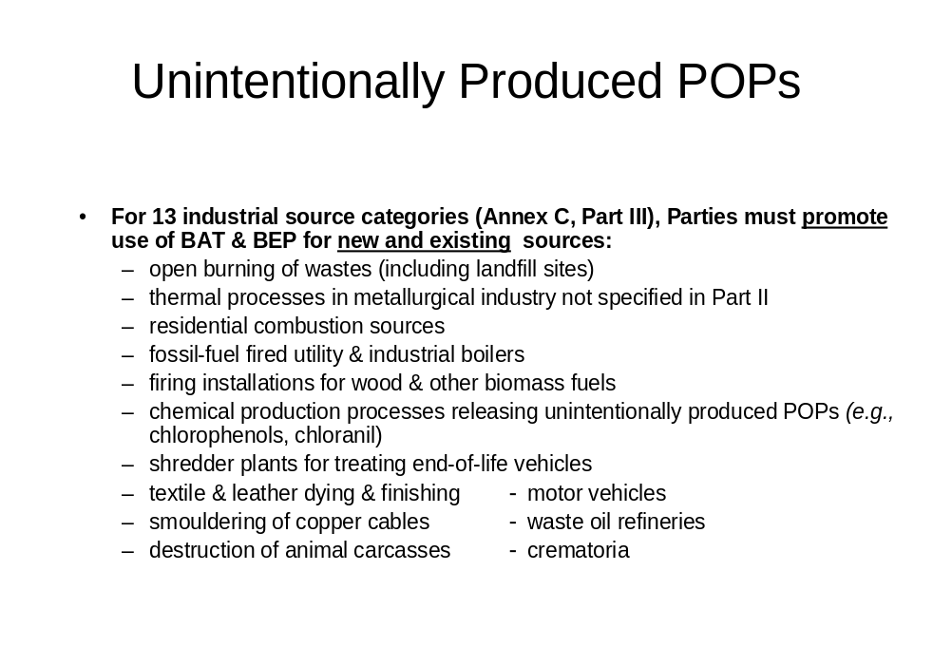

Slide 17

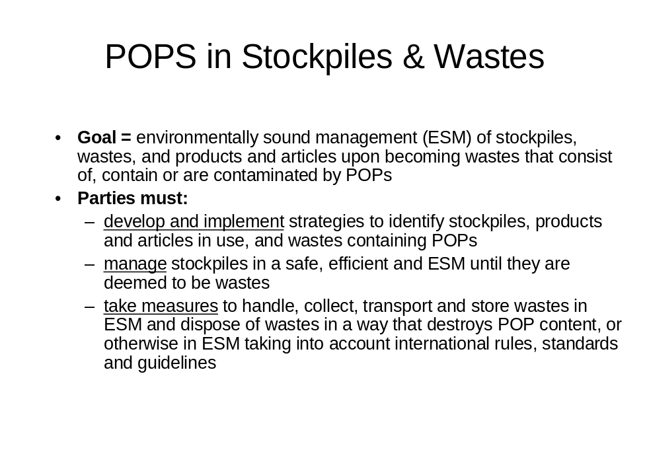

Slide 18

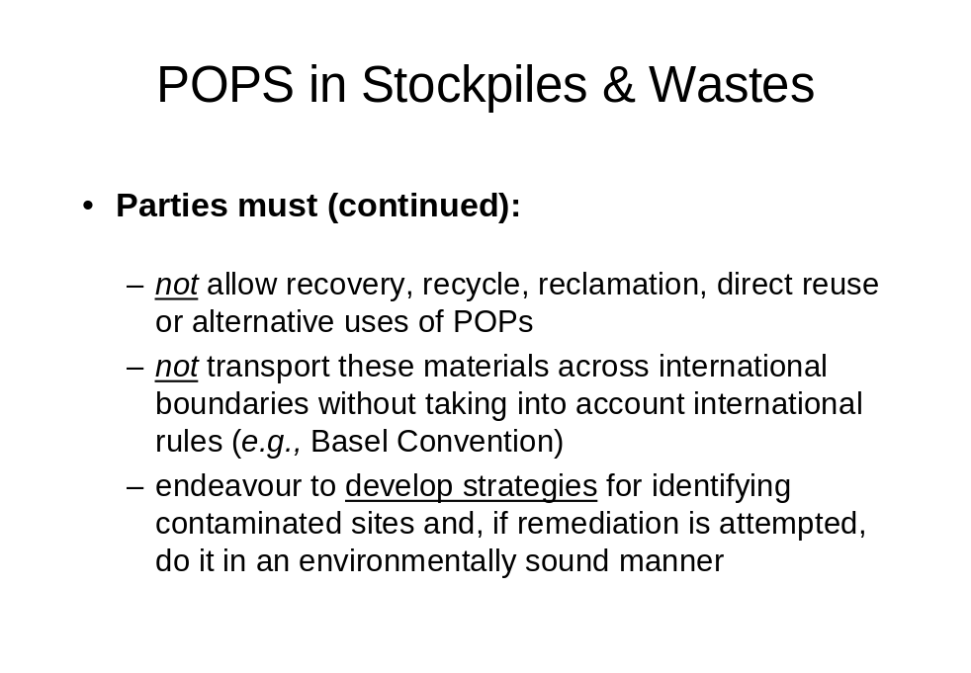

Slide 19

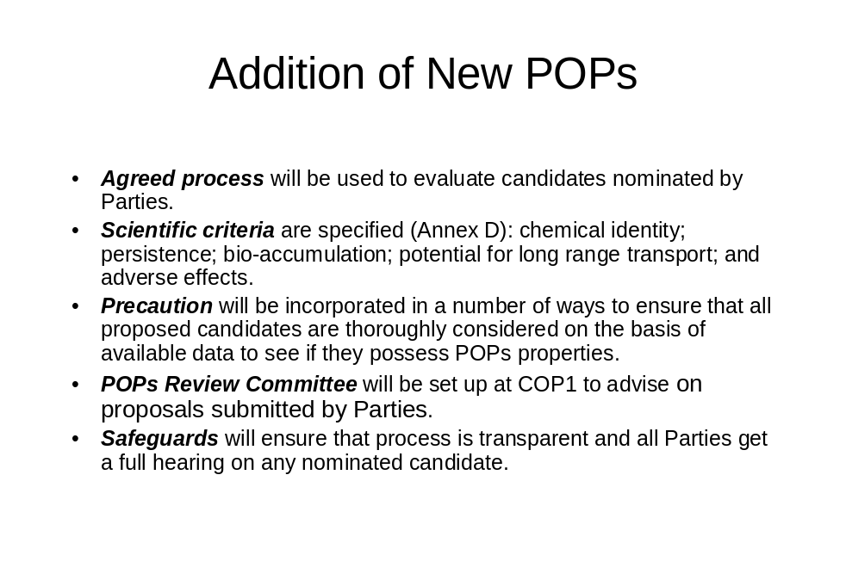

Slide 20

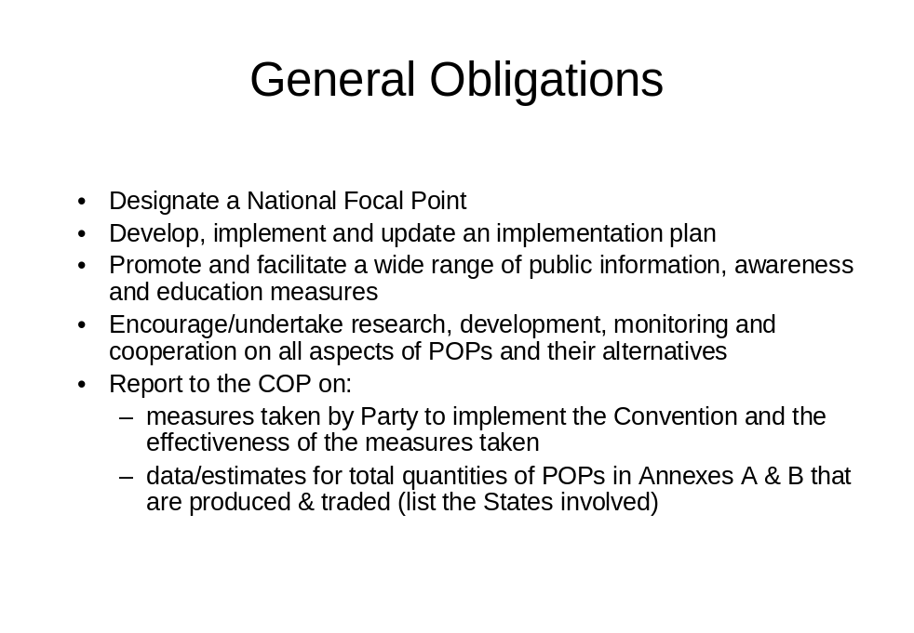

Slide 21

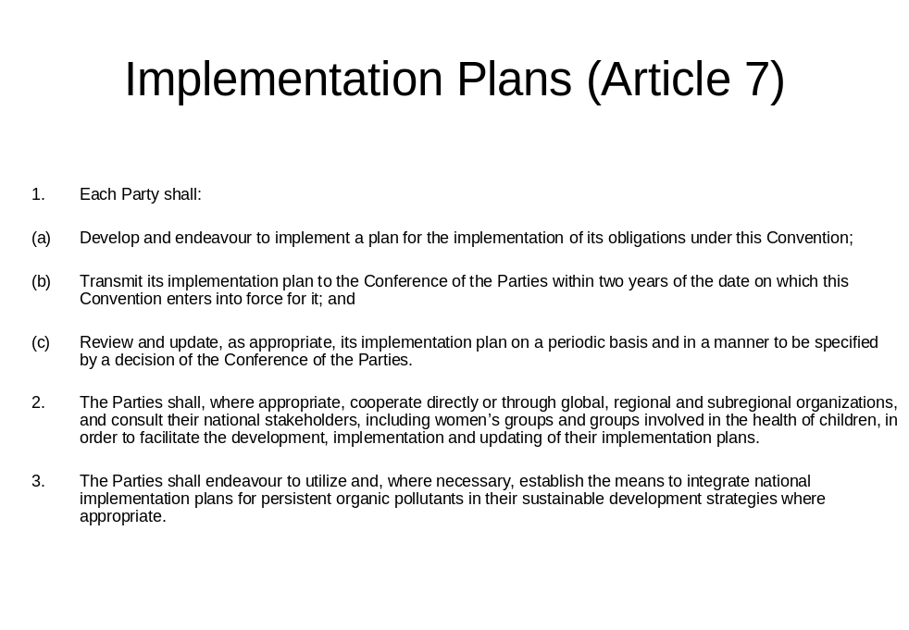

Slide 22

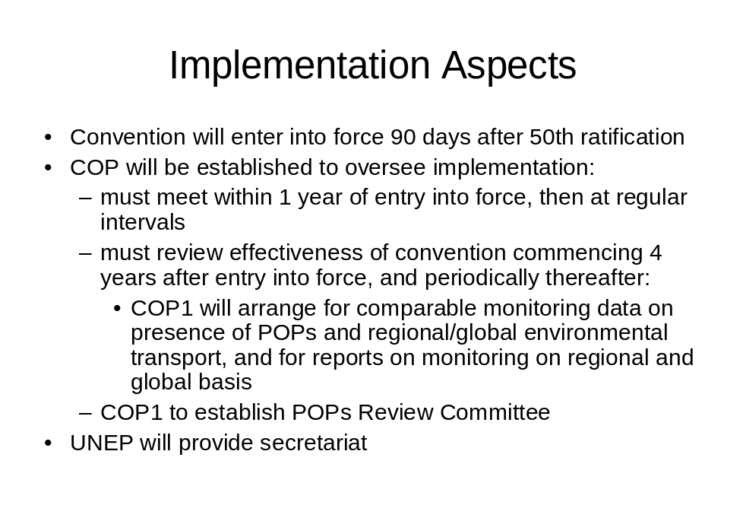

Slide 23

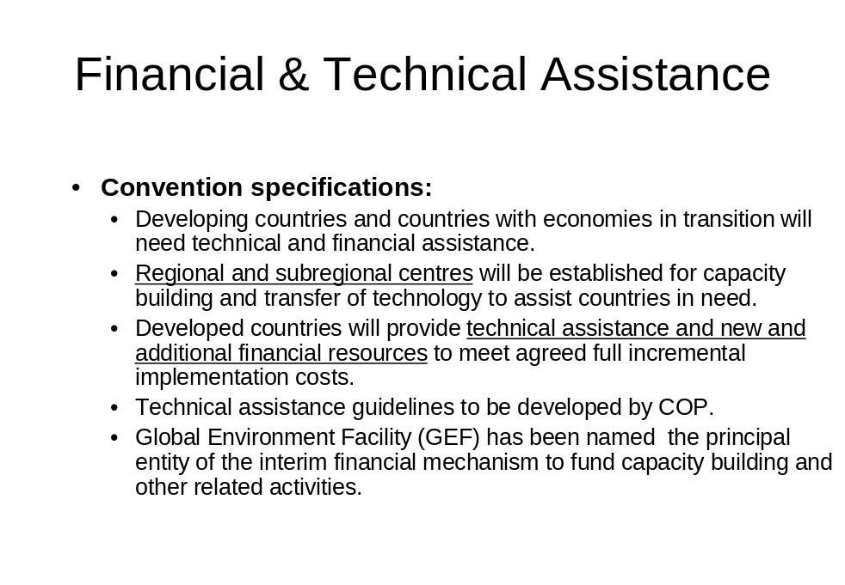

Slide 24

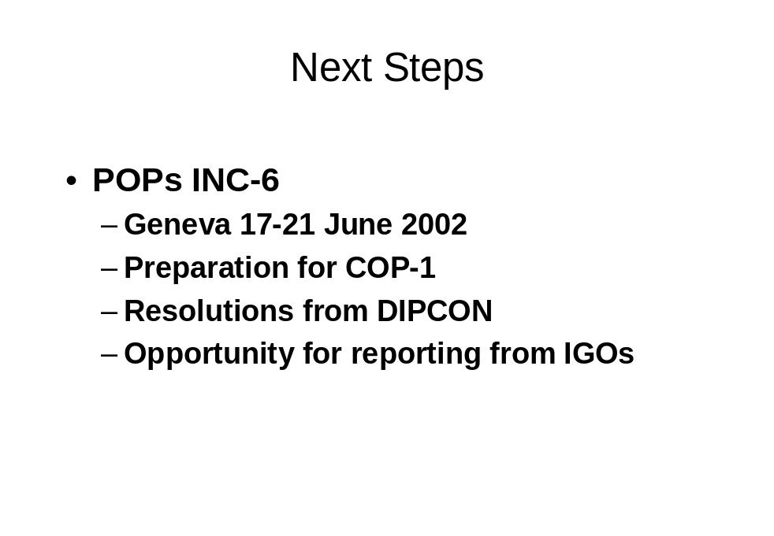

ANNEX IV: UNDP-GEF POPs enabling activities

Region/Country | Requested by Govt (GEF OFP) | Prepared and Submitted | Approved
Europe/CIS  Slovakia  Kazakhstan  Latvia | x  x  x | x  x | x  x
Asia-Pacific  Vietnam  Philippines  Bangladesh  I.R. of Iran  Samoa | x  x  x  x  x | x  x  x  x  x | x  x  x
Arab States  Sudan  Morocco  Djibouti | x  x  x | in prep  in prep  in prep
Africa  Comoros | x | in prep
Latin America/Carib.  Dominican Republic  Jamaica  Panama  El Salvador  Nicaragua  Uruguay | x  x  x  x  x  x | in prep  in prep  in prep

-----

* UNEP/POPS/INC.6/1.
** Stockholm Convention, Article 7.
UNEP, UNDP and World Bank are eligible to submit proposals under the GEF funding procedure as they are GEF Implementing Agencies.

