Section V.A.1.

Guidance by source category: Annex C, Part II Source Categories

Waste Incinerators:

Municipal and hazardous waste, and sewage sludge

Coordinated by Mr. Robert Kellam (United States of America)

15 April 2004
Note to Reviewers:

The attached draft, per the discussions of the Expert Group at their December, 2003, meeting, expands the discussion of BAT/BEP for municipal solid waste incineration to include the incineration of hazardous waste and sewage sludge. The document also incorporates a number of comments and suggestions on the MSW incineration sections offered by the Expert Group at the December meeting. Changes to the October, 2003, draft include:

- Addition of hazardous waste and sewage sludge incineration, and co-incineration;
- Broadening of the discussion of air pollution control devices;
- Expansion of the sections on cost/economic implications;
- Inclusion of gasification, catalytic oxidation and SCR, wet scrubbing, and high temperature melting technologies;
- Added of information on waste pre-treatment;
- Inclusion of AMESA method in monitoring section;
- Expansion residue management section to include potential for leaching of PCDD/Fs from ash in humic conditions.

The authors are particularly indebted to Don Litten and the European Integrated Pollution Prevention and Control (IPPC) Bureau for the recently released (March, 2004) 2nd draft of their Incineration BAT Reference (BREF) document. The BREF represents the most current and comprehensive compilation of data on this subject and is the primary reference for much of the information on hazardous waste, sewage sludge, cost and economic data, and illustrations in the present draft.

Thanks also to Germany (Ute Karl), UNEP (Heidi Fiedler), Japan (Shinichi Sakai), Finland (Hille Hyytiä), UNIDO (Zoltan Csizer), and Greenpeace (Pat Costner) for their suggestions and the materials they forwarded.

Bob Kellam

P.S. During the Villarrica meeting, Canada (Patrick Finlay) suggested that we might include, as examples, relevant national standards for the industry categories covered by the BAT/BEP guidance. If you would like to volunteer your standards on MSW, hazardous waste, or sewage sludge incineration for inclusion, please forward me a relatively concise summary with your comments.

Bob

Table of Contents

- Background
- Formation and Release of Unintentional POPs
- Incinerator Design and Operation
  - General Incinerator Design
  - Design and Operation of MSW Incinerators
    - Delivery, Storage, and Pre-Treatment of MSW
    - MSW Incinerator Designs
  - Design and Operation of Hazardous Waste Incinerators
    - Merchant Hazardous Waste Incinerators
      - Delivery, Storage, and Pre-Treatment of Hazardous Waste
      - Merchant Hazardous Waste Incinerator Design
    - Dedicated Hazardous Waste Incinerators
  - Design and Operation of Sewage Sludge Incinerators
    - Pre-Treatment of Sewage Sludge
    - Sewage Sludge Incinerator Designs
      - Multiple Hearth Furnace
      - Multiple Hearth/Fluidized Bed Furnace
      - Cycloid Furnace
    - Co-incineration of Sewage Sludge with MSW
- Flue Gas Treatment (Air Pollution Control Devices)
  - Cyclones and multi-cyclones
  - Electrostatic Precipitators
  - Fabric Filters
  - Static Bed Filters
  - Sorbent/Scrubber Systems
    - Dry sorbent
    - Spray Dry
    - Wet Scrubbers
  - Selective Catalytic Reduction (SCR)
  - Rapid Quenching Systems
  - Carbon Adsorption
- Best Environmental Practices for Incineration
  - Waste Management Practices
    - Waste Inspection and Characterization
    - Waste Minimization
    - Source Separation and Recycling
    - Removal of Non-Combustibles at Incinerator
    - Proper Handling, Storage, and Pre-Treatment
    - Minimizing Storage Times
    - Establishing Quality Requirements
    - Waste Loading
  - Incinerator Operating and Management Practices
    - Ensuring Good Combustion
    - Cold Starts, Upsets, and Shut Downs
    - Regular Facility Inspections and Maintenance
    - Monitoring
    - Operator Training
- Best Available Techniques for Incineration
  - Combustion Techniques
    - General Combustion Techniques
    - MSW Incineration Techniques
    - Hazardous Waste Incineration Techniques
    - Sewage Sludge Incineration Techniques
  - Flue Gas Treatment Techniques
    - Dust Removal Techniques
    - Flue Gas Polishing Techniques
    - Acid Gas Removal Techniques
    - Nitrogen Oxides (NO_{X}) Reduction Techniques
  - Residue Management Techniques
    - Bottom Ash Techniques
    - Fly Ash and Other Flue Gas Treatment Residue Techniques
    - Effluent Treatment Techniques
- New and Significantly Modified Incinerators
  - Additional Factors in the Siting of New MSW Incinerators
  - Additional Factors in the Siting of New Hazardous Waste Incinerators
  - Additional Factors in the Siting of New Sewage Sludge Incinerators
  - Modification of Existing Waste Incinerators
- Costs and Economic Considerations
  - General Considerations
  - MSW Incineration
  - Hazardous Waste Incineration
  - Sewage Sludge Incineration
- Alternative and Emerging Technologies
  - Pyrolysis and Gasification
  - Thermal Depolymerization
  - Plasma Technologies
  - High Temperature Melting

Appendix A – Comparison of the Main Combustion and Thermal Treatment Technologies
Figures and Tables

Figure 3.1 Typical Layout of a large MSW Incinerator
Figure 3.2 Mass Burn Waterwall MSW Incinerator
Figure 3.3 Mass Burn Rotary Kiln MSW Incinerator
Figure 3.4 Modular Excess Air MSW Incinerator
Figure 3.5 Modular Starved Air MSW Incinerator with Transfer Rams
Figure 3.6 RDF-Fired Spreader Stoker MSW Incinerator
Figure 3.7 Fluidized Bed MSW Incinerator
Figure 3.8 Schematic of a Rotary Kiln Incineration System
Figure 3.9 A Dedicated HWI with HCl Recovery
Figure 3.10 Liquid Waste Incineration with HCl Recovery
Figure 3.11 Example of a Multiple Hearth Sewage Sludge Incinerator
Figure 3.12 Cross Section of a Multiple Hearth Furnace
Figure 3.13 Schematic of a Stationary (Bubbling) Fluidized Bed Furnace
Figure 3.14 Combination Multiple Hearth/Fluidized Bed Furnace
Figure 4.1 Electrostatic Precipitator Principle
Figure 4.2 Condensation electrostatic precipitator
Figure 4.3 Schematic of a Fabric Filter
Figure 4.4 Spray dry scrubbing/adsorption
Figure 4.5 Selective Catalytic Reduction

Table 5.1 Example Inspection Techniques
Table 5.2 Example Segregation Techniques
Table 6.1 Comparison of Dust Removal Systems
Table 6.2 Characteristics of Bag Filter Materials
Table 6.3 Solid Residues from MSW Incineration
Table 8.1 Investment Costs of Waste Gas Cleaning in Germany
Table 8.2 Example Cost Structure for a 250,000 tpy MSW Incinerator
Table 8.3 Economies of Scale in MSW Incineration
Table 8.4 Costs of Steam Extraction (turbine) as a Function of Waste Throughput
Table 8.5 Gate Fees in European MSW and HW incineration plants
Table 8.6 Example Cost Structure for a 70,000 tpy HW Incinerator

Appendix A Comparison of the Main Combustion and Thermal Treatment Technologies

1.0 Background

The incineration of waste, often accompanied by the recovery of energy and recycling of residues, constitutes a disposal option practiced by many developed and a smaller number of developing and industrializing countries. This section of the guidance focuses on the incineration of municipal solid waste, hazardous waste, and sewage sludge. The incineration of medical waste and the disposal of hazardous waste in cement kilns are covered under separate sections of this document.

The environmentally sound design and operation of waste incinerators requires the use of best environmental practices and best available techniques to prevent or minimize the formation and release of the unintentional POPs. The purpose of this guidance is to identify such practices and techniques, summarize their effectiveness, and estimate their relative cost, for consideration by the Parties in the development of national action plans under the Stockholm Convention on Persistent Organic Pollutants.

1.1 Municipal Solid Waste Incineration

Although landfilling remains the principal means for the disposal of municipal solid waste (MSW), incineration and the subsequent landfilling of residues has become a common practice in many developed and industrializing countries. In the United States, for example, there are currently 130 municipal waste incinerators in operation, handling approximately one-sixth of the country’s MSW. Where landfill space is scarce, or other factors such as a shallow water table restrict its use, the proportion of MSW incinerated may reach 75% or greater.

MSW incineration is frequently accompanied by the recovery of energy in the form of steam or the generation of electricity. Incinerators can also be designed to accommodate processed forms of MSW known as refuse-derived fuels or RDF, as well as co-firing with fossil fuels. Municipal waste incinerators can range in size from small package units processing single batches of only a few tons per day to very large units with continuous daily feed capacities in excess of a thousand tons. The capital investment costs of such facilities can range from tens of thousands to hundreds of millions of USD.

The primary benefit of waste incineration is a 70-90% reduction in the volume of the waste. Other benefits include the destruction of toxic materials, sterilization of pathogenic wastes, recovery of energy, and the re-use of some residues.

Large municipal waste incinerators are major industrial facilities and have the potential to be significant sources of environmental pollution. In addition to the release of acid gases (sulfur oxides, nitrogen oxides, hydrogen chloride) and particulate matter, poorly designed or operated incinerators can lead to the unintentional formation and release of persistent organic pollutants (dioxins and furans [PCDD/F], and unintentionally produced polychlorinated biphenyls [PCBs] and hexachlorobenzene [HCB]).

  - Hazardous Waste Incineration

Incineration and other forms of thermal treatment also represent options for the disposal of hazardous waste. Hazardous wastes are distinguished from other wastes by their listing in waste statutes and regulations or by exhibiting hazardous properties. In the United States, for example, a waste may be considered hazardous if it is shown to be ignitable, corrosive, reactive, or toxic. Mixtures of hazardous wastes with other wastes may also be considered hazardous.

Because of the higher potential hazard of dealing with such wastes and the uncertainty often associated with their composition, special procedures for transportation, handling, and storage are required. Special handling may also be necessary for any residues remaining after treatment.

Hazardous waste is normally incinerated in two types of facilities: merchant plants who accept different types of waste for disposal; and dedicated incinerators that handle a particular waste stream. An example of the latter might be a chemical manufacturing plant treating chlorinated wastes to recover HCl.

The most common combustion technology in hazardous waste incineration is the rotary kiln. Facilities in the merchant sector range in size from 30,000 to 100,000 tons/year throughput (EU BREF, 2004). Certain hazardous wastes, particularly spent solvents, are also burned as fuel in cement kilns. This latter application is covered under a separate section of this guidance. Dedicated hazardous waste incinerators use a variety of incineration, pyrolysis, and plasma treatment techniques.

Similar to the incineration of municipal solid waste, hazardous waste incineration offers the benefits of volume reduction and energy recovery. This technology, however, if poorly designed or operated, also has the potential to form and release unintentional POPs.

  - Sewage Sludge Incineration

Domestic sewage sludge is disposed of in a number of ways including land application, surface disposal, incineration, and co-disposal with municipal solid waste. The incineration of sewage sludge is practiced in a number of countries, either alone or in through co-incineration with municipal solid waste. The effective disposal of sewage sludge by this process depends on a number of factors. These include whether the sewage is mixed with industrial waste streams (which can increase heavy metal loadings), location (coastal locations can result in salt water intrusion), pre-treatment (or the lack thereof), and weather (rainfall dilution) (EU BREF, p. 28).

Pre-treatment, especially de-watering and drying, is particularly important in preparing sludge for incineration. Drying reduces the volume of the sludge and increases the heat energy of the product. Moisture removal to at least 35% DS (dry solids) is normally required to provide the necessary heat energy for autothermal incineration. Further drying may be necessary if co-incineration with municipal solid waste is envisioned.

A typical sewage sludge incinerator may process as much as 80,000 tons of sewage sludge per year. The most common furnace types are multiple hearth and fluidized bed, with preferred operating temperatures in the range of 850-950ºC with a 2 second residence time. Operation at or above 980ºC can cause ash to fuse (EU BREF, p.69). Like MSW and hazardous waste incinerators, unintentional POPs and their precursor compounds are available in the inputs to sewage sludge incinerators and poorly designed or operated plants have the potential for formation and release.

- Formation and Release of Unintentional POPs

Combustion research has led to the development of three theories for the formation and release of unintentional POPs from waste incinerators: (1) pass through, in which the POPs (e.g., dioxins and furans) are introduced into the combustor with the feed and pass through the system unchanged; (2) formation during the process of combustion; and 3) de novo synthesis in the post-combustion zone. Emission testing has confirmed that composition of the waste, furnace design, temperatures in the post-combustion zone, and the types of air pollution control devices (APCD) used to remove pollutants from the flue gases are important factors in determining the extent of POPs formation and release. Depending on the combination of these factors, POPs releases can vary over several orders of magnitude per ton of waste incinerated.

- Incinerator Design and Operation

Incinerators come in a variety of furnace types and sizes as well as combinations of pre- and post combustion treatment. There is also considerable overlap among the designs of choice for MSW, hazardous waste, and sewage sludge incineration. To avoid unnecessary duplication, this guidance focuses on the predominant configurations for each source category as well as any special considerations for the type of waste being fed.

  - General Incinerator Design

Incinerators are designed for full oxidative combustion over a general temperature range of 850-1400ºC. Gasification and pyrolysis represent alternative thermal treatments that restrict the amount of combustion air to convert waste into process gas, increase the amount of recyclable inorganics, and reduce the amount of flue gas cleaning. These techniques are included in the alternatives section of this guidance.

Waste incinerator installations can be characterized in five component areas: waste delivery, storage, pre-treatment, incineration/energy recovery, and flue gas cleaning/residue management. The nature of the input waste will have a significant bearing on how each component is designed and operated.

  - Design and Operational Considerations for MSW Incinerators

Figure 3.1 shows a typical layout for a large MSW incinerator.
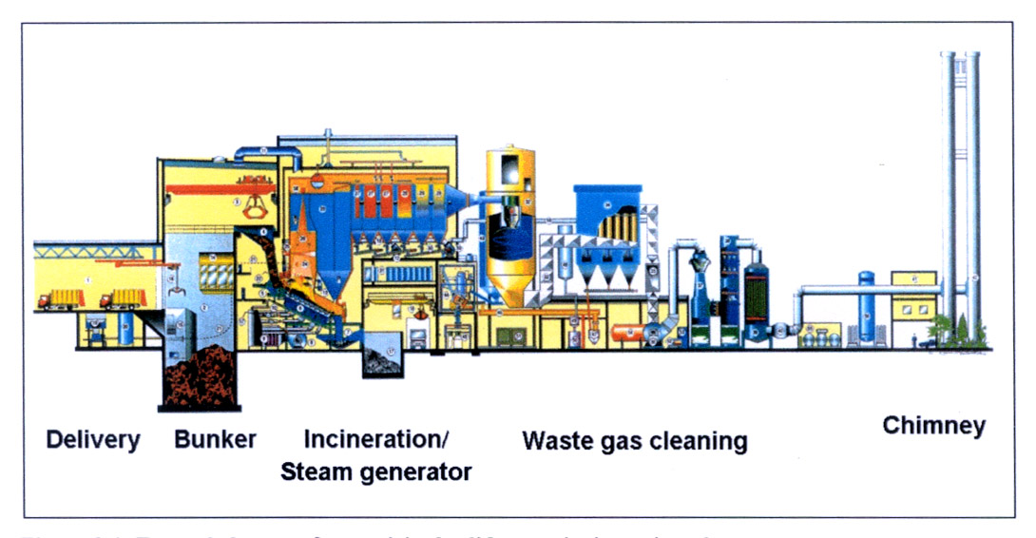
Figure 3.1 A Typical MSW Incinerator [source: EU BREF, 2004]

3.2.1 Delivery, Storage, and Pre-Treatment of MSW

Waste may be delivered to the incinerator by truck or rail. Recycling or source separation programs upstream of waste delivery can significantly influence the efficiency of processing. Removing glass and metals prior to incineration will increase the per unit energy value of the waste. Recycling paper, cardboard, and plastics will reduce the energy value of the waste but may also reduce available chlorine. Separating bulky wastes reduces the need for removal or shredding onsite.

In addition to waste separation, pre-treatment of mass burn MSW may include crushing and shredding to facilitate handling and homogeneity. Bunker storage areas are normally covered to protect against additional moisture and the facility is typically designed to draw combustion air through the bunker to reduce odor.

3.2.2 MSW Incinerator Designs

MSW incinerators can be divided into three major design categories: mass burn (including traveling grate and rotary kiln), Refuse-derived fuel (RDF) (including fluidized bed and spreader/stoker processes) and modular or package incinerators. The mass-burn and RDF technologies are more common in larger incinerators (greater than 250 metric tons per day of MSW) and the modular technology dominates among smaller units. The major types are described below.

3.2.2.1 Mass Burn. The term “mass burn” was originally intended to describe incinerators that combust MSW as received (i.e., no preprocessing of the waste other than removal of items too large to go through the feed system). Currently, several types of incinerators are capable of burning unprocessed waste. Mass burn facilities can be distinguished in that they burn the waste in a single stationary combustion chamber. In a typical mass burn facility, MSW is placed on a grate that moves through the combustor. Combustion capacities of mass burn facilities typically range from 90 to 2700 metric tons of MSW per day. There are three principal subcategories of the mass burn technology.

 Mass burn refractory-walled systems represent an older class of incinerators (available in the late 1970s to early 1980s) that were designed primarily to reduce by 70-90% the volume of waste disposed. These facilities usually lacked boilers to recover the combustion heat for energy purposes. In the mass burn refractory-walled design, the MSW is delivered to the combustion chamber by a traveling grate or a ram feeding system. Combustion air in excess of stoichiometric amounts (i.e., more oxygen than is needed for complete combustion) is supplied both below and above the grate. Few mass burn refractory-walled incinerators are currently operational in developed countries; almost all have closed or been dismantled.

- Mass burn waterwall facilities offer enhanced combustion efficiency, compared with mass burn refractory-walled incinerators. Although it achieves similar volume reductions, the waterwall incinerator design provides a more efficient delivery of combustion air, resulting in higher sustained temperatures. Figure 3.2 is a schematic of a typical mass burn water wall MSW incinerator. The term “waterwall” refers to a series of steel tubes that run vertically along the walls of the furnace through which water is pumped. Heat from the combustion of the waste produces steam, which is then used to drive an electrical turbine generator or for other energy needs. This transfer of energy is called energy recovery. Mass burn water wall incinerators are the dominant form of incinerator found at large municipal waste combustion facilities.
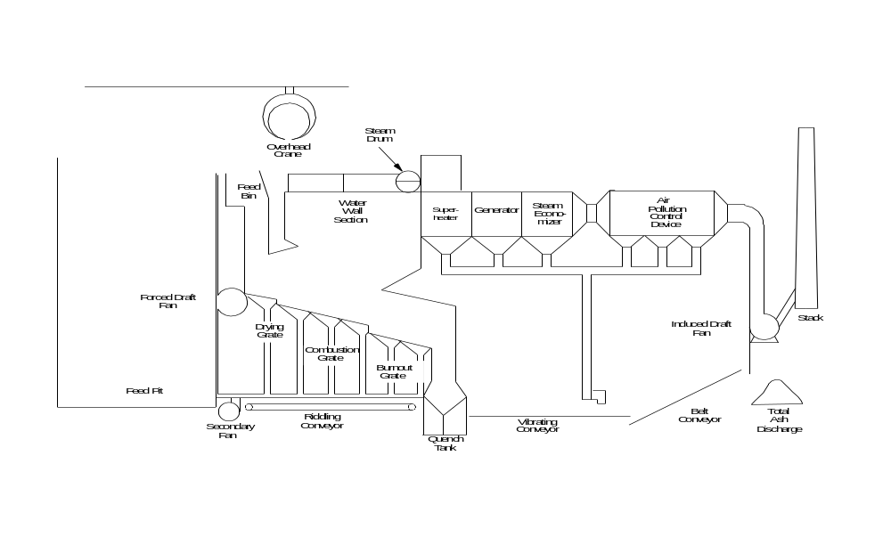
Figure 3.1 A Typical MSW Incinerator 1

Figure 3.2 Mass Burn Waterwall MSW Incinerator

- Mass burn rotary kiln incinerators use a water-cooled rotary combustor that consists of a rotating combustion barrel configuration mounted at a 15- to 20-degree angle of decline. The refuse is charged at the top of the rotating kiln by a hydraulic ram. Preheated combustion air is delivered to the kiln through various portals. The slow rotation of the kiln (10 to 20 rotations per hour) causes the MSW to tumble, thereby exposing more surface area for complete burnout of the waste. These systems are also equipped with boilers for energy recovery. Figure 3.3 provides a schematic view of a typical rotary kiln combustor.

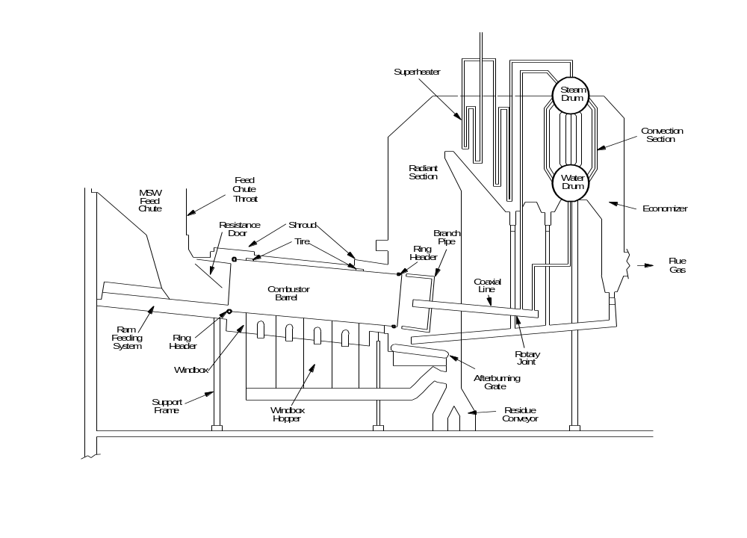
Figure 3.3 Mass Burn Rotary Kiln MSW Incinerator

3.2.2.2 Modular. This is a second general type of municipal solid waste incinerator used widely in the United States, Europe and Asia. As with the mass burn type, modular incinerators burn waste without preprocessing. Modular incinerators consist of two vertically mounted combustion chambers (a primary and secondary chamber). In modular configurations combustion capacity typically ranges from 4 to 270 metric tons per day, that is, predominately in the small-sized MWS incinerators. The two major types of modular systems, excess air and starved air, are described below.

- The modular excess air system consists of a primary and a secondary combustion chamber, both of which operate with air levels in excess of stoichiometric requirements (i.e., 100 to 250% excess air). Figure 3.4 illustrates a typical modular excess air MSW incinerator.
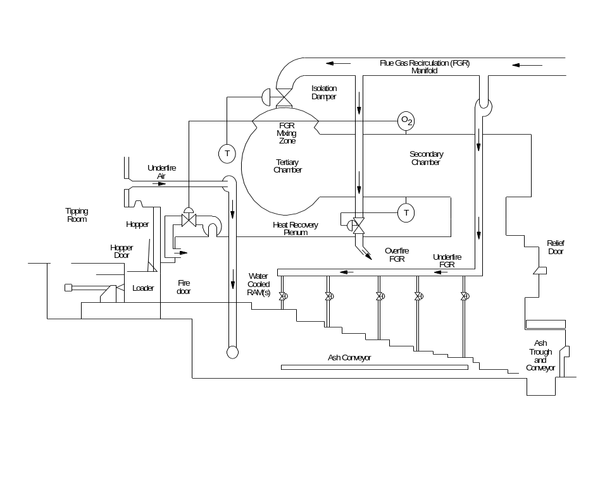
Figure 3.4 Modular Excess Air MSW Incinerator

- In the starved (or controlled) air type of modular system, air is supplied to the primary chamber at substoichiometric levels. The products of incomplete combustion entrain in the combustion gases that are formed in the primary combustion chamber and then pass into a secondary combustion chamber. Excess air is added to the secondary chamber, and combustion is completed by elevated temperatures sustained with auxiliary fuel (usually natural gas). The high, uniform temperature of the secondary chamber, combined with the turbulent mixing of the combustion gases, results in low levels of PM and organic contaminants being formed and emitted. Therefore, many existing modular units are not accompanied by post-combustion APCDs. Figure 3.5 is a schematic view of a modular starved-air MWC.
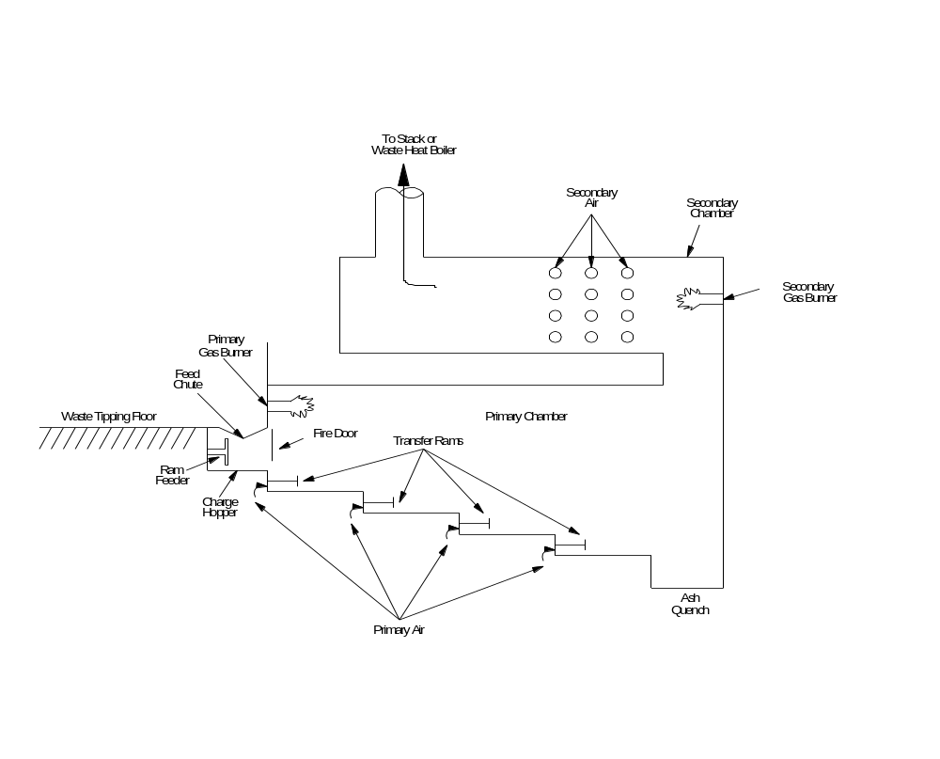
Figure 3.5 Modular Starved Air MSW Incinerator with Transfer Rams

3.2.2.3 Refuse-derived fuel. The third major type of MSW incinerator design involves the pre-processing of the MSW feed. This technology is generally applied only at very large MWC facilities. RDF is a general term that describes MSW from which relatively noncombustible items are removed, thereby enhancing the combustibility of the waste. RDF is commonly prepared by shredding, sorting, and separating out metals to create a dense MSW fuel in a pelletized form of uniform size. Three types of RDF systems are described below.

- The dedicated RDF system burns RDF exclusively. Figure 3.6 shows a typical dedicated RDF furnace using a spreader-stoker boiler. Pelletized RDF is fed into the combustor through a feed chute using air-swept distributors; this allows a portion of the feed to burn in suspension and the remainder to burn out after falling on a horizontal traveling grate. The traveling grate moves from the rear to the front of the furnace, and distributor settings are adjusted so that most of the waste lands on the rear two-thirds of the grate. This allows more time to complete combustion on the grate. Underfire and overfire air are introduced to enhance combustion, and these incinerators typically operate at 80 to 100% excess air. Waterwall tubes, a superheater, and an economizer are used to recover heat for production of steam or electricity. The dedicated RDF facilities range from 227 to 2720 metric tons per day total combustion capacity.
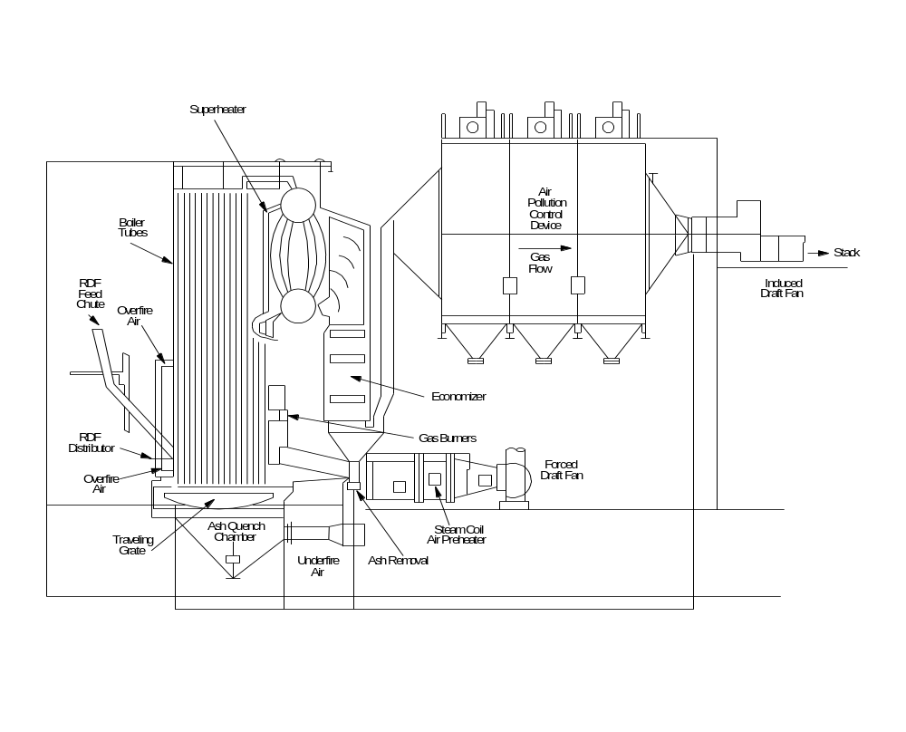
Figure 3.6 RDF-Fired Spreader Stoker MSW Incinerator

- Co-fired RDF incinerators burn either RDF or normal MSW, along with another fuel. RDF, because of its greater surface area, can support more catalytic reactions. Co-firing RDF with coal tends to reduce dioxin formation due to the inhibitory behavior of the sulfur content in the latter.

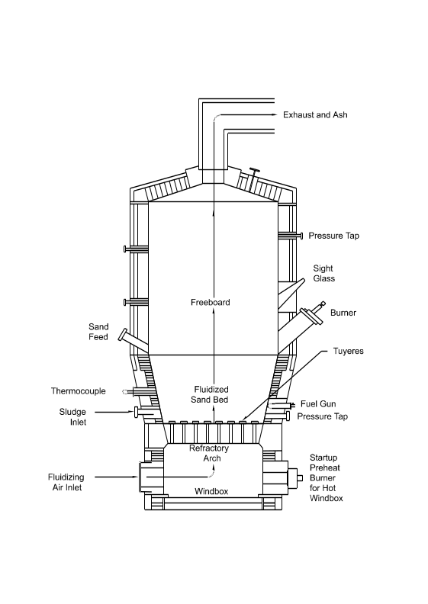
- The fluidized-bed RDF burns the waste in a turbulent and semisuspended bed of sand. The MSW may be fed into the incinerator either as unprocessed waste or as a form of RDF. The RDF may be injected into or above the bed through ports in the combustor wall. The sand bed is suspended during combustion by introducing underfire air at a high velocity, hence the term “fluidized.” Overfire air at 100% of stoichiometric requirements is injected above the sand suspension. Waste-fired fluidized-bed RDFs typically operate at 30 to 100% excess air levels and at bed temperatures around 815ºC (1500ºF). A typical fluidized-bed RDF is represented in Figure 3.7. The technology has two basic designs: (1) a bubbling-bed incineration unit and (2) a circulating-bed incineration unit. Fluidized-bed MSW incinerators in the United States, for example, have capacities ranging from 184 to 920 metric tons per day. These systems are usually equipped with boilers to produce steam. Similar systems in the European Union range from 36-200 tons per day (EU BREF, 3/2004)
Figure 3.7 Fluidized Bed MSW Incinerator

  - Design and Operation of Hazardous Waste Incinerators

As noted above, hazardous waste incinerators are of two principal types: merchant plants and dedicated facilities. Merchant incinerators handle a variety of waste streams and compete globally for business. Dedicated hazardous waste incinerators are normally integrated into larger industrial complexes and process singular or specialized waste streams.

    - Design and Operation of Merchant Hazardous Waste Incinerators

Merchant hazardous waste incinerators range in size from 30,000 to 100,000 tpy capacity (EU BREF, 2004). Due to the hazardous, and often uncertain, composition of the incoming waste streams, there is a greater emphasis on acceptance criteria, storage, handling, and pre-treatment than with MSW. For low energy value wastes, auxiliary fuels may be required.

      - Delivery, Storage, and Pre-Treatment of Hazardous Waste

Before accepting a hazardous waste for treatment, merchant incinerators must assess and characterize the material. Documentation by the producer is routinely required, including the origin of the waste, its code or other designation, the identification of responsible persons, and the presence of particular hazardous materials. The waste must also be properly packaged to avoid the possibility of reaction during transport.

Storage at the incinerator site will depend on the nature and physical properties of the waste. Solid hazardous waste is typically stored in bunkers constructed to prevent leakage and enclosed to allow the removal of bunker air to the combustion process. Liquid wastes are stored in tank farms, often under a non-reactive gas blanket (e.g., N₂), and transported to the incinerator by pipeline. Some wastes may be fed directly to the incinerator in their transport containers. Pumps, pipelines, and other equipment that may come in contact with the wastes must be corrosion proof and accessible for cleaning and sampling.

Pre-treatment operations may include neutralization, drainage, or solidification of the waste. Shredders and mechanical mixers may also be used to process containers or to blend wastes for more efficient combustion.

      - Merchant Hazardous Waste Incinerator Design

Although some hazardous wastes are incinerated in mass burn and fluidized bed furnaces, rotary kilns accompanied by a secondary combustion chamber are most commonly used for these streams. Figure 3.8 shows a typical layout for such incinerators.

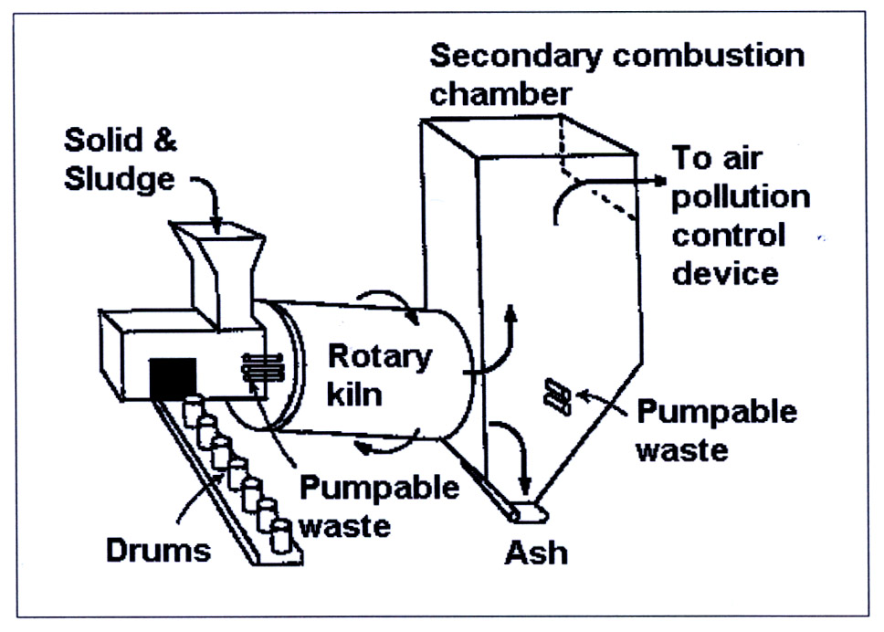
Figure 3.8 Schematic of a Rotary Kiln Incineration System [source: EU BREF 2004]

Rotary kilns used for hazardous waste incineration are comparable to those described above for the incineration of MSW (Section 3.2.2). Solid, sludge, containerized or pumpable waste is introduced at the upper end of the inclined drum. Temperatures in the kiln usually range between 850 and 1300ºC. The slow rotation of the drum allows a residence time of 30-90 minutes.

The secondary combustion chamber following the kiln completes the oxidation of the combustion gases. Liquid wastes and/or auxiliary fuels may be injected here along with secondary air to maintain a minimum residence time of two seconds and temperatures in the range of 900-1300ºC, effectively destroying any remaining organic compounds.

Hazardous waste is also incinerated in cement kilns. This application is addressed in another section of this guidance.

3.3.2 Dedicated Hazardous Waste Incinerators

Modular systems (see also Section 3.2.2) are typical in dedicated hazardous waste incinerators. Figure 3.9 illustrates the process for treating liquid and gaseous chlorinated wastes at a chlorinated chemical manufacturing facility.

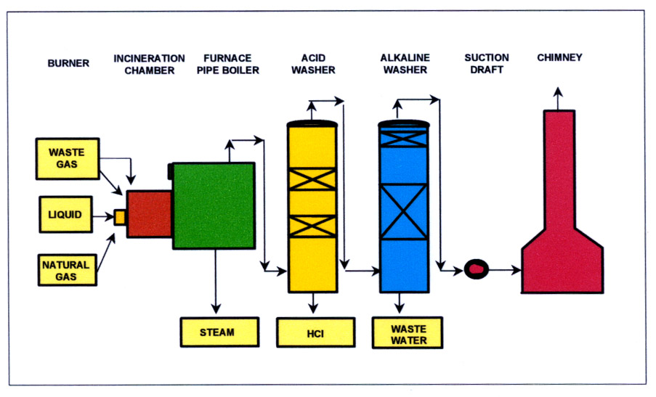
Figure 3.9 A Dedicated HWI with HCl Recovery [source: EU BREF, 2004]

Wastes, supplemented with auxiliary fuel at start up and as necessary and to maintain an operating temperature above 1100ºC, are converted to vapor by steam and fed to the incineration chamber under pressure. Post-combustion, flue gases are cleaned in two wash towers and HCl is recovered and returned to the process cycle.

Another example of a dedicated incineration involves the high-temperature incineration of liquid highly chlorinated wastes with the recovery of HCl. This process is outlined in Figure 3.10.
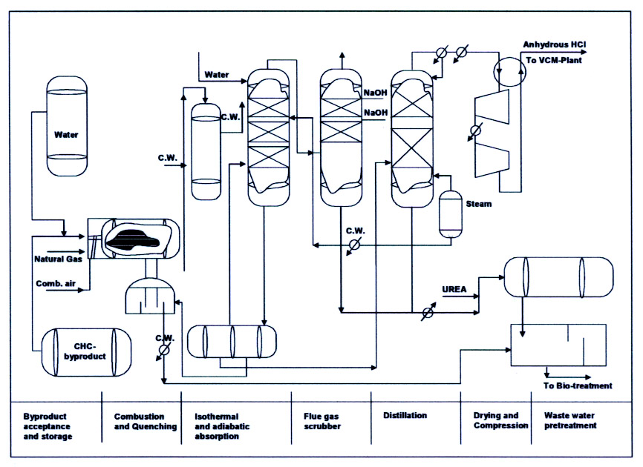
Figure 3.10 Liquid Waste Incineration with HCl Recovery [source: EU BREF, 2004]
The waste is fed to a high temperature furnace (1450-1550ºC) designed to provide a residence time of 0.2-0.3 sec. Water is also injected to suppress molecular chlorine formation. After combustion, the gas stream is rapidly quenched to 100ºC and put through an absorber. The recovered HCl is removed and reprocessed. The remaining flue gas is scrubbed and filtered with activated carbon. The waste water from this process is cleaned by physical/chemical and biological wastewater treatment.

The dedicated sector also includes a number of more specialized destruction alternatives including several types of plasma technologies. These are further described in Section 10 (Alternative and Emerging Technologies).

3.4 Design and Operation of Sewage Sludge Incinerators

The incineration of sewage sludge presents some differences from the incineration of MSW and hazardous waste. The variability of moisture content, energy value, and possible mixture with other wastes (e.g., industrial waste if sewage systems are interconnected) require special considerations in handling and pre-treatment.

The incineration technologies of choice for sewage sludge are the multiple hearth and fluidized bed furnace systems although rotary kilns are also used in smaller applications. Sewage sludge may also be co-incinerated with MSW or used as a supplemental fuel in coal-fired utilities and some industrial processes.

    - Pre-Treatment of Sewage Sludge
Some pre-treatment of sludge may occur before delivery to an incineration facility. This may include screening, anaerobic and aerobic digestion, and the addition of treatment chemicals.

Physical de-watering reduces sludge volume and increases heating value. Mechanical de-watering processes include decanters, centrifuges, belt filter and chamber filter presses. Conditioners (e.g., flocking agents) are often added before de-watering to facilitate drainage. Mechanical de-watering can routinely achieve 20-45% dry solids (EU BREF, 2004).

Drying introduces heat to further de-water and condition the sludge. Heat for drying at the incineration facility is often provided by the incineration process itself. Drying processes can be direct (sludge contacts thermal carrier) or indirect (e.g., heat supplied by steam plant). In direct drying the vapor and gas mixture must be subsequently cleaned.

Several thermal drying processes are used including: disk, drum, fluidized bed, and belt dryers; cold air, thin film, centrifugal, and solar drying. Autothermal (self-sustaining) incineration of sludge requires 35% dry solids. Although mechanical de-watering can reach this threshold, additional drying of sludge to as much as 80-95% dry solids may be employed to increase the heat value. Co-incineration with MSW generally requires additional sludge drying.

    - Design and Operation of Sewage Sludge Incinerators
A typical sewage sludge incinerator (Figure 3.11) may process 80,000 tpy of sludge and sludge components (swim scum, screenings, and extracted fats). Depending on the percent dry solids (dryness), an auxiliary fuel, usually heating oil or natural gas, is provided. Most sludge incinerators operate in an 850-950ºC temperature range, although some fluidized bed facilities are able to operate as low as 820ºC without deterioration in performance (EU BREF, 2004).

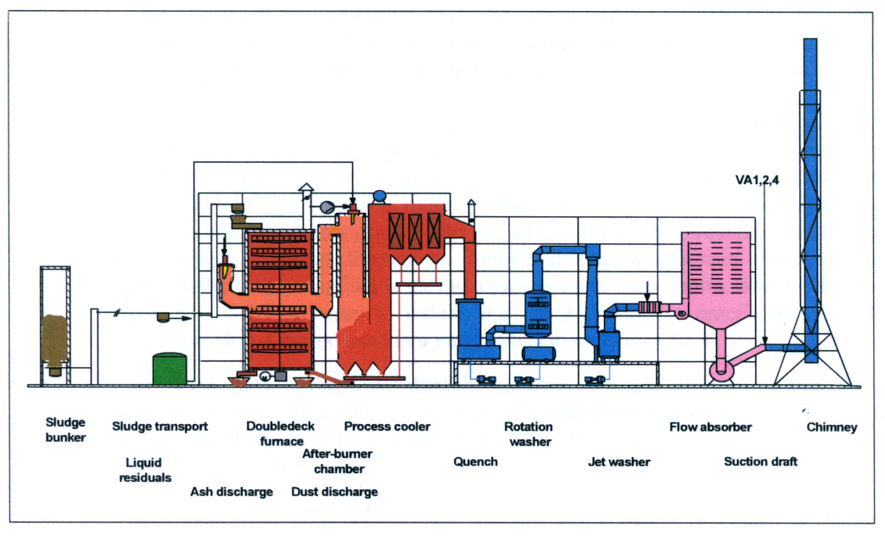
Figure 3.11 Example of a Multiple Hearth Sewage Sludge Incinerator [source: EU BREF, 2004]

      - Multiple Hearth Furnaces
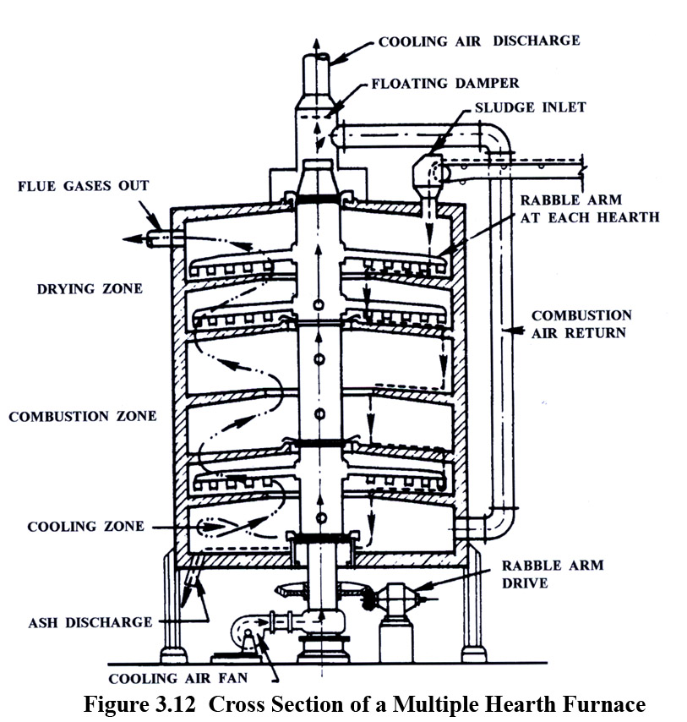
Multiple hearth furnaces were originally developed for ore roasting. Figure 3.12 illustrates the basic multiple hearth design. The furnace is cylindrical in shape with multiple levels and a central, rotating shaft with attached agitating arms. The sludge is supplied at the highest level and moves down through the multiple hearths by rotation and agitation. Combustion air is injected at the bottom of the furnace and moves countercurrent with the sludge.

Drying takes place in the upper hearths of the furnace as a result of the countercurrent combustion gases. Most of the incineration takes place in the central hearths at an optimal temperature of 850-950ºC. This temperature is maintained by an auxiliary fuel start-up burner as needed. Counter-flowing air from below cools the ash to 150ºC on the lower hearths where it is removed and the flue gases fed into a post-combustion chamber with adequate residence time (i.e., 2 seconds) to complete oxidation of remaining organic compounds.

      - Fluidized Bed Furnaces
Fluidized bed furnaces, as noted above with respect to MSW incineration (see Section 3.2.2.3), are suitable for finely divided wastes such as dried and conditioned sludges. Two types of fluidized bed furnaces are readily applicable to the incineration of sewage sludge.

In the Stationary (or bubbling) Fluidized Bed Furnace (Figure 3.13), air preheated with oil or gas burners fluidizes the bed material (e.g., sand). Sludge can be added from various points in the furnace and mixes with the bed material. If the sludge is sufficiently dry, good combustion can be maintained without auxiliary fuel. Volatiles and the fine particle fraction are incinerated in the zone above the fluidized bed. Ash and flue gases are removed at the head of the furnace.
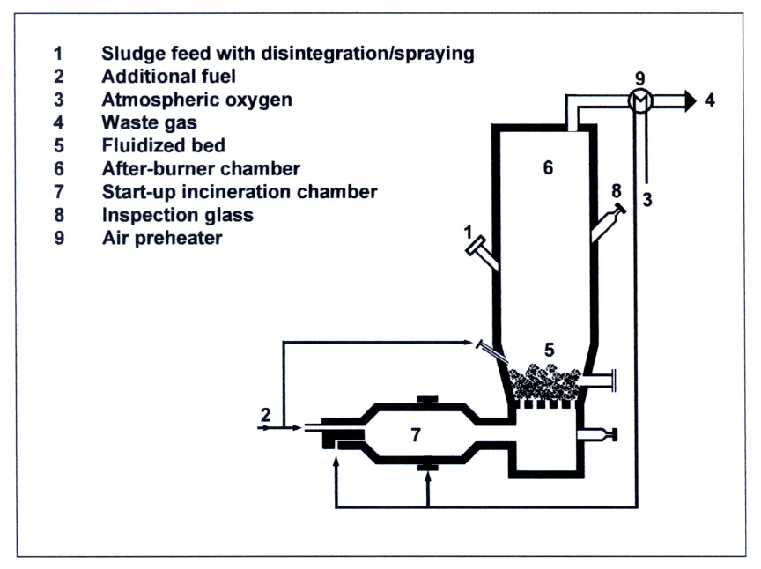
Figure 3.13 Schematic of a Stationary (Bubbling) Fluidized Bed Furnace [source: EU BREF, 2004]

Circulating Fluidized Bed Furnaces (Figure 3.14) are normally larger than the stationary fluidized bed counterpart and can treat a wider variety of sludges. Flue gases are removed and pass through a cyclone that recirculates particles to the furnace.

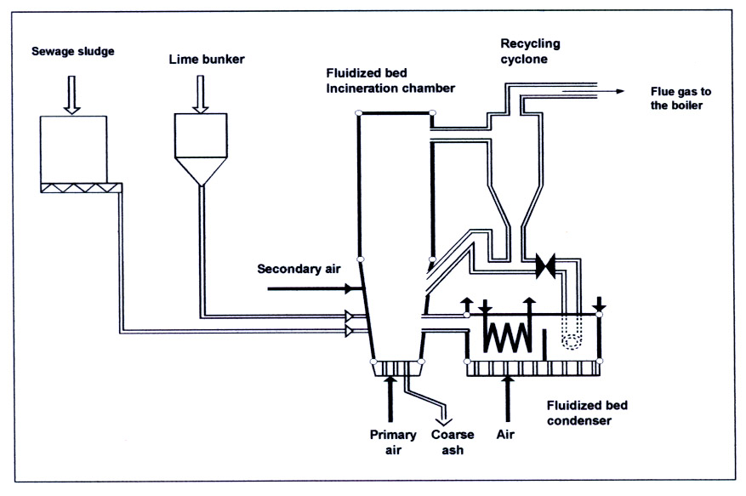
Figure 3.14 Circulating Fluidized Bed Furnace [source: EU BREF, 2004]

      - Multiple Hearth/Fluidized Bed Furnace
The fluidized bed technology can also be combined with the multiple hearth furnace (Figure 3.15). In this configuration, the flue gases from the fluidized bed dry the sludge as it moves down through the multiple hearths. The multiple hearth/fluidized bed has the advantage of lowering NO_{x} emissions by avoiding higher temperature differences between the head and the foot of the incinerator (EU BREF, 2004)

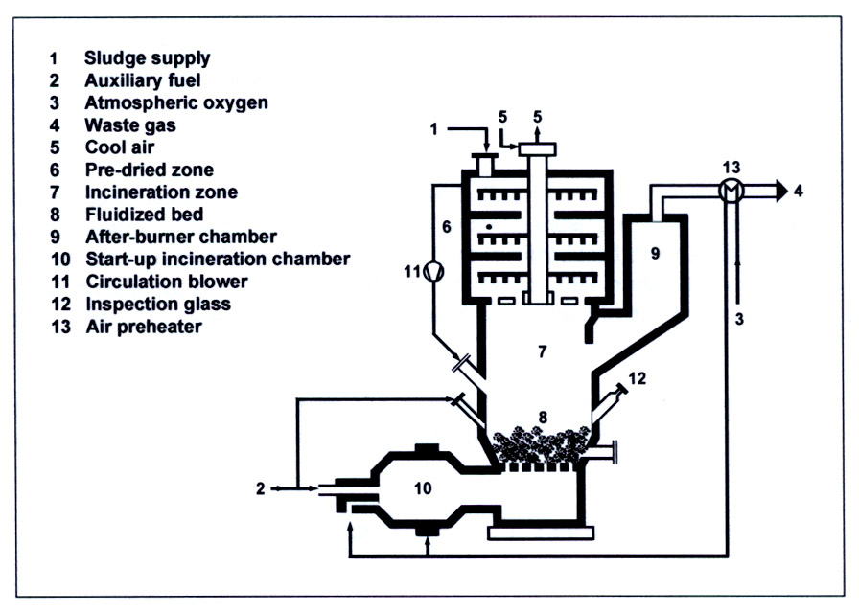
Figure 3.15 Combination Multiple Hearth/Fluidized Bed Furnace [source: EU BREF, 2004]

      - Cycloid Furnace
The cycloid technology was originally developed to treat residues from waste incineration plants. For sewage sludge incineration the material must be dried and available in granular form (size 1-5mm). The granules are fed into the lower part of the incineration chamber with primary air provided at various levels. Secondary air is injected tangentially above the fuel feed and creates a circular flow to complete incineration. Temperatures are maintained between 900 and 1,000ºC to keep the ash below the softening point. Ash is removed from below with a lock system (EU BREF, 2004).

    - Co-Incineration of Sewage Sludge with MSW
Sewage sludge is co-incinerated with MSW in both fluidized bed and mass burn (grated) incinerators. In the latter case, a ratio of 1:3 (sludge to MSW) is typical with dried sludge introduced into the incineration chamber as a dust or drained sludge applied to the grate through sprinklers. In some cases, drained or dried sludge may be mixed with MSW in the bunker or hopper before being charged to the incinerator. The feeding methods represent a significant proportion of the additional capital investment required for co-incineration.

4.0 Flue Gas Treatment (Air Pollution Control Devices)

Flue gases are a principal source of environmental releases from the incineration of wastes. Commercial incinerators are commonly equipped with one or more post-combustion air pollution control devices (APCDs) to remove various pollutants prior to release from the stack, such as PM, heavy metals, acid gases, and organic contaminants. APCDs may be “wet,” “dry,” or “semi-dry” depending on the role of water in the process. “Wet” and, to some extent, “semi-dry” APCDs require additional processes to clean any wastewater generated before it leaves the facility. Examples of APCD’s relevant to the prevention or reduction of unintentional POPs releases include:

- Cyclones and multi-cyclones
- Electrostatic filters (precipitators) – wet, dry, or condensation
- Fabric filters – including catalytic bag filters
- Static Bed Filters
- Sorbent/scrubbing systems - wet, spray dry, or ionization
- Selective catalytic reduction (SCR)
- Rapid Quenching Systems
- Carbon Adsorption

[Note: Combustion controls and other factors which affect unintentional POPs formation and release upstream of the flue gases are described in subsequent sections on best environmental practices and best available techniques.]

4.1 Cyclones and multi-cyclones. Cyclones and multi-cyclones (consisting of several small cyclones) extract particulate matter from the gas stream through the use of centrifugal force. Cyclones are less effective than particle capture devices such as ESPs and fabric filters and are rarely used alone in incineration facility flue gas cleaning applications.

4.2 Electrostatic precipitators. The ESP (in Europe these systems are usually referred to as electrostatic filters) is generally used to collect and control particulate matter that evolves during incineration by introducing a strong electrical field in the flue gas stream (Figure 4.1). This acts to charge the particles entrained in the combustion gases.
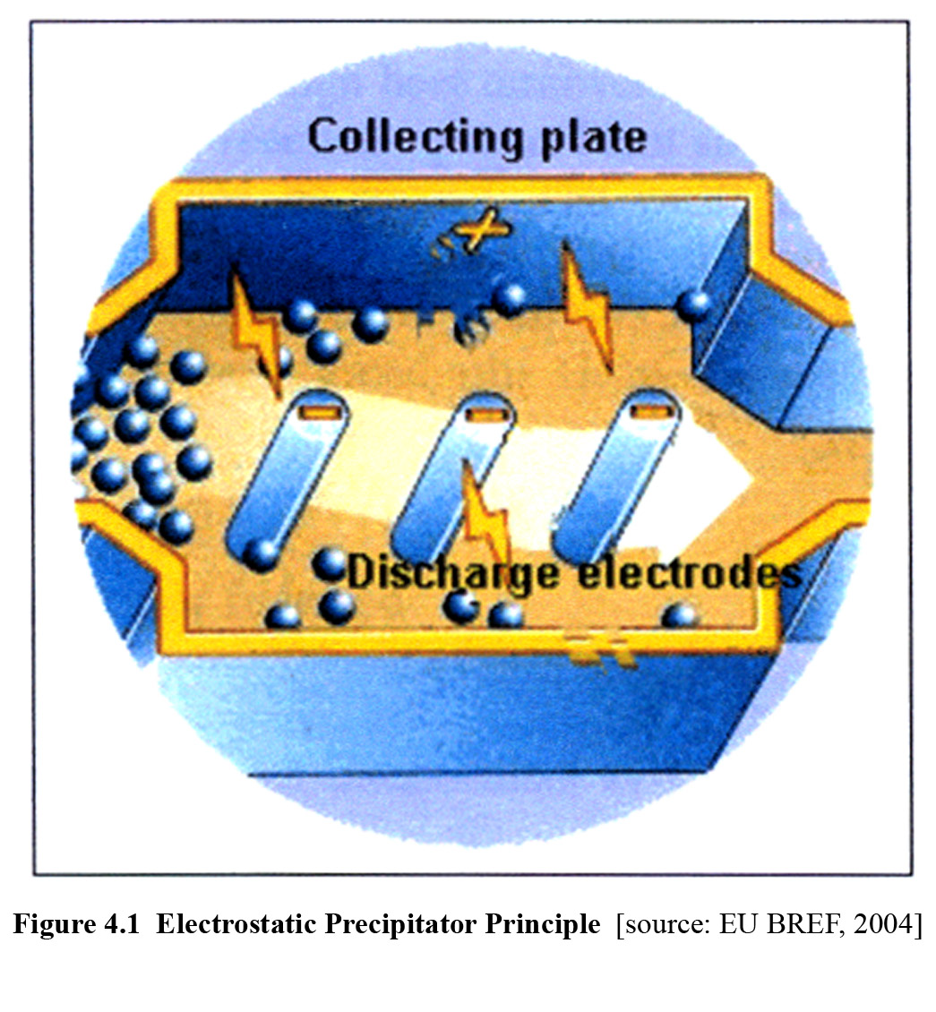
Large collection plates receive an opposite charge to attract and collect the particles. The efficiency of collection is a function of the electrical resistivity of the entrained particles.
Unintentional POPs formation can occur within the ESP at temperatures in the range of 200ºC to about 450ºC. Operating the ESP within this temperature range can lead to the formation of unintentional POPs in the combustion gases released from the stack. As temperatures at the inlet to the ESP increase from 200 to 300ºC, PCDD/PCDF concentrations have been observed to increase by approximately a factor of 2 for each 30ºC increase in temperature. ESPs that operate within this temperature range are referred to as ‘hot-sided’ ESPs. As the temperature increases beyond 300ºC, formation rates decline.

Although ESPs in this temperature range efficiently remove most particulate matter and the associated unintentional POPs, formation can result in a net increase in emissions. Cold-sided ESPs, which operate at or below 230ºC, do not foster unintentional POPs formation. However, many ESPs have been replaced with better-performing and lower-cost fabric filter technology.

Wet ESPs use liquids, usually water, to wash pollutants off the collection plates. These systems operate best when the incoming gases are cooler or moist.

Condensation ESPs use externally water-cooled bundles of plastic tubes that collect fine liquids or solids by facilitating condensation with a water quench (Figure 4.2).

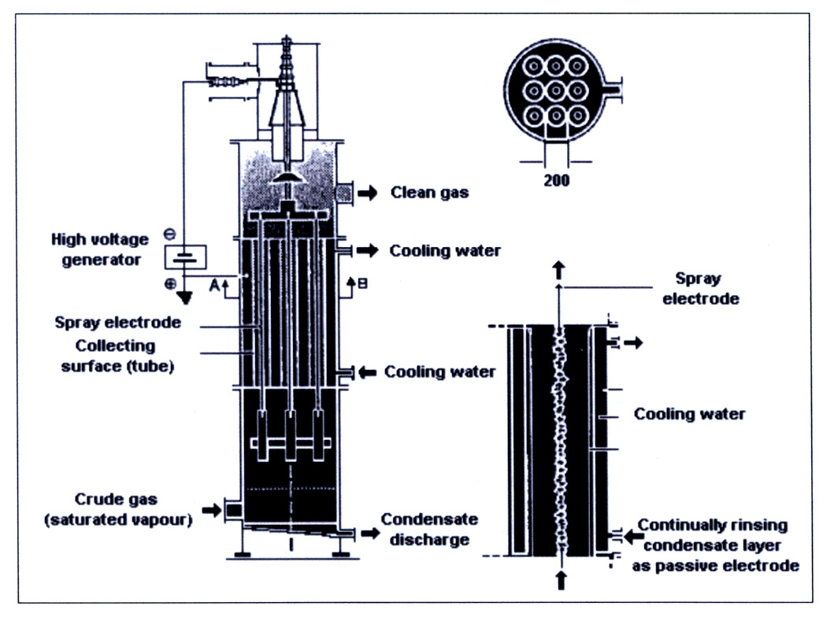
Figure 4.2 Condensation electrostatic precipitator [source: EU BREF, 2004]

4.3 Fabric filters are also referred to as baghouses or dust filters (Figure 4.3). These particulate matter control devices can effectively remove unintentional POPs that may be associated with particles and any vapors that adsorb to the particles in the exhaust gas stream.
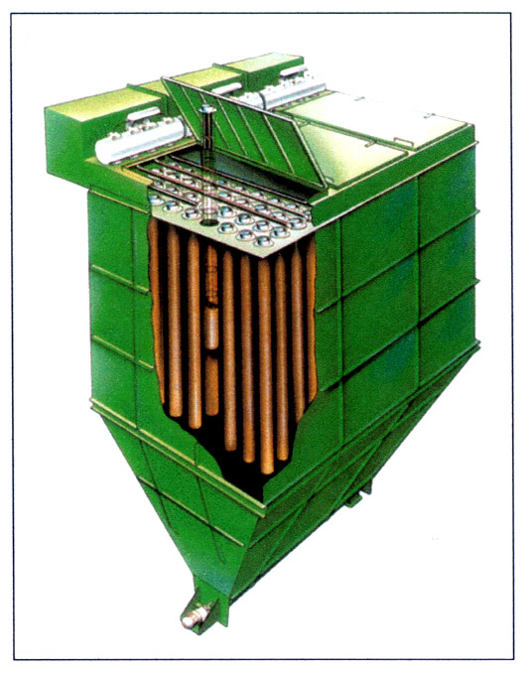
Figure 4.3 Schematic of a Fabric Filter [source: EU BREF, 2004]

Filters are usually 16 to 20 cm diameter bags, 10 m long, made from woven fiberglass material, and arranged in series. An induction fan forces the combustion gases through the tightly woven fabric. The porosity of the fabric allows the bags to act as filter media and retain a broad range of particle sizes down to less than 1 m in diameter (although at 1 m capture efficiency begins to decrease). Fabric filters are sensitive to acids; therefore, they are usually operated in combination with spray dryer adsorption systems for upstream removal of acid gases.

4.4 Static Bed Filters. These systems use both wet and dry activated coke or lignite filter beds to collect pollutants in the flue gas stream at very low concentrations. Wet systems periodically wash the filter substrate with water to remove deposits.

4.5 Sorbent/Scrubbing systems.

4.5.1 Dry sorbent systems use lime or soda ash injected into a reactor to convert the sulfur and halogens in the flue gas into dissolved or dry salts. This technique, while useful in the removal of some unintentional POPs precursors, probably has little effect on the collection of the POPs themselves.

4.5.2 Spray dry scrubbing, also called spray dryer adsorption, removes both acid gas and particulate matter from the post-combustion gases. In a typical spray dryer, hot combustion gases enter a scrubber reactor vessel (Figure 4.4).

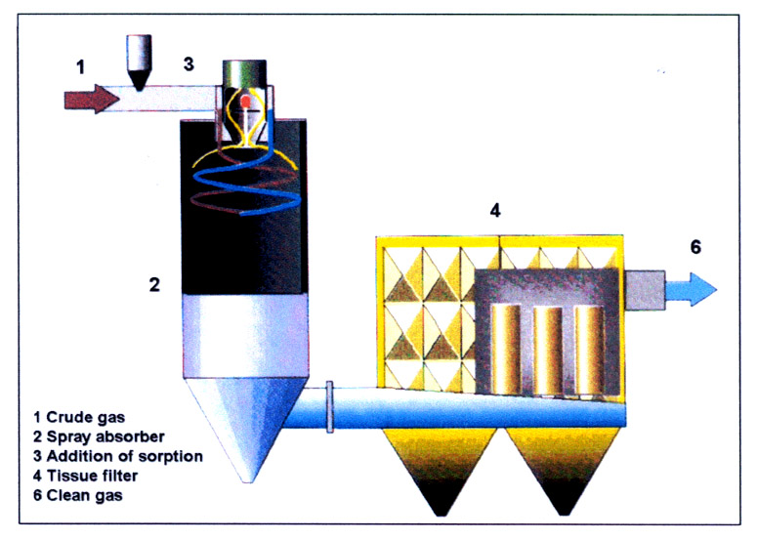
Figure 4.4 Spray dry scrubbing/adsorption [source: EU BREF, 2004]

An atomized hydrated lime slurry (water plus lime) is injected into the reactor at a controlled velocity. The slurry rapidly mixes with the combustion gases within the reactor. The water in the slurry quickly evaporates, and the heat of evaporation causes the combustion gas temperature to rapidly decrease. The neutralizing capacity of hydrated lime reduces the acid gas constituents of the combustion gas (e.g., HCl and SO₂) by greater than 70%. A dry product consisting of particulate matter and hydrated lime settles to the bottom of the reactor vessel.

The spray drying technology is often used in combination with ESPs and fabric filters. Spray drying reduces ESP inlet temperatures to create a cold-side ESP. In addition to acid gas, particulate matter, and metals control, spray dryers with fabric filters or ESPs typically achieve greater than 90% reduction in unintentional POPs emissions as well as better than 90% SO₂ and HCl control. PCDD/PCDF formation and release is substantially prevented by quenching combustion gases quickly to a temperature range that is unfavorable to their formation, and by the higher collection efficiency of the resulting particulate matter.

4.5.3 Wet scrubbers encompass a number of processes designed for acid gas removal and are common in European incineration facilities. Alternative technologies include: jet, rotation, venturi, spray, dry tower, and packed tower scrubbers (EU BREF p.108). Wet scrubbers help reduce formation and release of unintentional POPs in both vapor and particle forms. The device consists of a two-stage scrubber. The first stage removes HCl through the introduction of water, and the second stage removes SO₂ by addition of caustic or hydrated lime.

4.6 Selective Catalytic Reduction (SCR) is a secondary control measure primarily designed to reduce NO_{x} emissions. The process also destroys unintentional POPs via catalytic oxidation. SCR is a catalytic process in which an air-ammonia mix is injected into the flue gas stream and passed over a mesh catalyst (Figure 4.5). The ammonia and NO_{x} react to form water and N₂.

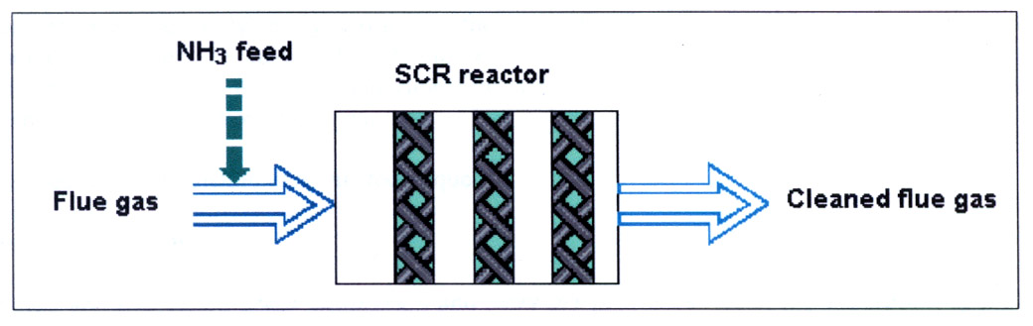
Figure 4.5 Selective Catalytic Reduction [source: EU BREF, 2004]

SCR units are usually placed in the clean gas area after acid gas and particulate matter removal. Efficient operation of the SCR process requires maintenance of the catalyst between 130 and 400ºC. For this reason, SCR units are often placed after ESPs to avoid the need for reheating of the flue gases. Caution must be exercised in such placement to avoid additional unintentional POPs formation in the ESP (see above description of ESPs). Multiple layered SCR systems offer both NO_{x} and unintentional POPs control (EU BREF, 2004).

4.7 Rapid Quenching Systems. Water quench systems are also used to bring flue gas temperatures down quickly to below unintentional POPs formation thresholds (e.g., 100ºC). These systems and associated wastewater treatment systems must be designed to deal with the higher particulate matter loadings that will end up in the scrubber water as a consequence.

4.8 Carbon Adsorption. Activated carbon is injected into the flue gas prior to the gas reaching the spray dryer-fabric filter/ESP combination. PCDD/PCDF (and mercury) are absorbed onto the activated carbon, which is then captured by the fabric filter or ESP. The carbon injection technology improves capture of the unintentional POPs in the combustion gases by an additional 75% and is commonly referred to as flue gas polishing. Many APCDs have been retrofitted to include carbon injection, including more than 120 large municipal incinerators operating in the United States.

5.0 Best Environmental Practices for Waste Incineration

Well-maintained facilities, well-trained operators, a well-informed public, and constant attention to the process are all important factors in minimizing the formation and release of the unintentional POPs from the incineration of waste. In addition, effective waste management strategies (e.g., waste minimization, source separation, and recycling), by altering the volume and character of the incoming waste, can also significantly impact releases.

5.1 Waste Management Practices

5.1.1 Waste Inspection and Characterization. A thorough knowledge of the characteristics and attributes of the incoming waste is essential. Checking, sampling, and analyses should be performed. This is particularly true for hazardous wastes. Manifests and audit trails are important to maintain and keep updated. Table 5.1 illustrates some of the techniques applicable to the different types of waste.

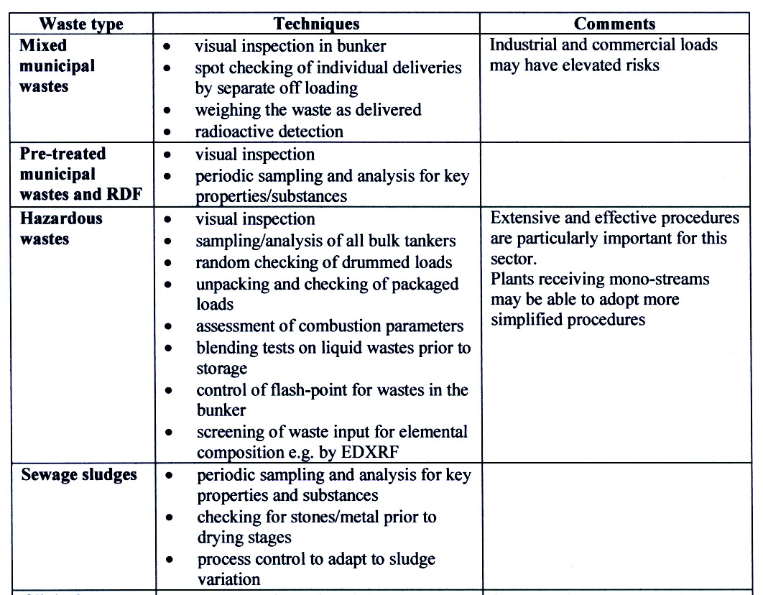
Table 5.1 Example Inspection Techniques [source: EU BREF, 2004]

5.1.2 Waste Minimization. Reducing the overall magnitude of wastes that have to be disposed by any means serves to reduce both the releases and residues from incinerators. Diversion of biodegradables to composting and initiatives to reduce the amount of packaging materials entering the waste stream can significantly affect waste volumes.

5.1.3 Source Separation and Recycling. Curbside or centralized sorting and collection of recyclable materials (e.g., aluminum and other metals, glass, paper, recyclable plastics, construction & demolition waste) also reduces waste volume and removes some non-combustibles.

5.1.4 Removal of Non-combustibles at the Incinerator. The removal of both ferrous and non-ferrous metals on-site is a common practice at MSW incinerators.

5.1.5 Proper Handling, Storage, and Pre-Treatment. Proper handling, particularly of hazardous waste, is essential. Appropriate sorting and segregation should be undertaken to enable safe processing (Table 5.2).

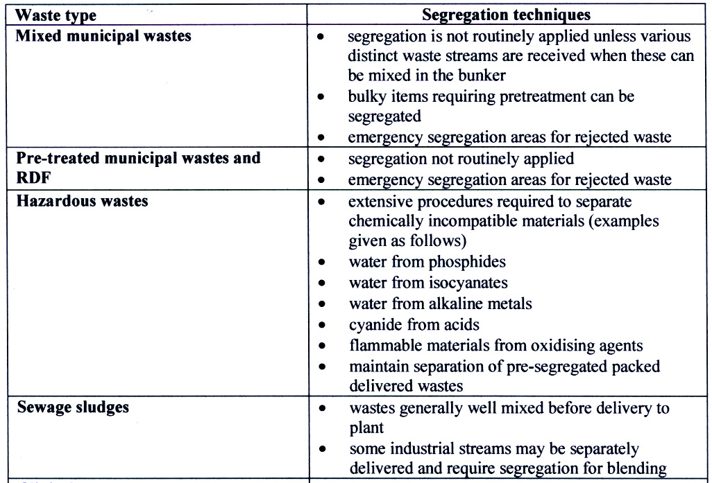
Table 5.2 Example Segregation Techniques [source: EU BREF, 2004]
Storage areas must be properly sealed with controlled drainage and weatherproofing. Fire detection and control systems for these areas should also be considered. Storage and handling areas should be designed to prevent contamination of environmental media and to facilitate clean up in the event of spills or leakage. Odors can be minimized as noted earlier by using bunker air for the combustion process. In the case of sewage sludge, pre-treatment must ensure that adequate drying and conditioning has been performed.

5.1.6 Minimizing Storage Times. Although having a constant supply of waste is important for continuous operations like large MSW incinerators, stored wastes are unlikely to improve with age. Minimizing the storage period will help prevent putrefaction and unwanted reactions, as well as the deterioration of containers and labeling. Managing deliveries and communicating with suppliers will help ensure that reasonable storage times (e.g., 4-7 days for MSW) are not exceeded.

5.1.7 Establishing Quality Requirements for Waste Fed. Facilities must be able to accurately predict the heating value and other attributes of the waste being combusted in order to ensure that the design parameters of the incinerator are being met.

5.1.8 Waste Loading. For facilities that accept heterogeneous MSW, proper mixing and loading of the feed hopper is critical. Loading crane operators must have both the experience and the appropriate vantage point to be able to select the appropriate mix of waste types to keep the incinerator performing at peak efficiency.

5.2 Incinerator Operating and Management Practices

5.2.1 Ensuring Good Combustion. To achieve optimal prevention of formation and capture of the unintentional POPs, proper care and control of both burn and exhaust parameters are necessary. In continuous feed units, the timing of waste introduction, control of burn conditions, and post burn management are important considerations.

Optimal burn conditions involve:

- mixing of fuel and air to minimize the existence of long-lived, fuel rich pockets of combustion products,
- attainment of sufficiently high temperatures in the presence of oxygen for the destruction of hydrocarbon species, and
- prevention of quench zones or low temperature pathways that will allow partially reacted fuel to exit the combustion chamber.

Proper management of time, temperature, and turbulence (the “3 T’s”), as well as oxygen (air flow), by means of incinerator design and operation will help to ensure the above conditions. The recommended residence time of waste in the primary furnace is 2 seconds. Temperatures at or above 850°C are required for complete combustion in most technologies. Turbulence, through the mixing of fuel and air, helps prevent cold spots in the burn chamber and the buildup of carbon which can reduce combustion efficiency. Oxygen levels in the final combustion zone must be maintained above those necessary for complete oxidation.

5.2.2 Cold Starts, Upsets, and Shutdowns. These events are normally characterized by poor combustion, and consequently the conditions for unintentional POPs formation. For smaller, modular incinerators operating in batch mode, start-up and shutdown may be daily occurrences. Preheating the incinerator and initial co-firing with a fossil fuel will allow efficient combustion temperatures to be reached more quickly. Wherever possible, however, continuous operation should be the practice of choice. Upsets can be avoided through periodic inspection and preventive maintenance.

5.2.3 Regular Facility Inspections and Maintenance. Routine inspections of the furnace and APCDs should be conducted to ensure system integrity and the proper performance of the incinerator and its components.

5.2.4 Monitoring. High efficiency combustion can be facilitated by establishing a monitoring regime of key operating parameters, such as carbon monoxide (CO). Low CO is associated with higher combustion efficiency in terms of the burnout of the MSW. Generally, if the CO concentration is kept to below 50 ppm by volume in the stack flue gases, this provides a general indication that high combustion efficiency is being maintained within the combustion chamber. Good combustion efficiency is related to the minimization of the formation of PCDD/PCDFs within the incinerator.

In addition to carbon monoxide, oxygen in the flue gas, air flows and temperatures, pressure drops, and pH in the flue gas can be routinely monitored at reasonable cost. While these measurements represent reasonably good surrogates for the potential for unintentional POPs formation and release, periodic or quasi-continuous (AMESA method) measurement of PCDD/PCDF in the flue gas will aid in ensuring that releases are minimized and the incinerator is operating properly.

5.2.5 Handling of Residues. Bottom and fly ash from the incinerator must be properly handled, transported, and disposed of. Covered hauling and dedicated landfills are a common practice for managing these residues. If re-use of the residues is contemplated, an evaluation of the unintentional POPs content and potential environmental mobility is advisable.

Scrubber effluents, including the filter cake from wet flue gas cleaning, must be properly treated and disposed of. If the concentration of unintentional POPs or other toxic materials (e.g., heavy metals) is sufficiently high, these materials may be consigned to landfilling as hazardous waste.

    - Operator Training. Regular training of personnel is essential for proper operation of waste incinerators.

    - Maintaining Public Awareness and Communication. Creating and maintaining public good will towards a waste incineration project is critical to the success of the venture. Outreach should begin as early in the planning of the project as possible. The public and citizen’s advocacy groups will have understandable concerns about the construction and operation of a facility and dealing with these openly and honestly will help prevent misinformation and misunderstanding.

Effective practices for improving public awareness and involvement include: placing advance notices in newspapers; distributing information to area households; soliciting comment on design and operational options; providing information displays and in public spaces; and holding frequent public meetings and discussion forums.

Successful incineration projects have been characterized by: holding regular meetings with concerned citizens; providing days for public visitation; posting release and operational data to the Internet; and displaying real time data on operations and releases at the facility site.

6.0 Best Available Techniques

In addition to applying best environmental practices to the incineration of MSW, hazardous waste, and sewage sludge, there are a variety of demonstrated combustion engineering, flue gas cleaning, and residue management techniques that are available for preventing the formation or minimizing the releases of unintentional POPs. There are also non-incineration and emerging technology options, described in a later section of this guidance, that may represent feasible and environmentally sound alternatives to incineration. The purpose of this section, however, is to identify the best techniques applicable to the process of incineration.

  - Combustion Techniques

    - General Combustion Techniques

- Ensure design of furnace is appropriately matched to characteristics of the waste to be processed.
- Maintain temperatures in the gas phase combustion zones in the optimal range for completing oxidation of the waste (e.g., 850-950ºC in grated MSW incinerators).
- Provide for sufficient residence time (e.g., 2 seconds) and turbulent mixing in the combustion chamber(s) to complete incineration.
- Pre-heat primary and secondary air to assist combustion.
- Use continuous rather than batch processing wherever possible to minimize start-up and shut-down releases.
- Establish systems to monitor critical combustion parameters including grate speed and temperature, pressure drop, and levels of CO, CO₂, O₂.
- Provide for control interventions to adjust waste feed, grate speed, and temperature, volume, and distribution of primary and secondary air.
- Install automatic auxiliary burners to maintain optimal temperatures in the combustion chamber(s).

    - MSW Incineration Techniques

- Mass burn (moving grate) incinerators are well demonstrated in the combustion of heterogeneous MSW and have a long operational history.
- Water-cooled grated incinerators have the added advantages of better combustion control and the ability to process MSW with higher heat content.
- Rotary kilns with grates can accept heterogeneous MSW but a lower throughput than the mass burn/moving grate furnaces.
- Static grated furnaces with transport systems (e.g., rams) have fewer moving parts but waste may require more pretreatment (i.e., shredding, separation).
- Modular designs with secondary combustion chambers are well demonstrated for smaller applications. Depending on size, some of these units may require batch operation.
- Fluidized bed furnaces and spreader/stoker furnaces are well demonstrated for finely divided, consistent wastes such as RDF.

    - Hazardous Waste Incineration Techniques

- Rotary kilns are well demonstrated for the incineration of hazardous waste and can accept liquids and pastes as well as solids.
- Water-cooled kilns can be operated at higher temperatures and allow acceptance of wastes with higher energy values.
- Waste consistency (and combustion) can be improved by shredding drums and other packaged hazardous wastes.
- A feed equalization system (e.g., screw conveyors that can crush and provide a constant amount of solid hazardous waste to the furnace) will

    - Sewage Sludge Incineration Techniques
- Fluidized bed incinerators are well demonstrated for thermal treatment of sewage sludge.
- Circulating fluid bed furnaces allow greater fuel flexibility than bubbling beds, but require cyclones to conserve bed material.
- Care must be exercised with bubbling bed units to avoid clogging.
- The use of heat recovered from the process to aid sludge drying will reduce the need for auxiliary fuel.
- Supply technologies are important in the co-incineration of sewage sludge in MSW incinerators. Demonstrated techniques include: dried sludge blown in as dust; drained sludge supplied through sprinklers and distributed and mixed on the grate; and drained or dried sludge mixed with MSW and fed together (EU BREF, 2004).
- In the co-incineration of sewage sludge in coal-fired power plants, attention must be paid to the moisture content of the sludge and the proportion of sludge to coal. Some data (Luts, 2000) suggest that drying to 85% dry solids is preferable and firing rates above 7.6 wt% dry solids may lead to ESP fouling. In the study, best performance was achieved with a co-firing rate of 2.5 wt% dry solids.

Note: Additional information on the comparison of combustion techniques among furnace types, abstracted from the European Union incineration BREF may be found in Appendix A.

  - Flue Gas Treatment (FGT) Techniques

The type and order of treatment processes applied to the flue gases once they leave the incineration chamber is important, both for optimal operation of the devices as well as for the overall cost effectiveness of the installation. Waste incineration parameters that affect the selection of techniques include: waste type, composition, and variability; type of combustion process; flue gas flow and temperature; and the need for, and availability of, wastewater treatment. Choices must also consider whether flue gas components (e.g., APCD residues, fly ash) are to remain separate following collection or be re-mixed, since this will impact residue volume and re-cycling opportunities. The following treatment techniques have direct or indirect impacts on preventing the formation and minimizing the release of the unintentional POPs.

    - Dust Removal Techniques

- Dust removal from the flue gases is essential for all incinerator operations.
- Cyclones and multi-cyclones, ESPs, and fabric filters have demonstrated effectiveness as capture techniques for particulate matter in incinerator flue gases. Table 6.1 provides a comparison of the primary dust removal systems.
- Cyclones and dry ESPs tend to be less efficient in the size fraction captured are often used in a pre-dedusting step to remove coarser particles from the flue gases and reduce dust loads on downstream treatment devices.
- The collection efficiency of ESPs is reduced as electrical resistivity of the dust increases. This may be a consideration in situations where waste composition varies rapidly (e.g., hazardous waste incinerators).
- Operation of ESPs in the temperature range for PCDD/DF formation (200-450ºC) should be avoided.
- Wet ESPs can capture very small particle sizes (<mg/m³) but require effluent treatment and are usually employed following dedusting.
- Fabric filters (bag filters) are widely applied in waste incineration and have the added advantage, when coupled with semi-dry sorbent injection (spray drying), of providing additional filtration and reactive surface on the filter cake.
- Pressure drop across fabric filters should be monitored to ensure filter cake is in place and bags are not leaking.
- Fabric filters are subject to water damage and corrosion and are best suited for dry gas streams with upstream removal of acid gases. Some filter materials are more resistant to these effects. Table 6.2 outlines filter material choices and attributes.

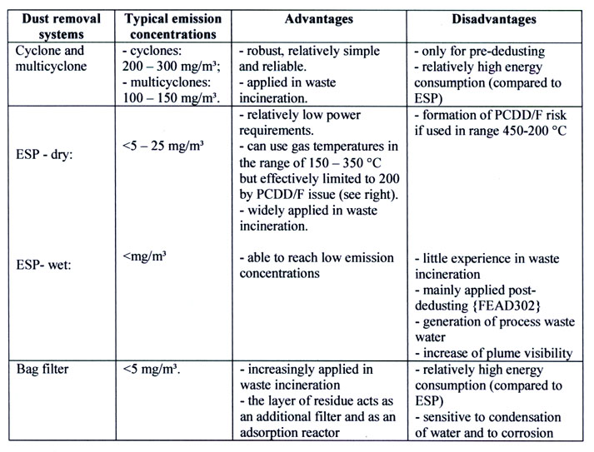
Table 6.1 Comparison of Dust Removal Systems [source: EU BREF]

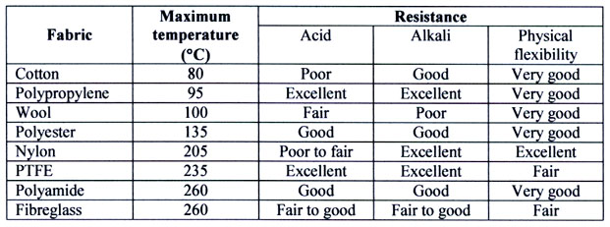

Table 6.2 Characteristics of Bag Filter Materials [source: EU BREF]

    - Flue Gas Polishing Techniques

- Additional dust removal may be appropriate before cleaned flue gases are sent to the stack. Techniques for the “polishing” of flue gas include fabric filters, wet ESPs, and venturi scrubbers.
- Double filtration (filters in series) can routinely achieve collection efficiencies at or below 1 mg/m³.
- The additional benefits of these techniques may be small, and the cost effectiveness disproportionate, if effective upstream techniques are already being applied.
- Flue gas polishing may have greatest utility at large installations and in further cleaning of gas streams prior to SCR.

    - Acid Gas Removal Techniques

- Wet scrubbers have the highest removal efficiencies for soluble acid gases among the demonstrated techniques.
- Pre-dedusting of the gas stream may be necessary to prevent clogging of the scrubber, unless scrubber capacity is sufficiently large.
- The use of carbon impregnated materials, activated carbon, or coke in scrubber packing materials can achieve a 70% reduction in PCDD/F across the scrubber (EU BREF, 2004).
- Spray dryers (semi-wet scrubbing) also provide high removal efficiencies and have the advantage of not requiring subsequent effluent treatment. In addition to the alkaline reagents added for acid gas removal, activated carbon injection is also effective in removing PCDD/F.
- Spray dryers, as noted above, are often deployed upstream of fabric filters. The filters provide for capture of the reagents and reaction products as well as offering an additional reactive surface on the filter cake.
- Inlet temperatures to the fabric filter in such combinations is important. Temperatures above 130-140ºC are normally required to prevent condensation and corrosion of the bags.
- Dry scrubbing systems cannot reach the efficiency of wet or semi-dry scrubbers without significantly increasing the amount of reagent/sorbent. Increased reagent use adds to the volume of fly ash.

    - Nitrogen Oxides (NO_{X}) Removal Techniques

- Although the primary role of selective catalytic reduction (SCR) is to reduce NO_{X} emissions, this technique can also destroy unintentional POPs (e.g., PCDD/DF) with an efficiency of 98-99.5% (EU BREF, 2004).
- Flue gases may have to be re-heated to the 250-400ºC required for proper operation of the catalyst.
- Performance of SCR systems improves with upstream flue gas polishing. These systems are installed after dedusting and acid gas removal.
- The significant cost (capital and energy) of SCR is more easily borne by large facilities with higher gas flow rates and economies of scale.

  - Residue Management Techniques

Residues from incineration include various types of ash (e.g., bottom ash, boiler ash, fly ash), and residues from other FGT processes, including liquid effluents in the case of wet scrubbing systems. Table 6.3 illustrates the relative solid residue volumes for a typical MSW incinerator.

Types of Solid Residue | % (per ton MSW incinerated)
Bottom Ash | 21%
Fly ash + gas cleaning residue + wet scrubber sludges | 4.2%
Scrap recovered from bottom ash | 1.2%

Table 6.3 Solid Residues from MSW Incineration [source: EU BREF, 2004]

Because constituents of concern may vary considerably, maintaining the separation of residues for treatment, management, and disposal is often appropriate. The presence and concentration of unintentional POPs in these residues is a function of their presence in the incoming waste, survival or formation in the incineration process, and formation and capture during flue gas treatment. The following techniques are relevant to preventing releases to the environment of these substances, once present in the residues.

6.3.1 Bottom and Boiler Ash

- Bottom ash from modern incinerators tends to be very low in unintentional POPs content, in the same order of magnitude as background concentrations in urban soils (i.e., <0.001-0.01 ng PCDD/F/g ash). Boiler ash levels tend to be higher (0.02-0.5 ng PCDD/F/g ash) but both well below the average concentrations found in fly ash (EU BREF, 2004).
- Because of the differences in pollutant concentration, the mixing of bottom ash with fly ash will contaminate the former. Separate collection and storage of these residues provides operators with more options for disposal. Bottom ash (or slag from fluidized bed incinerators) may be reused in construction and road-building material. Prior to such use, however, an assessment of content and leachability should be conducted.
- Leachability of unintentional POPs is known to increase with increasing pH and humic (presence of organic matter) conditions. This would suggest that disposal of in lined and dedicated landfills is preferable to mixed waste facilities.
- If levels are found to be excessive, bottom ash may be treated for unintentional POPs by re-incineration or other thermal treatment (e.g. high temperature plasma)

6.3.2 Fly Ash and Other Flue Gas Treatment Residue Techniques

- Unlike bottom ash, APCD residuals including fly ash and scrubber sludges may contain relatively high concentrations of heavy metals, organic pollutants (including PCDD/F), chlorides and sulfides.
- Mixing fly ash and FGT residues with bottom ash should be avoided since this will limit the subsequent use and disposal options for the bottom ash.
- Treatment techniques for these residues include:

  - Cement solidification. Residues are mixed with mineral and hydraulic binders and additives to reduce leaching potential. Product is landfilled.
  - Vitrification . Residues are heated in electrical melting or blast furnaces to immobilize pollutants of concern. Organics, including PCDD/F are typically destroyed in the process.
  - Catalytic treatment of fabric filter dusts under conditions of low temperatures and lack of oxygen;
  - The application of plasma or similar high temperature technologies.

- Fly ash and scrubber sludges are normally disposed of in landfills set aside for this purpose. Some countries include ash content limits for PCDD/F in their incinerator standards. If the content exceeds the limit, the ash must be re-incinerated.

    - Effluent Treatment Techniques

- Process wastewater in incineration arises mainly from the use of wet scrubbing technologies. The need for and treatment of wastewater can be alleviated by the use of dry and semi-wet systems.
- One wastewater-free technique involves the neutralization and subsequent treatment of the scrubber effluent to produce sedimentation. The remaining wastewater is evaporated and the sludge can be landfilled (dedicated) or further processed to recover gypsum and calcium chloride (EU BREF, 2004).
- Re-circulation of process water also helps to reduce the volume for eventual treatment.
- Use of boiler drain water as scrubber feed may also reduce the total volume of process water and subsequent treatment capacity.
- Depending on the design of the incinerator, some effluent streams can be fed back through the process and any surviving pollutants concentrated in the solid rather than liquid residues..

7.0 New and Significantly Modified Incinerators

The Stockholm Convention (Annex C, Part V, B, (b)) states that before Parties proceed with proposals to construct or significantly modify sources that release unintentional POPs, they should give “priority consideration” to “alternative processes, techniques or practices that have similar usefulness but which avoid the formation and release” of these compounds. In cases where such consideration results in a determination to proceed with construction or modification, the Convention provides a set of general reduction measures for consideration. While these general measures have been incorporated in the preceding discussion of best environmental practices and best available techniques for these categories, there are additional factors that will be important in deciding whether it is feasible to construct or modify a waste incinerator.

  - Additional Factors in the Siting of New MSW Incinerators

- Do I have an accurate prediction of the MSW generation in the area to be served for the cost recovery period?
- Will the supply allow for continuous operation of the incinerator?
- Does this prediction include appropriate waste minimization, recycling, and recovery programs?
- Do I have the necessary transportation infrastructure to support collection and hauling?
- Have I investigated the likelihood of intra- or interstate restrictions on waste transportation?
- Do I have available markets for any on-site separated materials?
- Do I have available markets for excess steam or electricity generated on-site (WTE)?
- Do I have environmentally sound options for the disposal of residues?

  - Additional Factors in the Siting of New Hazardous Waste Incinerators

- Do I have an accurate prediction of the hazardous waste generation in the area to be served for the cost recovery period?
- Will the supply allow for continuous operation of the incinerator?
- Do I have the necessary infrastructure to support transportation needs?
- If international transport is envisioned, have I made the necessary agreements to allow transfer across borders?
- Do I have the necessary agreements with suppliers to ensure safe packaging and handling?
- Do I have environmentally sound options available for the treatment and disposal of residues?

  - Additional Factors in the Siting of New Sewage Sludge Incinerators

- Do I have an accurate prediction of the sewage sludge generation in the area to be served for the cost recovery period?
- Will the supply allow for continuous operation of the incinerator?
- Have I determined whether the sewage sludge in the service area is mixed with industrial or other wastes?
- Do I intend to co-incinerate the sewage sludge with MSW or as a supplemental fuel in a utility generating facility?

  - Modification of Existing Waste Incinerators

Significant modifications to an existing waste incinerator may be considered for several reasons. These could include: an expansion of capacity, the necessity of major repairs, enhancements to improve combustion efficiency and/or energy recovery, and the retrofitting of APCDs. Before undertaking such a modification, in addition to the “priority consideration” noted above, the following factors will be important to consider.

- How will the modification affect the potential releases of unintentional POPs?
- If the modification is the addition of an APCD, is it sized properly for the facility?
- Is there sufficient space to install and operate it properly? For example, available space may dictate the retrofit of a double filtration (filters in series, though not necessarily adjacent) technique rather than an alternative scrubbing system.
- Will the retrofitted device operate in concert with the existing APCDs to minimize releases?
The costs of making modifications to an existing facility may exceed similar changes at a new installation by 25-50% (EU BREF, 2004). Factors influencing this increase include: the additional engineering necessary, the removal and disposal of replaced equipment, reconfiguring connections, and losses in productivity with down time.

8.0 Costs and Economic Considerations

The construction of large state-of -the-art incinerators requires major capital investment, often approaching hundreds of millions USD. Installations recover capital and operating costs through tipping or treatment fees and, in the case of waste-to-energy facilities, through the sale of steam or electricity to other industries and utilities. The ability to fully recover the costs of construction and operation is dependent on a number of factors including: the relative cost of alternative disposal methods (e.g., landfills); the availability of sufficient waste within the local area; provisions for disposal of residues; and proper staffing, operation, and maintenance to maintain peak efficiency and minimize downtime. Recycling and recovery programs to remove non-combustibles and other recyclable materials from the waste stream are economically compatible with large incinerator operations, provided these programs are incorporated into the planning and design of the facility.

Small waste incinerators, particularly the modular designs, require significantly lower capital investment but do not benefit from the economies of scale available to larger facilities. While modern designs can generally achieve high levels of combustion efficiency through starved air and secondary combustion chambers, the addition of APCDs to further reduce releases may be considered disproportionately expensive. There will be, however, situations in which smaller units may be the most feasible and cost effective incineration option. These could include: low population density; low waste generation; and the lack of transportation infrastructure.

The following sections provide an overview of the cost and economic factors that may assist Parties in the development of national and regional strategies with regard to these source categories. The data are drawn from the March, 2004, Draft Reference Document on Best Available Techniques for Waste Incineration prepared by the European Integrated Pollution Prevention and Control Bureau (EIPPCB).

  - General Considerations

The economics of waste incineration may vary significantly from country to country depending on a number of factors. In addition to the technical and infrastructural requirements, existing waste policies (or their absence) and practices may affect the ultimate costs and cost-effectiveness of these technologies.

Factors that can influence the costs of incineration include: land acquisition costs; operational scale; capacity and utilization rates; flue gas treatment and residue disposal requirements; revenue streams from re-cycled materials, energy recovery and sale; taxes levied or subsidies provided; competition from other disposal options; cost of capital; insurance; and administrative and labor costs. Waste incineration plants may be publicly or privately owned or operated as public/private partnerships. In each case, the financial costs of capital investment may vary. Tipping fees (or other fees charged per unit of waste) may not reflect the true cost of operation if the incinerator is part of a broader publicly owned service organization.

Capital investment costs for incinerators vary significantly with the selection of techniques for FGT and residue handling. Table 8.1 provides an example of the relative investment cost by FGT type and incinerator capacity in Germany.

Type of Waste Gas Cleaning | Specific Investment Costs (EUR/ton waste input)
Type of Waste Gas Cleaning | 100,000 tpy | 200,000 tpy | 300,000 tpy | 600,000 tpy
Dry | 670 | 532 | 442 | 347
Dry/Wet | 745 | 596 | 501 | 394
Dry/Wet + Residue Processing | 902 | 701 | 587 | 457
Table 8.1 Investment Costs of Waste Gas Cleaning in Germany [source EU BREF, 2004]

  - MSW Incineration

Table 8.2 provides an example of capital and investment costs for a 250,000 tpy MSW incinerator. These costs will vary by the size of the installation since there are economies of scale. Table 8.3 illustrates the reduction in average cost/ton with increasing size.

Cost Structure | EUR
Planning/approval | 3,500,000
Machine parts | 35,000,000
Other components | 14,000,000
Electrical works | 9,000,000
Infrastructure works | 7,000,000
Construction time | 3,000,000
Total investment costs | 70,000,000
Capital financing costs | 7,000,000
Personnel | 2,000,000
Maintenance | 1,500,000
Administration | 300,000
Operating resources/energy | 1,500,000
Waste disposal | 1,800,000
Other | 500,000
Total operational costs | 15,000,000
Per ton incineration costs (without revenues) | 115

Table 8.2 Example Cost Structure for a 250,000 tpy MSW Incinerator
[source: EU BREF, 2004]

Capacity (tpy) | Cost (EUR/ton)
50,000 | 230
100,000 | 140
200,000 | 105
300,000 | 85
600,000 | 65

Table 8.3 Economies of Scale in MSW Incineration
[source: EU BREF, 2004]

Revenue streams from MSW incineration include the sale of recovered energy and materials. New MSW installations routinely offer energy in the form of steam or electricity. The revenue from energy production in terms of kWh varies widely and is dependent on prevailing energy prices and competing generators. In Sweden, for example, electricity production from MSW incinerators is not profitable, however, the export of steam for district heating is a significant incentive (EU BREF, 2004).

A number of options are available for recovering and utilizing the energy from waste incineration, ranging from simple steam production to extensive co-generation facilities. In general, the higher costs associated with realizing higher rates of electricity production are economically favorable, provided customers are readily available. Table 8.4 provides an example of the proceeds from a water-steam cycle plant maximizing electricity generation at different waste throughputs.

Parameter | Throughput (tpy)
Parameter | 100,000 | 200,000 | 300,000
Investment Costs (EUR) approx. | 8,000,000 | 12,000,000 | 16,000,000
Specific Investment Costs (EUR/t) | 8.24 | 6.18 | 5.49
Specific Maintenance Costs (EUR/t) | 2.40 | 1.80 | 1.60
Heat Delivery (MWh/t) | 0 | 0 | 0
Specific Proceeds from Heat Production (EUR/t) | 0 | 0 | 0
Electricity Delivery (MWh/t) | 0.44 | 0.44 | 0.44
Specific Proceeds from Electricity Production (EUR/t) | 19.8 | 19.8 | 19.8
Rated Proceeds from Water/Steam Cycle (EUR/t) | 9.16 | 11.82 | 12.71
Table 8.4 Costs of Steam Extraction (turbine) as a Function of Waste Throughput [source: EU BREF, 2004]

  - Hazardous Waste Incineration

Merchant hazardous waste incineration facilities are generally smaller in size than MSW incinerators and benefit less from the economies of scale. Table 8.5 illustrates difference in gate (tipping) fees between MSW and hazardous waste incinerators in several European countries.

Country | Gate Fees in EUR/ton
Country | MSW | Hazardous Waste
Belgium | 56-130 | 100-1500
Denmark | 40-70 | 100-1500
France | 50-120 | 100-1500
Germany | 100-350 | 50-1500
Italy | 40-80 | 100-1000
Netherlands | 90-180 | 50-5000
Sweden | 20-50 | Not available
United Kingdom | 20-40 | Not available
Table 8.5 Gate Fees in European MSW and HW incineration plants [source: EU BREF, 2004]

The capacity of hazardous waste incinerators usually varies between 30,000 and 100,000 tpy. Capital and operating costs for an average 70,000 tpy facility are provided in Table 8.6.

Cost Structure | EUR
Planning/approval | 3,000,000
Machine parts | 16,000,000
Other components | 14,000,000
Electrical works | 10,000,000
Infrastructure works | 6,000,000
Construction time | 3,000,000
Total investment costs | 54,000,000
Capital financing costs | 5,000,000
Personnel | 3,000,000
Maintenance | 4,000,000
Administration | 300,000
Operating resources/energy | 1,300,000
Waste disposal | 800,000
Other | 300,000
Total operational costs | 14,700,000
Per ton incineration costs (without revenues) | 200-300
Table 8.6 Example Cost Structure for a 70,000 tpy HW Incinerator [source: EU BREF, 2004]
  - Sewage Sludge Incineration

Sewage sludge incinerators share many of the same cost factors that apply to MSW incineration with the exception of pre-treatment, including drying, and a generally lower energy value that necessitates additional auxiliary fuel use. Co-incineration of sludge with MSW or in coal-fired boilers may have cost advantages over mono-incineration depending on supply and transport factors.

9.0 Emerging Technologies

The Convention defines the “available” in “best available techniques” as “those techniques that are accessible to the operator and that are developed on a scale that allows implementation in the relevant industrial sector, under economically and technically viable conditions, taking into consideration the costs and advantages”. Although most of the following technologies are not considered fully demonstrated on an industrial scale for the environmentally sound disposal of MSW, they warrant consideration and further study.

9.1 Pyrolysis and Gasification. While incineration converts MSW into energy and ash, these processes limit conversion so that combustion does not take place. Instead, the waste is converted into intermediates that can be further processed for recycling and energy recovery. Many of these systems currently in use have been designed for a particular waste (e.g., discarded tires) or have only operated at a pilot scale.

A full scale gasification plant (50 MW capacity) is in operation in Lahti, Finland, using a mixture of household and industrial wood-based waste to produce gas as a supplemental fuel to a main coal-fired boiler.

  - Thermal Depolymerization. This process mimics the natural processes that convert organic matter, under heat and pressure, into oil. The feedstock waste is shredded into fine particles and introduced into a kiln. Heat and pressure are applied in an anaerobic environment to obtain hydrocarbon oils, fatty acid oils, gas, solid carbon and minerals. Similar to pyrolysis, the process appears to work best when the waste stream is more homogeneous (e.g., turkey offal). For heterogeneous MSW, the result is more often an inconsistent and dirty oil/gas that is difficult to harvest and market.

9.3 Plasma Technologies. These technologies employ a variety of means to generate high temperature (e.g., 10,000°C), plasmas to atomize waste, breaking all chemical bonds. A variant of this technique relies on pyrolysis/gasification of materials by indirect exposure to plasma heat. In this process, MSW is exposed to temperatures of 1,800°C in an oxygen starved environment and the organic fraction is converted largely to hydrogen and carbon monoxide. Inorganic materials are reduced to a magma from which metals can be further separated. Proponents argue that there can be as much as a four-fold net energy recovery from the process. Combined with conventional APCDs, PCDD/F levels can be held under conventional detection limits. A full scale application of this technology for MSW is currently under development in Japan.

9.4 High Temperature Melting. This technology makes use of a fluidized bed gasifying furnace to partially burn sized MSW to char and flammable gas. The char and gas are further burned in a high temperature melting furnace (1,250-1,450ºC) and a secondary combustion chamber (1,000-1,100ºC ). A plant with a processing capacity of 10 tons per day began operation in Kakegawa, Japan in 1998.

Appendix A – Comparison of the Main Combustion and Thermal Treatment Technologies
[source: EU BREF]

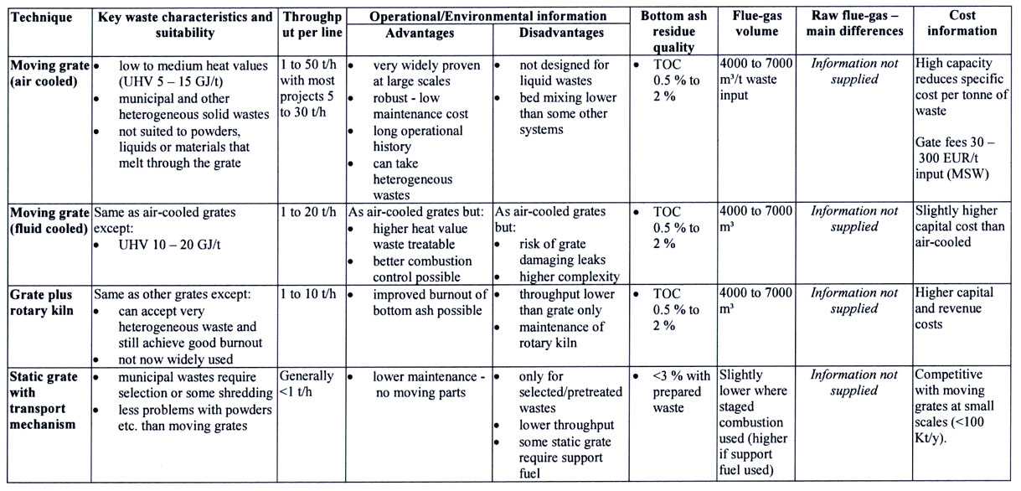

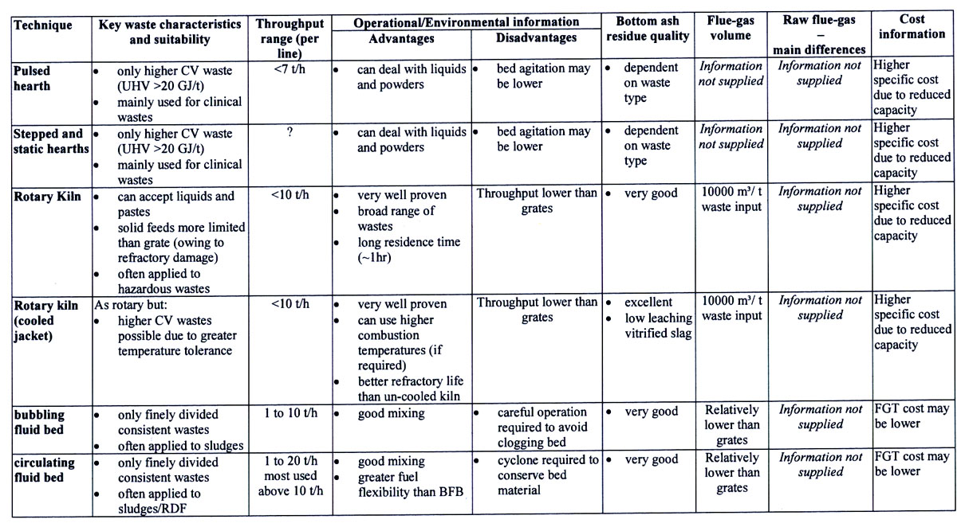

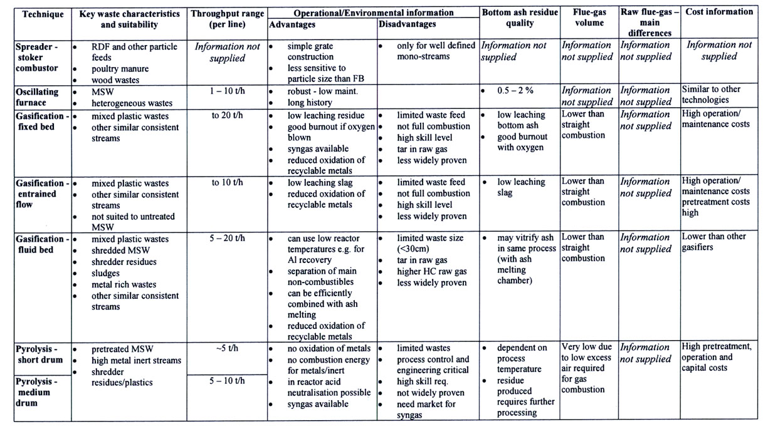
Partial Bibliography

- Draft Reference Document on Best Available Techniques for Waste Incineration. European Integrated Pollution Prevention and Control Bureau, European Commission March, 2004.
- Draft Dioxin Reassessment, Volume 2,Chapter 3: Combustion Sources of CDD/CDF: Waste Incineration. U.S. Environmental Protection Agency, 2000.
- AP-42, Compilation of Air Pollutant Emission Factors, Fifth Edition, Volume 1. U.S. Environmental Protection Agency, 1995.
- Luts, D., K. Devoldere, B. Laethem, W. Bartholomeeusen, and P. Ockier Co-Incineration of sewage sludge in coal-fired power plants: A Case Study. Water Science and Technology, Vol. 42, No. 9, 2000.
- Kim, Y, D. Lee. Solubility enhancement of PCDD/F in the presence of dissolved humic matter. Journal of Hazardous Materials Vol. 91, No. 1-3, p.113-127, April 2002..

