PROPIEDADES FISICOQUÍMICAS
Technical-grade endosulfan contains at least 94% of two pure isomers, α- and β-endosulfan (Maier-Bode
1968; NRCC 1975). The α- and β-isomers of endosulfan are present in the ratio of 7:3, respectively.
Technical-grade endosulfan may also contain up to 2% endosulfan alcohol and 1% endosulfan ether.
Endosulfan sulfate is a reaction product found in technical endosulfan; it is also found in the environment
due to photolysis and in organisms as a result of oxidation by biotransformation (EPA 1979; Coleman and
Dolinger 1982). It should be noted that β-endosulfan is slowly converted to α-endosulfan (Hapeman et al. 1997; Rice et al. 1997).

Chemical identity endosulfan

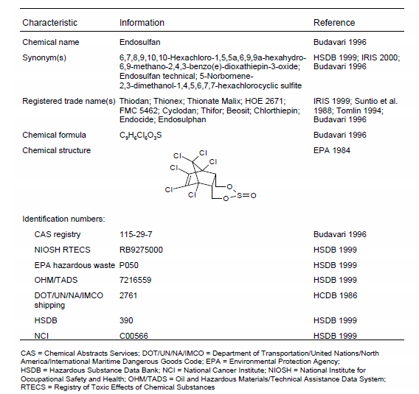

Physical and chemical properties of Endosulfan

Property Information Reference

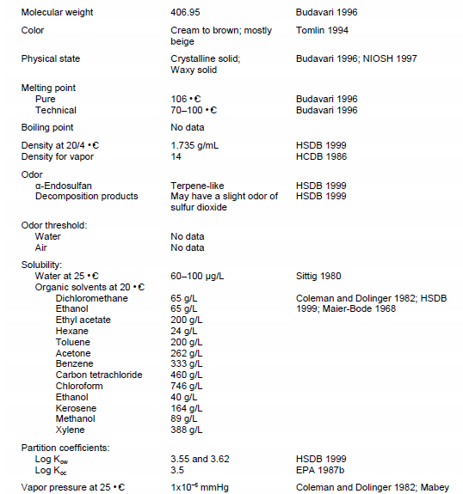

Physical and chemical properties of Endosulfan

Property Information Reference

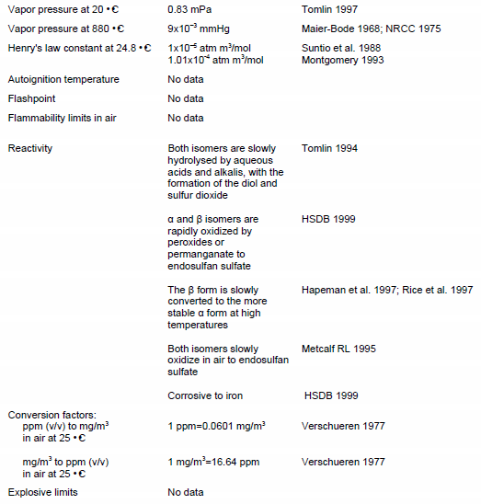

Chemical identity of α-endosulfan

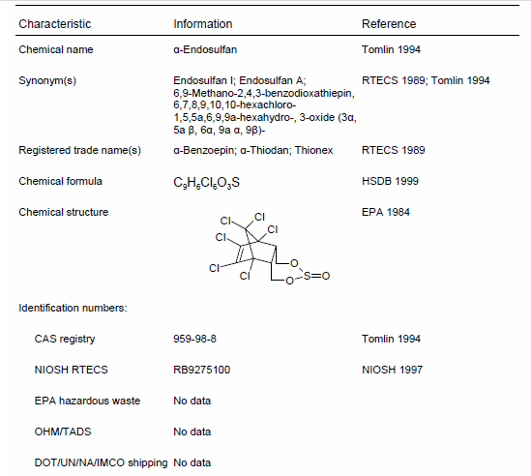

Physical and chemical properties of α−Endosulfan

Property Information Reference

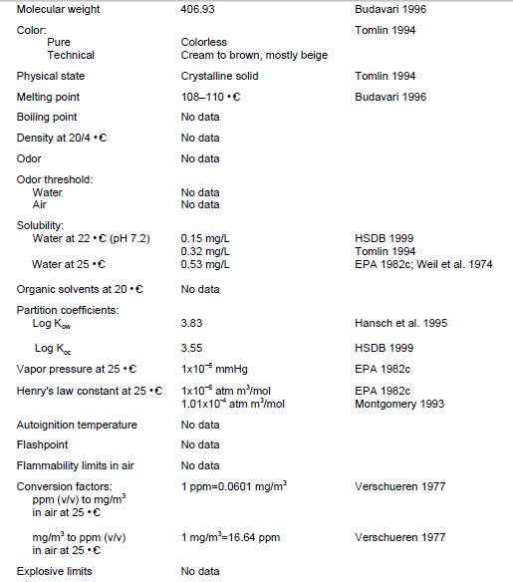

Chemical identity of β−Endosulfan

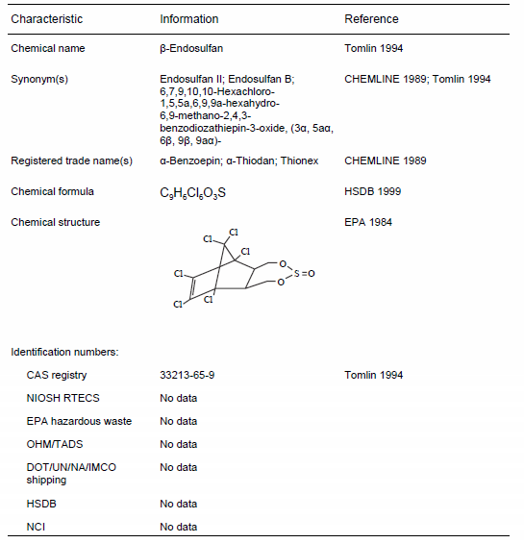

Physical and chemical properties of β−Endosulfan

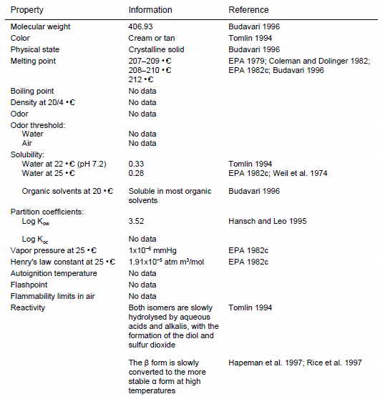

Chemical identity of Endosulfan sulfate

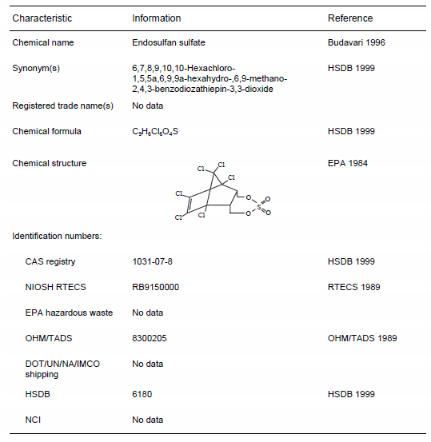

Physical and chemical properties of Endosulfan sulfate

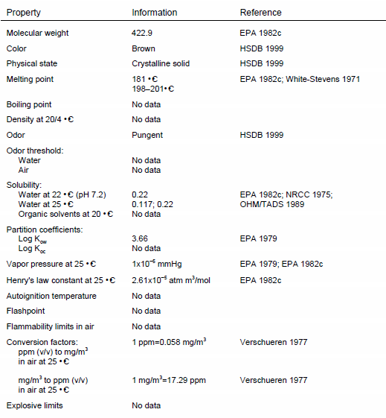

BIOCONCENTRACIÓN O FACTOR DE BIOACUMULACIÓN

La US EPA considera que el endosulfán tiene un alto potencial de bioacumulación en los peces16, pero no hay mucha evidencia disponible sobre la bioacumulación en los niveles tróficos más altos. (Endosulfan, hoja informativa. Thanal L-14 Jawaha r Nagar, Kowdiar, Thiruvananthapuram - 695 003
Kerala, India. Thanal)

Octanol-Water Partition Coefficient:
log Kow = 3.5 is indicated [95].
Employing the HPLC method yielded in a log Kow = 4.65 for α-endosulfan and a log Kow = 4.34 for β-endosulfan under neutral conditions [96].
Test using the shake flask method also resulted in considerably higher values of Kow = 55,500 for α-endosulfan (log Kow > 4.7) and Kow = 61,400 (log Kow = 4.8) for β-endosulfan at pH 5.1 and 22 °C.
The Kow of endosulfan sulfate has also been determined by means of HPLC technique [96], resulting in log Kow = 3.77.

TOXICOLOGICAL PROFILE FOR ENDOSULFAN. U.S. DEPARTMENT OF HEALTH AND HUMAN SERVICES Public Health Service Agency for Toxic Substances and Disease Registry. September 2000.

