Annex F Questionnaire (one per chemical)
Chemical name  (as used by the POPs Review Committee (POPRC)) | Alpha and Beta Hexachlorocyclohexane

Explanatory note:
1. This chemical is undergoing a risk management evaluation. It has already satisfied the screening criteria set out in paragraph 4 (a) of Article 8 of the Convention. A risk profile has also been completed for this chemical in accordance with paragraph 6 of Article 8 and with Annex E to the Convention.
Introductory information
Name of the submitting Party/observer | Republic of Moldova
Contact details (name, telephone, e-mail) of the submitting Party/observer | Mrs. Liudmila Marduhaeva, Consultant, National Focal Point of the Stockholm Convention, Ministry of Ecology and Natural Resources,  Tel.:+(373 22) 20 45 26, E-mail: Liudmila@moldovapops.md
Date of submission | 13 February 2008

Additional Annex E information
(i) Production data, including quantity and location | It was never produced in Moldova.
(ii) Uses | The use of HCHs was banned in former Soviet Union:  - technical HCH (Hexachlorane) on 21 March 1986  - γ- isomer HCH on 13 March 1991.  This prohibition has been in force in the Republic of Moldova before approval of a new national Chemicals Management Law, which is now under development. The new Law will include provisions on prohibitions and restrictions of POPs, including HCH, regulated by the Stockholm and Rotterdam Conventions, the UN ECE POPs Protocol and other MEAs.  At the same time, after gaining its independence, the Republic of Moldova created, also, an official register of substances permitted to be imported and used in agriculture, including in individual farms, forestry and household. HCHs and Lindane were not included in the above-mentioned register.  At the same time in conformity with data from the Ministry of Agriculture and Food Industry, the use of HCH was registered in some years after prohibition, as follows:  Hexachlorocyclohexane (HCH) use: in 1991 - 72 tons, in 1992 – 50 tons, in 1993 – 57 tons and in 1994 – 36, 5 tons.  Lindane use: in 1991 - 150 kg.  Since 1995 they have not been used.
(iii) Releases, such as discharges, losses and emissions | The main part of obsolete amount of HCHs and Lindane was stored into Vulcanesti Pesticides Dump Site (burial ground), which was built in 1978. Over a period of ten years (1978-1988) the accumulated volumes of obsolete HCHs were buried in this dump. According to State Ecological Inspectorate data, total volume of all forms of HCHs containing in the Vulcanesti Pesticide Dump Site is 113 tons, including: HCH-12% and 25% - 96,6 tons; HCH-20% - 14,3 tons; HCH-16% - 2,1 tons.  About 0.2 tons of Lindane is stored at Vulcanesti Pesticide Dump Site.  At the same time some HCH volumes were accumulated after above-mentioned period. In conformity with inventory, effectuated in 2003, there were identified 14,304 tons of HCH, including: HCH-12% - 11,395 t, HCH-16% - 0,719 t and HCH-2% - 2,190 t.  With the purposes to reduce and/or exclude emissions and risks of obsolete pesticides, including HCH, for human health and the environment, and to execute the Decision no 1543 “ On Additional Measures for Centralized Storage and Disposal of Obsolete Obsolete Pesticides ”, approved by the Government on 29 November 2002, and National Implementation Plan of the Stockholm Convention, approved by the Government Decision no 1155 of 20 October 2004, the obsolete pesticides, including HCH, were repackaged and evacuated from old destroyed warehouses to new modern warehouses.  Actually, under GEF/WB “POPs Stockpiles Management and Destruction” Project, 1150 tons of obsolete POPs contaminated pesticides, including HCH, are shipped to France for final destruction.  Inventory of contaminated sites and emissions from contaminated soils are now a part of GEF/WB “POPs Stockpiles Management and Destruction” Project.
Explanatory note:
2. This information was requested for preparation of the risk profile in accordance with Annex E of the Convention. The POPRC would like to collect more information on these items. If you have additional or updated information, kindly provide it.

A. Efficacy and efficiency of possible control measures in meeting risk reduction goals (provide summary information and relevant references):
(i) Describe possible control measures | It was never produced in Moldova. Its use is banned Since 1995 it has not been used anymore.  Alpha and Beta Hexachlorocyclohexane and other isomers are part of regular environmental control and monitoring of soils, surface waters, bottom sediments and atmospheric precipitations. This activity is supplemented by the sanitary-hygienic control and monitoring.  The existing volumes of HCH stockpiles have been repacked and evacuated from old destroyed warehouses to new modern warehouses in order to reduce the risk.  The old contaminated sites nearby former warehouses are still a problem for Moldova.
(ii) Technical feasibility | Currently the Republic of Moldova has no plant for disposal of hazardous waste, including POPs pesticides.  In this context Moldova, under GEF/WB “POPs Stockpiles Management and Destruction” Project, is actually carrying out the shipment of POPs pesticides, including HCH, to France for their final destruction.  At the same time the country is not able to destroy all obsolete pesticides and remediate all contaminated sites.
(iii) Costs, including environmental and health costs | Unknown
Explanatory notes:
3. If relevant, provide information on uses for which there may be no suitable alternative or for which the analysis of socio-economic factors justify the inclusion of an exemption when considering listing decisions under the Convention. Detail the negative impacts on society that could result if no exemption were permitted.
4. “Risk reduction goals” could refer to targets or goals to reduce or eliminate releases from intentional production and use, unintentional production, stockpiles, wastes, and to reduce or avoid risks associated with long-range environment transport.
5. Provide the costs and benefits of implementing the control measure, including environmental and health costs and benefits.
6. Where relevant and possible “costs” should be expressed in US dollars per year.

B. Alternatives (products and processes) (provide summary information and relevant references):
(i) Describe alternatives | The problem of modern types of pesticides became a topical question many years ago. Now Moldova does not use HCH.
(ii) Technical feasibility
(iii) Costs, including environmental and health costs | Unknown
(iv) Efficacy
(v) Risk
(vi) Availability
(vii) Accessibility
Explanatory notes:
7. Provide a brief description of the alternative product or process and, if appropriate, the sector(s), use(s) or user(s) for which it would be relevant.
8. If several alternatives could be envisaged for the chemical under consideration, including non-chemical alternatives, provide information under this section for each alternative.
9. Specify for each proposed alternative whether it has actually been implemented (and give details), whether it has only reached the trial stage (again, with details) or whether it is just a proposal.
10. The evaluation of the efficacy should include any information on the performance, benefits, costs, and limitations of potential alternatives.
11. Specify if the information provided is connected to the specific needs and circumstances of developing countries.
12. The evaluation of the risk of the alternative should include any information on whether the proposed alternative has been thoroughly tested or evaluated in order to avoid inadvertently increasing risks to human health and the environment. The evaluation should include any information on potential risks associated with untested alternatives and any increased risk over the life-cycle of the alternative, including manufacture, distribution, use, maintenance and disposal.
13. If the alternative has not been tried or tested, information on projected impacts may also be useful.
14. Information or comments on improving the availability and accessibility of alternatives may also be useful.

C. Positive and/or negative impacts on society of implementing possible control measures (provide summary information and relevant references):
(i) Health, including public, environmental and occupational health

(ii) Agriculture, including aquaculture and forestry
(iii) Biota (biodiversity)
(iv) Economic aspects | Unknown
(v) Movement towards sustainable development | Never produced in Moldova.
(vi) Social costs | None
Explanatory notes:
15. Socio-economic considerations could include:
- Any information on the impact (if any), costs and benefits to the local, national and regional economy, including the manufacturing sector and industrial and other users (e.g., capital costs and benefits associated with the transition to the alternatives); and impacts on agriculture and forestry;
- Any information on the impact (if any) on the wider society, associated with the transition to alternatives, including the negative and positive impacts on public, environmental, and occupational health. Consideration should also be given to the positive and negative impacts on the natural environment and biodiversity.
- Information should be provided on how control measures fit within national sustainable development strategies and plans.

D. Waste and disposal implications (in particular, obsolete stocks of pesticides and clean-up of contaminated sites) (provide summary information and relevant references):
(i) Technical feasibility | Currently the Republic of Moldova has no plant disposal of hazardous waste, including POPs pesticides.  In this context Moldova, under GEF/WB “POPs Stockpiles Management and Destruction” Project, is actually carrying out the shipment of POPs pesticides, including HCH, to France for their final destruction.  At the same time the country is not able to destroy all obsolete pesticides and remediate all contaminated sites.
(ii) Costs
Explanatory note:
16. Specify if the information provided is connected to the specific needs and circumstances of developing countries.

E. Access to information and public education (provide summary information and relevant references):
It is part of the Stockholm Convention and the UN ECE POPs Protocol education and awareness POPs campaign based on the National Strategy on the Reduction and Elimination of Persistent Organic Pollutants and National Implementation Plan for the Stockholm Convention.

Also with the purposes to promote and facilitate access to information, public education and awareness the relevant campaign was conducted within the GEF/WB Project “POPs Stockpiles Management and Destruction” in 2007.
The Objectives of the Campaign are oriented towards:
- Conducting an information, awareness and education campaign in the field of POPs in Moldova and organizing the conferences and workshops at the international, national and local level;
- Developing and carrying out an educational process for the target groups with higher exposure to POPs impact (women, children, farmers, employees of the energy sector etc);
- Providing assistance to the Ministry of Ecology and Natural Resources (MENR) in strengthening of the Environmental Information Centre (CIM) in the field of POPs information.
The Campaign was launched in June 2007 at the national and local levels and it is implemented by five teams (organizations) with experience in the field of information, awareness and education, selected through a tender procedure: Association INQUA-Moldova, the Regional Environmental Centre for Moldova (REC Moldova), Moldovan Ecological Movement (MEM), Garamond Studio SRL and Casa Imago SRL.
At the Press Conference, organized by MENR and POPs Office, which took place on 19 December 2007 at the Press Agency „Infotag” the major results of the implementation of this activities were presented. Among them could be mentioned:
- First national public opinion survey in order to evaluate the level of current POPs awareness and knowledge; planning of local surveys;
- Carrying out of 3 regional informational workshops with a total number of participants of 180 persons, including NGOs, local public authorities, environmental and health organizations, representatives of beneficiaries and key stakeholders;
- Organization of the 9th International HCH and Pesticides Forum in Chisinau, Moldova (20-22 September 2007).
- Establishment of the Initiative Groups in the districts where the WB/GEF project is repackaging the POPs pesticides.
- Evaluation of the capacities and needs (informational and technical) of CIM, preparation of the study visit;
- Development and publication of 2 posters and 2 leaflets;
- Publication of articles (monthly) on POPs issues and project implementation in “Natura” Magazine (6500 copies);
- Development and posing of 2 video and 2 audio spots on national TV and radio about the POPs problem in Moldova and risks prevention and reduction;
- Development and upgrade of the Project web site : www.moldovapops.md

Explanatory note:
17. Please provide details here of access to information and public education with respect to both control measures and alternatives.

F. Status of control and monitoring capacity (provide summary information and relevant references):
State Hydrometeorological Service of the Ministry of Ecology and Natural Resources: In conformity with environmental legislation, including Law on Environment Protection, Law on Hydrometeorological Activity, approved NIP and established program, the Monitoring Division on Environmental Quality of the State Hydrometeorological Service effectuates POPs monitoring of environment pollution. It is accredited by the Service on Standardization and Metrology of the Republic of Moldova and performs systematic POPs monitoring, including α-HCH, β-HCH, γ-HCH monitoring, in the environment (surface water, atmospheric precipitations, soil, fish, and bottom sediments) and has the monitoring network. Type of Accreditation is ISO 17025. The Division has the laboratory quality control system, quality assurance program and identified person, responsible for QA/QC in place. The Centre of Soil Quality Monitoring is included in Global POPs Monitoring Network.
The detailed information related to capacity, equipment and others was submitted to Secretariat last years.
Also, Moldova was selected as pilot country for realization of the second phase of the UNEP/GEF Project: “Assessment of Existing Capacity and Capacity Building Needs to Analyse POPs in Developing Countries” and participated in it. Relevant information about project, participating countries, their capacity and needs can be found at website of the above-mentioned project: http://www.chem.unep.ch/Pops/laboratory/default.htm .

HCH in agricultural soil:

The State Hydrometeorological Service is analysing HCHs (alfa, beta and gamma) content in soil from agricultural area more than 25 years. The exceeding of norms was revealed in 80th years, but from 90th - no sample exceeding the limit value (0, 1 mg/kg) has been revealed.
The contents of HCH are presented below in table 1 for years 2003-2005. The highest figures of HCHs were found in 2 northern districts Soroca and Briceni with maximum concentration of 0,029 mg/kg or 0, 29 MAC (Maximum Admissible Concentration).

Table 1

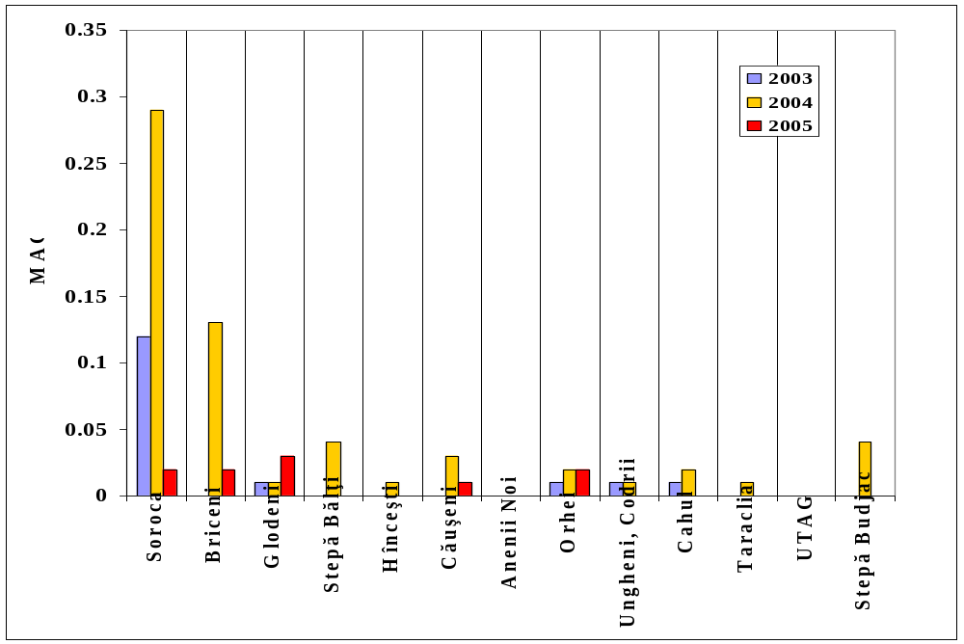

HCH in surface waters sediments:

Determination of HCHs in sediments from main water bodies - lakes, reservoirs, rivers and its tributaries started in 2003. HCHs content varied from 0.1 to 0.7 µg/kg.
Long-term data of HCHs is presented below in table 2.
Table 2
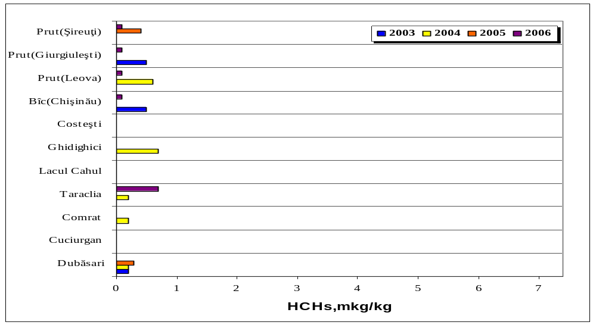

HCH in soil around warehouses:

Under the GEF/WB Project “POPs Stockpiles Management and Destruction” during 2004-2007 the soil around 21 warehouses was investigated. Data shows that the investigated soil is contaminated in 16 warehouses from 21 investigated with maximum concentration of HCHs 11,612 mg/kg. Data received is presented in tab.3, 4 and 5.
Table 3
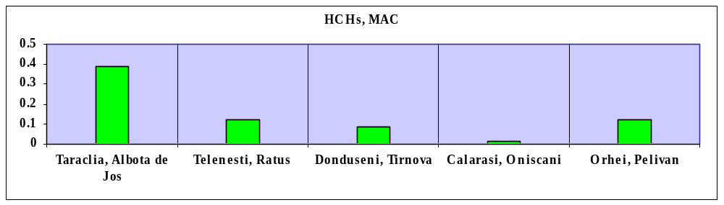

Tab.2

Table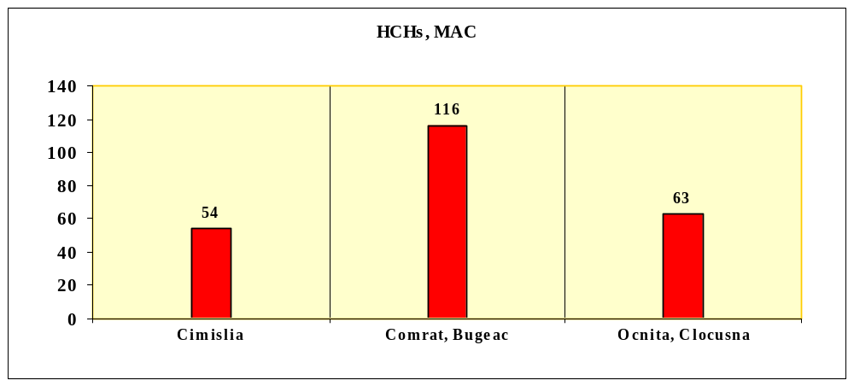 4

Table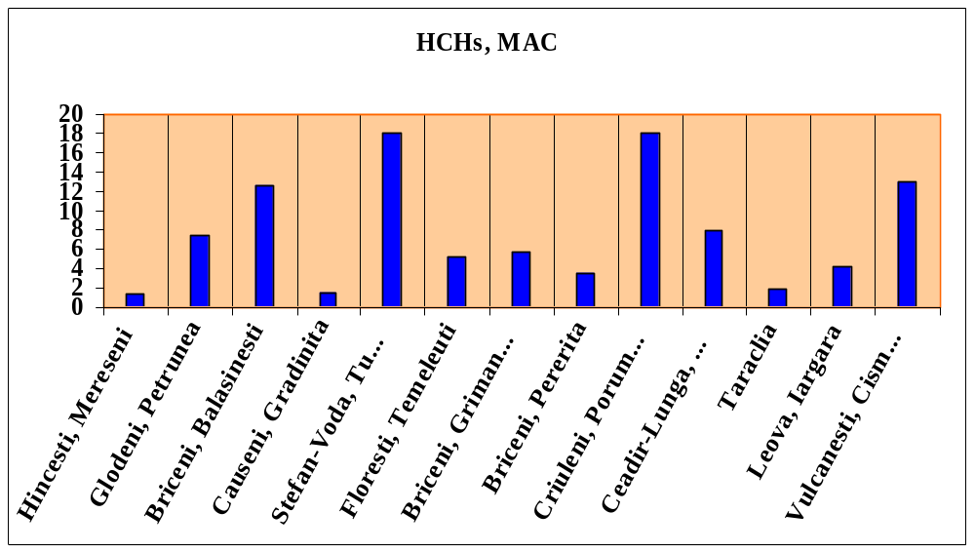 5

HCH in atmospheric precipitations:
Precipitations are measured at Chisinau Station and transboundary Leova EMEP station. Data presented in tab.6 shows that HCHs in precipitations was detected in smaller concentrations than other chlorinated compounds (PCBs and DDTs)
Table 6
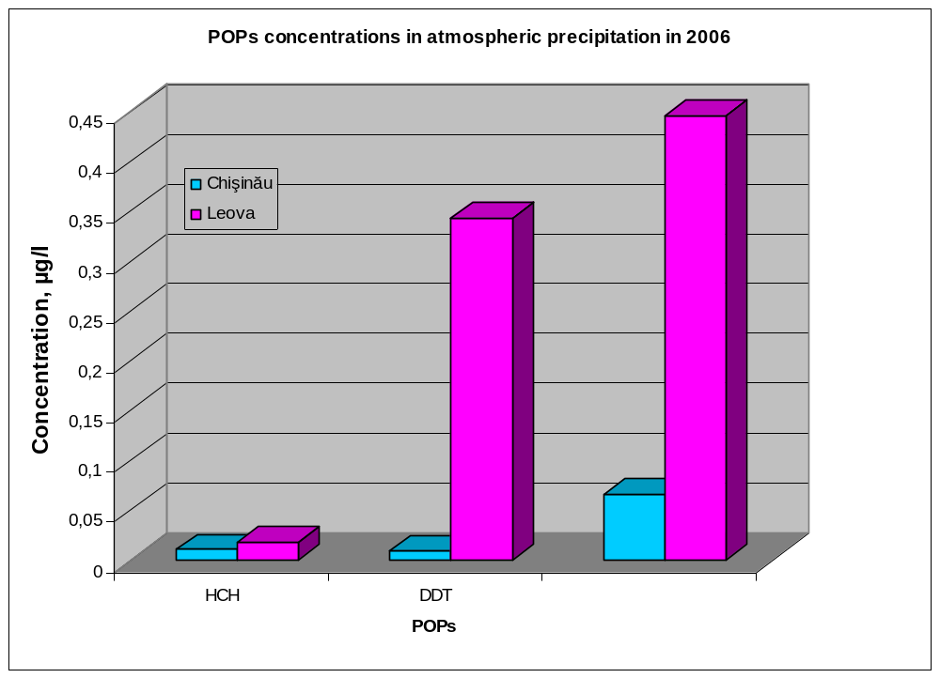

References:
1. Anna Cumanova, Gavril Gilca (Moldova)
Contents of organochlorinated pesticides and polychlorinated biphenyls in soil and sediments in Republic of Moldova -9th International HCH and Pesticide Forum, Chisinau, 2007. WEB: http://www.hchforum.com/presentations.php .
2. Annual Report: “Republic of Moldova. State of the Environment Report”, 2006. Chapter “State of air in Republic of Moldova”. WEB: http://www.mediu.gov.md/index/38/240/ .

The relevant information related to POPs and HCH environmental monitoring in the Republic of Moldova was presented during 9th International Forum on HCH and Pesticides, which was held on 20-22 September 2007 in Chisinau, the Republic of Moldova. The relevant presentation of Moldova as well as presentations of representatives of other Central and Eastern European countries can be found at WEB-site: http://www.hchforum.com/presentations.php .

Laboratory of Sanitary-Chemical Researches of the National Scientific – Practice Centre of Preventive Medicine (Ministry of Health) effectuates POPs monitoring, including α-HCH, β-HCH, γ-HCH monitoring, in conformity with health protection legislation and its established programme. It is accredited by the Service on Standardization and Metrology of the Republic of Moldova and performs systematic POPs pesticides monitoring in soil, water, animal and vegetal food products etc. Type of Accreditation is ISO 17025. The Laboratory has the laboratory quality control system, quality assurance program and identified person, responsible for QA/QC in place. The Laboratory is included in Global POPs Monitoring Network. This Laboratory, also, participated in the realization of UNEP/GEF Project “Assessment of Existing Capacity and Capacity Building Needs to Analyse POPs in Developing Countries”. Relevant information can be found at WEB-site of the above-mentioned project: http://www.chem.unep.ch/Pops/laboratory/default.htm .
The Laboratory does not effectuate permanent HCH and other POPs pesticide monitoring in biological liquids. At the same time in 2005 this Laboratory began pilot researches in 6 regions of the republic (Basarabeasca, Cahul, Hincesti, Ialoveni, Glodeni and Singerei). Objective of this research is to determine a migration of obsolete pesticides (DDT, HCH, Heptachlor, Kelthane, Tiazone and others) in soil from places of old warehouses. Also the estimation of surface waters, agricultural products, food stuffs and biological liquids, including breast milk, is conducted. Duration of this research was 2005-2007. The estimations confirmed presence of α-HCH, β-HCH, γ-HCH in breast milk. Unfortunately a report on investigations result is not published yet. At the same time this scientific research will be continued in years 2008-2011, according to the Ministry of Health Order.
During 2005 – 2006 the Laboratory carried out investigations of food milk products (cow’s milk, sour cream, curd and cheese) for the purpose of determining the residues of organochlorine pesticides (OCPs) such as: DDT and metabolites, HCH and isomers, heptachlor, dicofol and hexachlorobenzene (HCB). The samples of cow’s milk, sour cream and curd were collected from the cattle owners from 8 localities of southern, central and northern zones of the republic. The extraction methods used for determining the residues of DDT and metabolites, HCH and isomers, heptachlor, dicofol and hexachlorobenzene (HCB) were identical. Qualitative and quantitative determinations in purified sample extracts were performed by capillary gas chromatography with an electron capture detector. The number of total analyzes effectuated is 819.
Results:
It was determined that 49.5% of the analyzed samples, including 25.6% of milk, 86% of sour cream and 25% of curds and cheese samples contained OCPs residues.
Cow’s milk (39) - more than 25% samples contained OCPs residues; 25.6% of which included DDE, 2.56% - β- and γ- HCH. Dicofol, heptachlor and HCB were not detected in milk samples.
Sour cream (36) - more than 86% samples contained residues of DDT, in the form of metabolites: 68.3% - DDE, 2.78% - DDT and DDD. The isomers of HCH were established in 22.2% of samples: 22.2% held β- HCH, 8.3% - α-HCH and 11.1% - γ- HCH and heptachlor. Dicofol and HCB were determined in 5.55%.
Curds (16) – the residues of DDT (in form of metabolites DDE) were detected only in the cheese sample. 12.5% of samples contained dicofol and 6.25% - γ- HCH.
The results of our research (presented in the Table 1) show that the highest concentrations of DDT (sum of metabolites) and HCH (sum of isomers) were found in the sour cream samples and the lowest level - in the milk.
The OCPs can be listed in accordance with the frequency of determination: the first place is occupied by a metabolite of DDT – DDE < HCH < heptachlor< dicofol < hexachlorbenzene.

Table 1. The content of the OCPs residues in the milk and dairy products
Pesticide | Milk (mg/kg brut) | Sour cream (mg/kg brut) | Curds (mg/kg brut)
DDT | 0 | 0,001-0,0095 (1/36) | 0
DDE | 0,0002- 0,005 (10/39) | 0,002- 0,04 (21/36) | 0,008 (1/16)
DDD | 0 | 0,005 (1/36) | 0
α-HCH | 0 | 0,0006- 0,0015 (3/36) | 0
β-HCH | 0,001 (1/39) | 0,002 - 0,02 (8/36) | 0
γ-HCH | 0,0002 (1/39) | 0,001- 0,004 (4/36) | 0,002 (1/16)
Heptachlor | 0 | 0,001 - 0,008 (4/36) | 0,006 - 0,017 (2/16)
Dicofol | 0 | 0,009 - 0,079 (2/36) | 0
HCB | 0 | 0,002 - 0,003 (2/36) | 0

The most polluted dairy product is sour cream. The established concentrations of the mentioned pesticides in creams were 10-100 times higher in comparison to milk (figure 1).

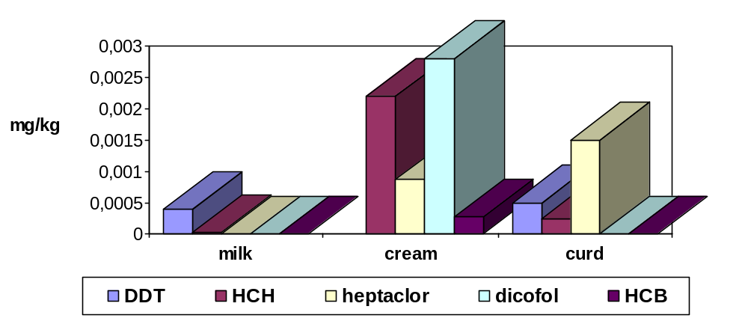 Figure 1. The content of OCPs residues in dairy products.
The comparison of the assessed levels of dairy products’ contamination with OCP in different regions of the republic showed that concentration of DDT is higher in samples collected in the South and Centre of the Republic of Moldova, while the residual level of HCH, dicofol, and HCB were sensed mostly in the samples from northern parts of the republic (Figure 2, 3). We presume that this fact is linked to the specifics of agricultural production.

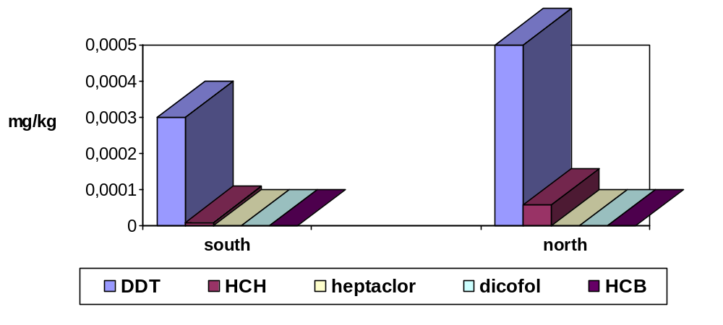
Figure 2. The content of OCPs residues in milk according to the zones of the republic.

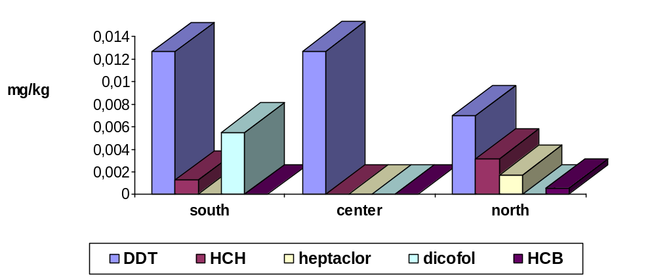Figure 3. The content of the OCPs residues in sour creams according to the zones of the republic.
The detected concentrations of the pesticides did not exceed the MRL, except for heptachlor (its residues are not admitted in food).
It has been calculated the possible level of OCPs intake, taking into consideration the daily dietary intake of milk and dairy products, which is equal to 1225 mg/day (calculated on milk). The potential summary daily intake of the HCH is 0.003 mg/kg, and DDT – 0.0127 mg/kg. The same can be said about the presumable level of dicofol and HCB receipt (0.003 mg/kg body weight/day). The average quantity of heptachlor that can enter the human organism together with milk and dairy products is equal with 0.0011 mg/kg b.w./day.
Thus, despite the determination of the OCPs in concentrations significantly lower than the admissible levels, and taking into consideration the persistence of these compounds and their tardive effects, besides the monitoring of their presence in the environmental objects and food, the assessment of the population’s health is required in order to prevent OCPs possible negative influence.
References: T. Stratulat, A. Volneanski, R. Sircu, P. Socoliuc, A.Covric. National Scientific and Practice Centre for Preventive Medicine. Ministry of Health. Poster “The assessment of dairy products’ level of contamination with organochlorine pesticides”, submitted to 9th International HCH and Pesticide Forum, Chisinau, 2007.
Explanatory note:
18. With regard to control capacity, the information required is on legislative and institutional frameworks for the chemical under consideration and their enforcement. With regard to monitoring capacity, the information required is on the technical and institutional infrastructure for the environmental monitoring and biomonitoring of the chemical under consideration, not monitoring capacity for alternatives.

G. Any national or regional control actions already taken, including information on alternatives, and other relevant risk management information:
- Prohibitions:
The use of HCHs was banned in former Soviet Union: technical HCH (Hexachlorane) on 21 March 1986, γ- isomer HCH – on 13 March 1991.
This prohibition has been in force in the Republic of Moldova before approval of new national Chemicals Management Law, which now is under development.
New Law will include provisions on prohibitions and restrictions of POPs, including HCH, regulated by the Stockholm and Rotterdam Conventions, the UN ECE POPs Protocol and other MEAs.
At the same time, having after gaining its independence, the Republic of Moldova created, also, an official register of substances permitted to be imported and used in agriculture, including in individual farms, forestry and household. HCHs and Lindane have not been included in the above-mentioned register.
- Restrictions:
- 1,2,3,4,5,6-Hexachlorocyclohexane: Hygienic standard – the maximum permissible concentration in air of the working zone (vapour and aerosols) is 0,1 mg/m3; in air of residential areas is 0,03 mg/m3; for the water used for potable purposes is 0,02 mg/l. The maximum permissible quantity in soil is 0,1 mg/kg.
- Lindane: Hygienic standard - the maximum permissible concentration for Lindane in air of the working zone (vapour and aerosols) is 0,05 mg/m3. Unfortunately the maximum permissible concentration for Lindane in air of residential areas has not been established yet. The indicative permissible level for the water used for potable purposes is 0,004 mg/l. The maximum permissible quantity in soil is 0,1 mg/kg. The allowable residual concentration in food: for potatoes is 0,05 mg/kg; for milk and milk product is 0,2 mg/kg; for apples, pears, vegetables (excepting carrot) is 0,5 mg/kg; for carrot, sugar-beet, peas, eggs is 0,1 mg/kg; flesh of poultry is 0,7 mg/kg; for dry beans is 1 mg/kg.
- National Strategy on the Reduction and Elimination of Persistent Organic Pollutants, approved by the Government Decision no. 1155 from 20.10.2004.
- National Implementation Plan for the Stockholm Convention., approved by the Government Decision no. 1155 from 20.10.2004.
- Protocol on Persistent Organic Pollutants to the Convention on Long-range Transboundary Air Pollution, ratified by the Republic of Moldova based on Law on the Ratification of Protocol on Persistent Organic Pollutants and Protocol on Heavy Metals to the Convention on Long-range Transboundary Air Pollution, no. 1018-XV from 25 April 2002.
- Rotterdam Convention on the Prior Informed Consent Procedure for Certain Hazardous Chemicals and Pesticides in International Trade, ratified by the Republic of Moldova based on Law on the Accession of the Republic of Moldova to the Convention on the Prior Informed Consent Procedure for Certain Hazardous Chemicals and Pesticides in International Trade, no. 389-XV from 25 November 2004.
- During 2003-2007 the Government of Moldova, with its own sources and with the support of NATO countries carried out the repackaging of about 3250 tons of obsolete pesticides contaminated with POP from about 350 damaged warehouses and their centralised storage in a safely manner in 37 district warehouses.
- Under the GEF/WB “POPs Stockpiles Management and Destruction” Project about 1150 tons of obsolete pesticides contaminated with POP, including HCH will have been shipped to France and destructed by April 2008.
- One of the main task of the given project envisage the inventory and mapping of POP contaminated sites. There are about 1000 of such sites in Moldova. The developed data base will be used for further monitoring of these sites and for developing of remediation measures.
- Ministry of Ecology and Natural Resources is currently implementing a project financed by the Canadian Trust Fund for POPs through the World Bank. The objective of this project is to select and test the technologies for the remediation of the sites contaminated with POP which are adequate for the Republic of Moldova.

Explanatory notes:
19. Actions or measures taken could include prohibitions, phase-outs, restrictions, cleanup of contaminated sites, waste disposal, economic incentives, and other non-legally binding initiatives.
20. Information could include details on whether these control actions have been cost-effective in providing the desired benefits and have had a measurable impact on reducing levels in the environment and contributed to risk reduction.

H. Other relevant information for the risk management evaluation:
None

Explanatory notes:
21. The above list of items is only indicative. Any other relevant information for the risk management evaluation should also be provided.

I. Other information requested by the POPRC:
None

___________________

