Annex F Questionnaire (one per chemical)
Chemical name  (as used by the POPs Review Committee (POPRC)) | Alpha-hexachlorocyclohexane  Beta-hexachlorcyclohexane

Explanatory note:
1. This chemical is undergoing a risk management evaluation. It has already satisfied the screening criteria set out in paragraph 4 (a) of Article 8 of the Convention. A risk profile has also been completed for this chemical in accordance with paragraph 6 of Article 8 and with Annex E to the Convention.

Introductory information
Name of the submitting Party/observer | Czech Republic
Contact details (name, telephone, e-mail) of the submitting Party/observer | Dr. Karel Bláha, +420 267 181 111; karel_blaha@env.cz  Prof. Dr. Ivan Holoubek, +420 549 491 475; holoubek@recetox.muni.cz
Date of submission | 05/02/2008

Additional Annex E information
(i) Production data, including quantity and location | Technical HCHs were produced since 1954. Since 1959 only pure lindane ( 99 % γ-isomer of HCH) was used in agriculture and its use was limited to seed treatment (flax, rape). Technical HCH, however, was still used in forestry.  In total, round 60 000 t of technical HCHs during the period 1954 – 1977 and 3 330 t of lindane were produced. The amount of lindane is about 5% of the production of technical HCH, even though at the beginning of production it was less than 2% (in the year 1958, 460 t of technical HCH, and 7 t of lindane were produced), while towards the end of production, the production of lindane was around 10% (in 1976 2 390 t / 223 t γ-isomer). That means that the use of technical HCH in various preparations was fairly high, especially at the beginning of production, and then decreased. Also data regarding trichlorobenzene (side product after the lindane isolation process) is accessible, and allows for a rough estimation of how much technical HCH was used.
(ii) Uses | The use of HCHs was banned in former Czechoslovakia at 1974 and in the CR the use of lindane was banned at 1995.
(iii) Releases, such as discharges, losses and emissions | The main part of obsolete amount of HCHs was disposed during the first part of 90´s.  Emissions from contaminated soils are now determined as a part of research project of RECETOX, MU, Brno
Explanatory note:
2. This information was requested for preparation of the risk profile in accordance with Annex E of the Convention. The POPRC would like to collect more information on these items. If you have additional or updated information, kindly provide it.

A. Efficacy and efficiency of possible control measures in meeting risk reduction goals (provide summary information and relevant references):
(i) Describe possible control measures | Production and use is banned.  Substances are a part of regular monitoring of all abiotic compartments, food, feed and human tissues including human milk.  Obsolete wastes were mainly destroyed in the 1990´s.  The former production facility Spolana Neratovice is now remediated using by non-combustion technology BCD, process is successfully finnished now.  Country has also hazardous waste incinerator suitable for the disposal of POPs waste
(ii) Technical feasibility | Country is able to destroy the obsolate waste and remediate the contaminated site such are soils, sediments, industrial hot spots.
(iii) Costs, including environmental and health costs | Unknown
Explanatory notes:
3. If relevant, provide information on uses for which there may be no suitable alternative or for which the analysis of socio-economic factors justify the inclusion of an exemption when considering listing decisions under the Convention. Detail the negative impacts on society that could result if no exemption were permitted.
4. “Risk reduction goals” could refer to targets or goals to reduce or eliminate releases from intentional production and use, unintentional production, stockpiles, wastes, and to reduce or avoid risks associated with long-range environment transport.
5. Provide the costs and benefits of implementing the control measure, including environmental and health costs and benefits.
6. Where relevant and possible “costs” should be expressed in US dollars per year.

B. Alternatives (products and processes) (provide summary information and relevant references):
(i) Describe alternatives | Modern types of pesticides – this problem was actual many years ago
(ii) Technical feasibility
(iii) Costs, including environmental and health costs
(iv) Efficacy
(v) Risk
(vi) Availability
(vii) Accessibility
Explanatory notes:
7. Provide a brief description of the alternative product or process and, if appropriate, the sector(s), use(s) or user(s) for which it would be relevant.
8. If several alternatives could be envisaged for the chemical under consideration, including non-chemical alternatives, provide information under this section for each alternative.
9. Specify for each proposed alternative whether it has actually been implemented (and give details), whether it has only reached the trial stage (again, with details) or whether it is just a proposal.
10. The evaluation of the efficacy should include any information on the performance, benefits, costs, and limitations of potential alternatives.
11. Specify if the information provided is connected to the specific needs and circumstances of developing countries.
12. The evaluation of the risk of the alternative should include any information on whether the proposed alternative has been thoroughly tested or evaluated in order to avoid inadvertently increasing risks to human health and the environment. The evaluation should include any information on potential risks associated with untested alternatives and any increased risk over the life-cycle of the alternative, including manufacture, distribution, use, maintenance and disposal.
13. If the alternative has not been tried or tested, information on projected impacts may also be useful.
14. Information or comments on improving the availability and accessibility of alternatives may also be useful.

C. Positive and/or negative impacts on society of implementing possible control measures (provide summary information and relevant references):
(i) Health, including public, environmental and occupational health | Decontamination is connected with strong control and monitoring control, there is not any evidence concerning to these possible impacts
(ii) Agriculture, including aquaculture and forestry
(iii) Biota (biodiversity)
(iv) Economic aspects | Unknown
(v) Movement towards sustainable development | These technical products are did not produce many years, from the 1960´s the technology was modified and alpha and beta were not produced.
(vi) Social costs | None
Explanatory notes:
15. Socio-economic considerations could include:
- Any information on the impact (if any), costs and benefits to the local, national and regional economy, including the manufacturing sector and industrial and other users (e.g., capital costs and benefits associated with the transition to the alternatives); and impacts on agriculture and forestry;
- Any information on the impact (if any) on the wider society, associated with the transition to alternatives, including the negative and positive impacts on public, environmental, and occupational health. Consideration should also be given to the positive and negative impacts on the natural environment and biodiversity.
- Information should be provided on how control measures fit within national sustainable development strategies and plans.

D. Waste and disposal implications (in particular, obsolete stocks of pesticides and clean-up of contaminated sites) (provide summary information and relevant references):
(i) Technical feasibility | The former production facility Spolana Neratovice is now remediated using by non-combustion technology BCD, process is successfully finnished now.  Contaminated sites are continusouly remediated
(ii) Costs | 100 000 000 € - Spolana Neratovice  Contaminated sites – exact estimation is not available – it can be in order ten´s milion € - but this contamination is usually connected with some other types of contamination.
Explanatory note:
16. Specify if the information provided is connected to the specific needs and circumstances of developing countries.

E. Access to information and public education (provide summary information and relevant references):
Part of SC/UN ECE CRLTAP education and awereness POPs campaign based on the Czech NIP

Explanatory note:
17. Please provide details here of access to information and public education with respect to both control measures and alternatives.

F. Status of control and monitoring capacity (provide summary information and relevant references):
RECETOX MU Brno/CHMI - Monitoring in ambient air – EMEP POPs Net – Central European background observatory Košetice, South part of the CR – 1996 – up to know – 4 isomers of HCHs
RECETOX MU Brno - Integrated monitoring of POPs including Lindan and other isomers HCHs - Central European background observatory – surface waters, sediments, soils, mosses, needles – from 1988 – up to now
RECETOX MU Brno Monitoring of ambient air including 4 isomers of HCHs sing by passive PUF samplers – 50 sampling sites in the CR (+ round 180 sampling sites in Estonia, Latvia, Lithuania, Slovakia, Serbia and Montenegro, Croatia, Bosnia and Herzegovina, Romania, Russia, Poland, Hungary, Slovenia, Croatia, Montenegro, Macedonia, Bulgaria, Moldova, Armenia, Azerbaijan, Belarus, Ukraine, Kazachstan, Kyrgystan + application in Sultanate of Oman, Fiji and 16 African countries)

Water Research Institute Monitoring of surface and ground waters and sediments.

Central Institute for Supervising and Testing in Agriculture (CISTA), Research Institute of Amelioration and Soil Conservation (RIASC) and RECETOX MU - monitoring of soils, feeds, sewage sludge

State Veterinary Inspection and Czech Food Inspection control measurements - foods

National Institutes of Public Health - human exposure, total diet study

Trends in the development of the medians of regional background concentrations in ambient air for HCHs are shown on the Figure and document the slightly decreasing tendency of monitored pollutants on a regional level but with a respect to the local situation. Changes in the annual medians of HCHs similarly as in the case of other chlorinated pesticides and PCBs reflect the results of floods in the CR (1997 and 2002).

Although the ambient air and wet deposition measurements have been carried on since 1988 in the Kosetice observatory, only POP data from the last ten years (1996-2005) were used for the evaluation of the long-term trends (Tab.). The main reason is a comparability of the results; the same sampling frequency as well as the same sampling and analytical techniques were employed during this period.

The measured concentrations of γ- HCHs were approximately two times higher than those of α-HCH

Table: Σ HCHs concentrations, Kosetice observatory, minimum, maximum, mean and median air, wet deposition, surface water, sediment, soil, mosses and needles, Kosetice 1996-2005
Matrix, Unit | Mean | Median | Min | Max | Matrix, Unit | Mean | Median | Min | Max
Air (PUF) [ng m⁻³] | 0.068 | 0.044 | BQL | 0.771 | Sediment [ng g⁻¹] | 0.47 | 0.27 | BQL | 4.09
Air (QF) [ng m⁻³] | 0.009 | 0.004 | BQL | 0.104 | Soil [ng g⁻¹] | 1.06 | 0.43 | BQL | 20.43
Rain water [ng L⁻¹] | 32.300 | 5.200 | BQL | 2256.8 | Mosses [ng g⁻¹] | 4.55 | 0.89 | BQL | 150.54
Water [ng L⁻¹] | 6.10 | 2.10 | BQL | 68.50 | Needles [ng g⁻¹] | 6.44 | 2.55 | BQL | 36.57

BQL = bellow quantification limit. Quantification limit is 1 pg m⁻³ for the individual compounds in the ambient air, 50 pg L⁻¹ in the rain water, 10 pg g⁻¹ for the individual compounds in the solid matrices, and 50 pg L⁻¹ in the surface water

Σ HCHs concentrations, Kosetice observatory, month averages, Kosetice 1996 - 2006
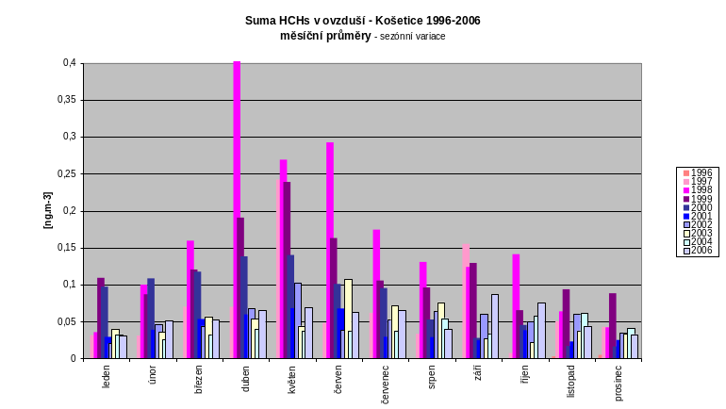
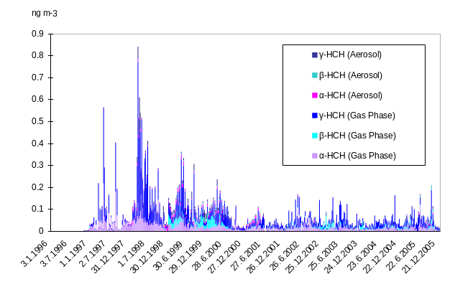

Σ HCHs in the ambient air, Kosetice observatory, 1996-2005

Rainwater POP concentrations reflect the air concentrations. γ-HCH was detected in highest concentrations from all chlorinated compounds. The mean concentration of chlorinated compounds were low - 5 ng L⁻¹ for the sum of HCHs.

Interestingly, high summer maxima of OCPs were observed in 1997/8 and 2002/3 years. These fluctuations in the annual medians of OCPs (and PCBs too) may reflect the major flood events in the Czech Republic in 1997 and 2002. A large area of central and southern Moravia (to the east from Kosetice) was flooded in 1997, including the industrial and agricultural facilities where various chemicals were stored. The floods were followed by extremely hot summer therefore those chemicals could evaporate from impacted areas and be a subject of the atmospheric transport. Similarly, the central part of Bohemia (to the west from Kosetice, Prague included) was flooded in 2002. Several large chemical enterprises located to the north of Prague were severely damaged and variety of chemicals escaped to the surface waters and was distributed with the flood. According to the results of our previous research focused on the impact of these flood events on aquatic and terrestrial environments⁹, one of the effects of floods is a re-distribution of the old burdens from the river sediments to the surface layers of the soils that were flooded. Semi-volatile persistent organic compounds can easily re-evaporate from these top soil levels during the warm season. This is probably the source of elevated atmospheric concentration of chlorinated POPs in the years following these disasters. The reason why the floods in 1997 so significantly affected the background levels of OCPs and PCBs, and the flood events in 2002 had much smaller impact, can be a character of the flooded regions. HCHs exhibited extremely high levels in the summer of 1998, and gradually decreased in 1999 and 2000 (Figs.).

Minimum, maximum, mean and median levels of selected organic compounds found in various environmental matrices in the Kosetice station between 1996 and 2005 are listed in Table 1. Highest concentrations of POPs were found in soils and sediments, the levels in surface water were generally very low. The measured concentrations of γ-HCH were higher than those of α-HCH in all moss, needle, and soil samples, but in sediments, α-HCH occasionally prevailed. There were several soil and sediment samples with the significant fraction of β-HCH as well.

Figure: Time related trends of POPs in environmental matrices, observatory Košetice, (PUF); the line represents estimated trend

Air, Gas Phase | Air, Aerosol (QUARTZ) | Air, (PUF + QUARTZ)
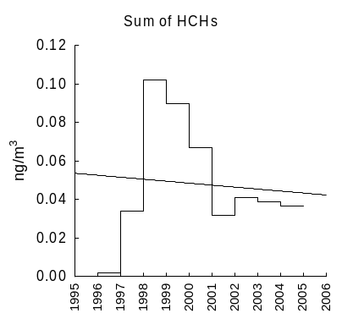 | 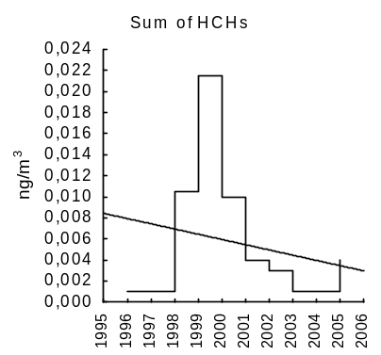 | 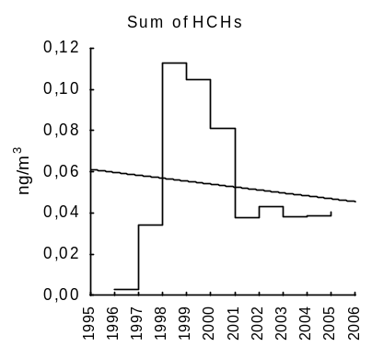
Rain water | Surface waters | Sediments
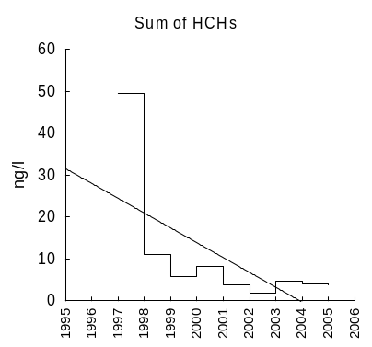 | 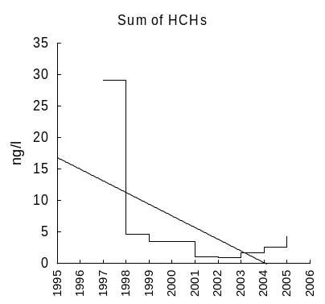 | 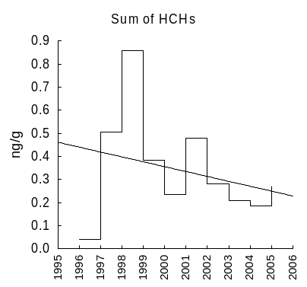
Soils | Mosses | Needles
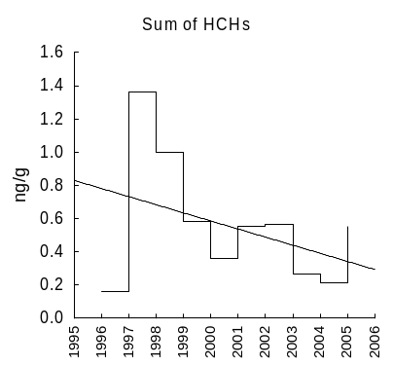 | 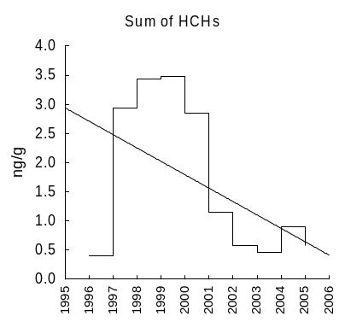 | 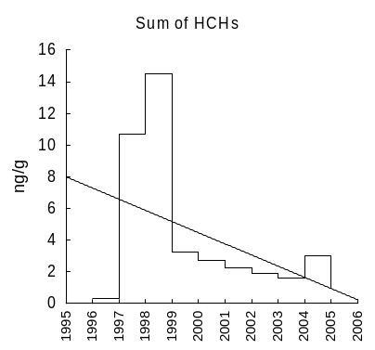

The impact of organochlorinated pesticides, for example, DDT and its metabolites, polychloric cyclodienes (aldrin, endrin, dieldrin, isodrin) and isomers of HCH, on the hydrosphere is not particularly significant in the area of the Czech Republic and is comparable to that of other countries. However, there are regions with certain problems. In the case of HCH, the most severe situation is in central and southern Moravia, where the sediment particles found are in tens of ng.g⁻¹ and there are cases where they amount to hundreds of ng.g⁻¹.

Czech Republic is the first from the signatory countries of the Stockholm convention that offers fully developed and functional tool capable of providing information on the Central European levels of POPs and the long-term trends in those levels. The major advantage is the availability of consistent high volume POPs monitoring data from Košetice EMEP station. This dataset with established time trends for the last ten years can itself serve the evaluation of the future trends in the atmospheric concentration of POPs. Parallel polyurethane foam passive sampling (PAS) monitoring in Košetice in the last three years gives another unique calibration dataset and at the same time, a centerpiece of the PAS network in the Czech Republic. Total amount of 16 background sites covering the country including the border mountains allows us to study the spatial variability in the background POPs concentration in various stations as well as to avoid the false interpretations derived from one site only. It can also evaluate an impact of various sources and the effectiveness of measures applied to reduce this impact. For this purpose, we succeeded in getting the interest and support of the industrial bodies as well as the local authorities and in consequent establishment of informal consortium, technically and financially supporting further development of the network (MONET_CZ). This is a unique achievement in the global scale.

There are other key aspects of the MONET_CZ network. Such well characterized region in the Central Europe with the dense monitoring network provides the core element for the spin-off projects in other countries of the Central, Southern and Eastern Europe. Since many of those countries lack not only data on the POP levels in the atmosphere but also appropriate monitoring and laboratory capacities, this aspect is very valuable.

Based on this assumption, MONET_CEEC project was initiated in 2006 with the goal of building the monitoring capacity in this region. Network of partner institutions was established and they cooperated in designing the pilot screening study in the CEE region in 2006-2007. Transfer of know-how, educational and training activities are an important part of the MONET_CEEC project. Results of this screening study performed in 2006 as well suggestions for future development of the CEEC networks are the subject of the separate report.

HCH levels (sum of α, β, γ, δ-HCH) in the ambient air (PAS, ng filter⁻¹) in the Czech Republic (hotspots omitted), 2006

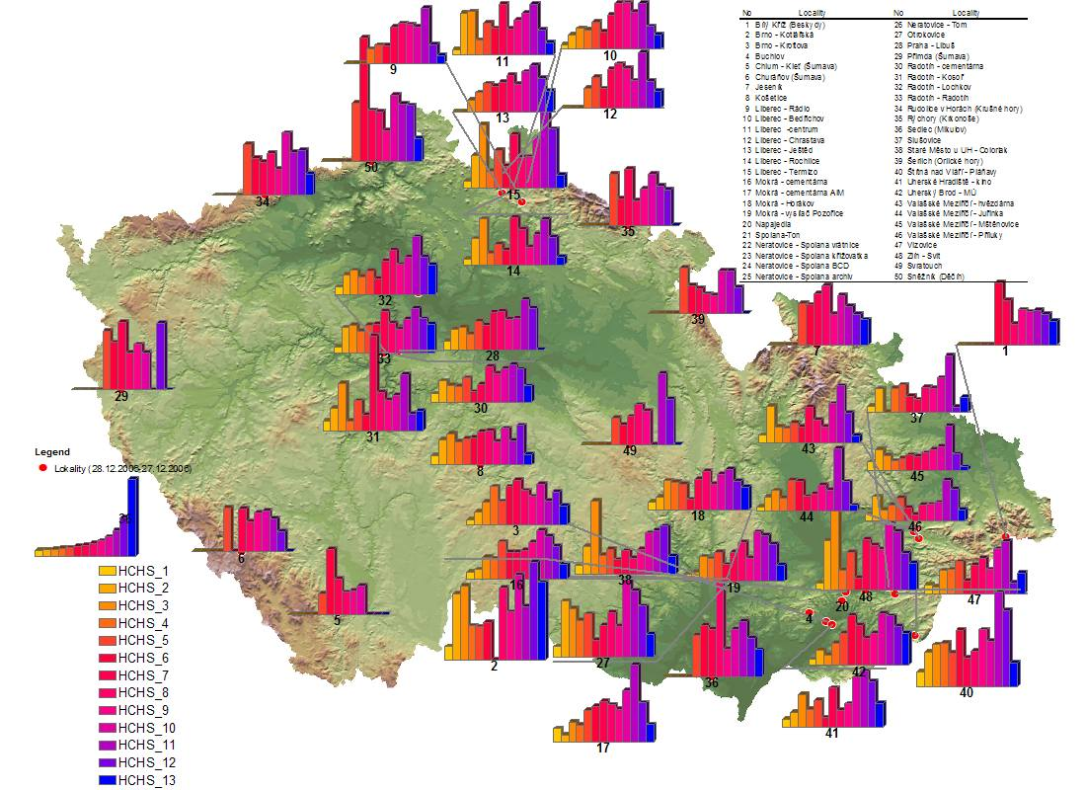

In the case of soils, for HCHs, no sample exceeding the limit value has been recorded, the observed values are in the range of units of ng.g⁻¹.

The average chronic exposure dosage of the population for alfa-, beta-, delta-, gamma- (lindane) isomer of hexachlorocyklohexan similarly as in the case of other OCPs in food did not attain, during the observational period (1994 – 2005), the values that are correlated to an unacceptable elevated probability of health damage (non-carcinogenic effect) to the consumer.

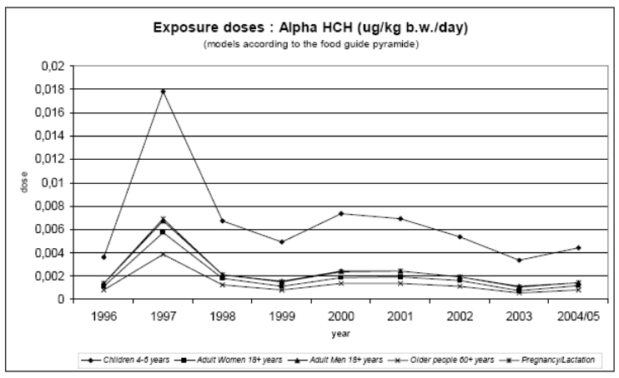

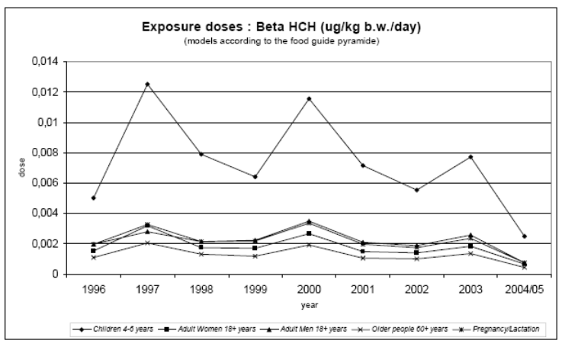

Exposure doses for alpha- and beta-HCHs (Monitoring of health status of the Czech population in the relationships to the environmental pollution, responsible person: Assoc. Prof. MVDr. Jiří Ruprich, CSc., ruprich@chpr.szu.cz)

The concentration of α, β and γ-HCH in human matrices (mother milk, blood) does not show a time correlation and is usually in various amounts under the level of detection by the used method.

REFERENCES:

- I. Holoubek, J. Klánová, J. Jarkovský, J. Kohoutek: Trends in background levels of persistent organic pollutants at Kosetice observatory, Czech Republic. Part I. Ambient air and wet deposition 1988-2005. J. Environ. Monitoring 9, 557 – 563 (2007).
- I. Holoubek, J. Klánová, J. Jarkovský, V., Kubík, V., J. Helešic: Trends in background levels of persistent organic pollutants at Kosetice observatory, Czech Republic. Part II. Aquatic and terrestric environments 1988-2005. J. Environ. Monitoring, 9, 564 – 571 (2007).
- J. Klánová, P. Čupr, J. Kohoutek, I. Holoubek: Application of passive sampler for monitoring of POPs in ambient air. I. Model monitoring network in the Czech Republic (MONET_CZ), Masarykova Univerzita, 2007, ISBN 978-80-210-4392-3
- J. Klánová, P. Čupr, I. Holoubek: Application of passive sampler for monitoring of POPs in ambient air. II. Pilot study for development of the monitoring network in the Central and Eastern Europe (MONET_CEEC), Masarykova Univerzita, 2007, ISBN 978-80-210-4393-0
- I. Holoubek, A. Ansorgová, V. Shatalov, S. Dutchak, J. Kohoutek: Regional background monitoring of PBT compounds. The comparison of the results from measurements and monitoring. Environ. Sci. Pollut. Res. 8, 201-211 (2001).
- Holoubek, J. Tříska, P. Cudlín, J. Čáslavský, K.-W. Schramm, A. Kettrup, J. Kohoutek, P. Čupr, E. Schneiderová: Project TOCOEN (Toxic Organic Compounds in the Environment), Part XXXI. The occurence of POPs in high mountain ecosystems of the Czech Republic. Toxicol. Environ. Chem., 66, 17-25 (1998).
- I. Holoubek: Persistent bioaccumulative and toxic chemicals in Central and Eastern Europe: Levels and Risks. Crit. Revs. in Anal. Chem., 29, 179-185 (1999).
- I. Holoubek, P. Kořínek, Z. Šeda, E. Schneiderová, I. Holoubková, A. Pacl, J. Tříska, P. Cudlín: The use of mosses and pine needles to detect atmospheric persistent organic pollutants at the local and regional scale. Environ. Pollut. 109, 283-292 (2000).
- I. Holoubek, E. Brörström-Lundén, J. Duyzer, V. Shatalov, J. Klánová, J. Kohoutek: Regional trends of POPs in European ambient air. Organohal. Compds., 61, 518-521 (2003).
- I. Holoubek, P. Čupr, V. Kužílek, M. Rieder, J. Klánová, L. Jech, T. Ocelka, M. Škarek: Spatial and temporal trends in POPs sediment contamination in the Czech Republic. Organohal. Compds., 62, 101-104 (2003).
- Holoubek, J. Hofman, M. Sáňka, R. Vácha, J. Zbíral, J. Klánová, L. Jech, T. Ocelka: Spatial and temporal trends in persistent organic pollutants soil contamination in the Czech Republic. Organohal. Compds., 62, 460-463 (2003).
- I. Holoubek, (coordinator, project manager), V. Adamec, M. Bartoš, M. Budňáková, M. Černá, P. Čupr, K. Bláha, K. Demnerová, J. Drápal, J. Hajšlová, M. Hanzálková, I. Holoubková, S. Hrabětová, L. Jech, J. Klánová, J. Kohoutek, V. Kužílek, P. Machálek, V. Matějů, J. Matoušek, M. Matoušek, V. Mejstřík, J. Novák, T. Ocelka, V. Pekárek, O. Petira, J. Petrlík, O. Provazník, M. Punčochář, M. Rieder, J. Ruprich, M. Sáňka, M. Tomaniová, R. Vácha, K. Volka, J. Zbíral: National POPs Inventory and National Implementation Plan for the implementation of the Stockholm Convention in the Czech Republic. Project GF/CEH/01/003: ENABLING ACTIVITIES TO FACILITATE EARLY ACTION ON THE IMPLEMENTATION OF THE STOCKHOLM CONVENTION ON PERSISTENT ORGANIC POLLUTANTS (POPs) IN THE CZECH REPUBLIC. RECETOX - TOCOEN & Associates, TOCOEN REPORT No. 252, Brno, 2003 – 2005. Inventory and NIP are available on the website: http://recetox.muni.cz
- I. Holoubek, V. Šatalov, S. Dutčak: Hexachlorocyclohexanes in the Central and Eastern European countries in the comparison with other part of the world – the results from European measurement and modelling programmes. TOCOEN s.r.o., Brno. TOCOEN REPORT No. 179, listopad 2000, 30 s. Internet: http://recetox.chemi.muni.cz/
- I. Holoubek, A. Kočan, I. Holoubková, K. Hilscherová, J. Kohoutek, J. Falandysz, O. Roots: Persistent, Bioaccumulative and Toxic Chemicals in the Central and Eastern European Countries - State-of-the-Art Report. The 2nd version. TOCOEN REPORT No. 150a, květen 2000. RECETOX - TOCOEN & Associates, Brno, Czech Republic. Internet: http://recetox.chemi.muni.cz/.
Explanatory note:
18. With regard to control capacity, the information required is on legislative and institutional frameworks for the chemical under consideration and their enforcement. With regard to monitoring capacity, the information required is on the technical and institutional infrastructure for the environmental monitoring and biomonitoring of the chemical under consideration, not monitoring capacity for alternatives.

G. Any national or regional control actions already taken, including information on alternatives, and other relevant risk management information:
Explanatory notes:
19. Actions or measures taken could include prohibitions, phase-outs, restrictions, cleanup of contaminated sites, waste disposal, economic incentives, and other non-legally binding initiatives.
20. Information could include details on whether these control actions have been cost-effective in providing the desired benefits and have had a measurable impact on reducing levels in the environment and contributed to risk reduction.

H. Other relevant information for the risk management evaluation:
Explanatory notes:
21. The above list of items is only indicative. Any other relevant information for the risk management evaluation should also be provided.

I. Other information requested by the POPRC:
[Note to the Secretariat]

___________________

