Section VI
Guidance/guidelines by source category:
Source categories in Part III of Annex C

Part III Source category (e):
Firing installations for wood and other biomass fuels

Table of contents

List of tables i
List of illustrations ii
VI.E Firing installations for wood and other biomass fuels 1
1. Introduction 1
2. Biomass combustion technologies 2
2.1 Technology selection and furnace types 2
2.2 Grate furnaces 3
2.3 Fluidized bed combustion 4
2.4 Further combustion technologies for wood 4
2.5 Energy conversion techniques 5
2.6 Co-combustion of (untreated) wood and wood-related biomass 5
2.7 Wood gasification 5
2.8 Combustion of other biomass 6
2.9 Recovery boilers in the pulp and paper industry 6
2.10 Combustion of peat 6
3. Emission control measures 7
3.1 Relevant primary and secondary measures 7
3.2 Fuel characteristics 8
4. Process outputs 8
4.1 Formation of PCDD and PCDF in combustion processes 8
4.2 Emissions of PCDD/PCDF 8
5. Best available techniques and best environmental practices 10
5.1 Primary measures and process optimization to reduce PCDD/PCDF emissions 10
5.2 Secondary measures 11
6. Performance levels associated with best available techniques 11
7. Performance monitoring and reporting 11
References 12

List of tables
Table 1. Types of biomass fuels used 2
Table 2. Types of biomass furnaces with typical applications and fuels 3
Table 3. PCDD/PCDF emission control measures for biomass firing installations 7
Table 4. PCDD/PCDF concentrations for different types of wood fuels 9
Table 5. PCDD/PCDF emissions from different types of biomass 9
Table 6. PCDD/PCDF emissions from kraft black liquor recovery boilers 10

List of illustrations
Figure 1. General scheme of a vibrating grate furnace 4
Figure 2. General scheme of furnace using circulating fluidized bed combustion 5

VI.E Firing installations for wood and other biomass fuels
Summary
The main purpose of firing installations for wood and other biomass fuels is energy conversion. Large-scale installations for firing wood and other biomass fuels mainly use fluidized bed combustion and grate furnaces. Technologies for small-scale plants include underfeed furnaces and cyclone suspension furnaces. Recovery boilers in the pulp and paper industry apply specific combustion conditions. Technology selection is related to fuel properties and required thermal capacity.
Chemicals listed in Annex C of the Stockholm Convention can result from the firing of wood and other biomass fuels, particularly in the case of fuel contamination. For biomass-fired plants, particularly wood-fired installations, emission levels associated with best available techniques are generally below 0.1 ng I-TEQ/Nm³. Among the primary measures, control of fuel quality is a key issue (including exclusion of treated wood). Control measures for non-contaminated biomass include optimized combustion techniques and dust removal. Straw combustion increases fouling of surfaces and requires combustion techniques that are not sensitive to the slagging of ashes.
Combustion of contaminated biomass, such as wood waste, should be avoided in these installations. Fly ash (especially the finest fraction) from biomass combustion has to be landfilled due to its high heavy metal content. In many countries (including in the European Union), wood treated with chlorinated compounds or heavy metals is regarded as waste and falls within the scope of waste incineration directives or regulations.
Other environmental benefits that accrue from applying best available techniques and best environmental practices include resource conservation and avoidance of carbon dioxide emissions originating from fossil fuels (in the case of substitution).

1. Introduction
At present around 12% of the global energy requirement is generated by combustion of biomass fuels, which vary from wood and wood waste, materials from agricultural crops and black liquor in pulp mills. Table 1 shows some of the types of materials used. A wide variety of appliances are used to convert this biomass into useful energy. In developing countries, around 35% of the energy used originates from biomass, but most of this is for non-commercial use in traditional applications such as cooking (see section VI.C of these guidelines). In a country such as Nepal, over 90% of the primary energy is produced from traditional biomass fuels, mainly forest timbers.
This section addresses the best available techniques and best environmental practices for large-scale applications in, for example, industry, power generation and district heating which combust biomass fuels as a source of energy.
Contaminated wood and other contaminated biomass can result from many anthropogenic activities, particularly wood processing industries (e.g. building materials, furniture, packing materials, toys, shipbuilding and general construction). The wood/biomass waste may contain paints, coatings, pesticides, preservatives, antifouling agents and many other contaminants. These materials can enhance the formation of PCDD/PCDF during combustion. As such, their use in firing installations for energy conversion should be avoided and they should only be burnt in dedicated hazardous waste incinerators. For further information refer to section V.A of these guidelines.

Table 1. Types of biomass fuels used
Wood: sawdust, bark, chips, wood shavings pellets
Timber and logs
Straw
Citrus pellets
Coconut husks
Nut husks (e.g. almonds, peanuts)
Coffee seed husks
Rice husks
Peat
Sugar cane bagasse
Animal dung
Black liquor in pulp mills

In industrialized countries, the total contribution of biomass to the primary energy mix is only 3%, but this amount is expected to increase as more countries use biomass fuels to reduce greenhouse gas emissions instead of burning fossil fuels. This mainly involves the combustion of commercial biomass fuels in modern devices (e.g. woodchip-fired co-generation plants for heat and power). Other applications are domestic space heating and cooking, industrial heat supply, and large-scale power generation in coal-fired plants (IEA Bioenergy 2004).

2. Biomass combustion technologies

2.1 Technology selection and furnace types
For technology selection the total heat input and the wood fuel quantity are of major importance. For large-scale plants, fluidized bed combustion and grate furnaces are most suitable. Technologies for small-scale plants include underfeed furnaces and cyclone suspension furnaces. Table 2 shows typical thermal capacities and required fuel properties for different types of wood combustion techniques.
Table 2. Types of biomass furnaces with typical applications and fuels
Application | Type | Typical size rangeª | Fuels | Ash | Water content
Manual | Log wood boilers | 5 kW–50 kW | Log wood, sticky wood residues | < 2% | 5–30%
Automatic | Understoker furnaces | 20 kW–2.5 MW | Woodchips, wood residues | < 2% | 5–50%
Automatic | Moving grate furnaces | 150 kW–15 MW | All wood fuels and most biomass | < 50% | 5–60%
Automatic | Pre-oven with grate | 20 kW–1.5 MW | Dry wood (residues) | < 5% | 5–35%
Automatic | Understoker with rotating grate | 2 MW–5 MW | Woodchips, high water content | < 50% | 40–65%
Automatic | Cigar burner | 3 MW–5 MW | Straw bales | < 5% | 20%
Automatic | Whole bale furnaces | 3 MW–5 MW | Whole bales | < 5% | 20%
Automatic | Straw furnaces | 100 kW–5 MW | Straw bales with bale cutter | < 5% | 20%
Automatic | Stationary fluidized bed | 5 MW–15 MW | Various biomass  d < 10 mm | < 50% | 5–60%
Automatic | Circulating fluidized bed | 15 MW–100 MW | Various biomass  d < 10 mm | < 50% | 5–60%
Automatic | Dust combustor, entrained flow | 5 MW–10 MW | Various biomass  d < 5 mm | < 5% | < 20%
Co-firing^{b} | Stationary fluidized bed | Total  50 MW–150 MW | Various biomass  d < 10 mm | < 50% | 5–60%
Co-firing^{b} | Circulating fluidized bed | Total  100 MW–300 MW | Various biomass  d < 10 mm | < 50% | 5–60%
Co-firing^{b} | Cigar burner | Straw  5 MW–20 MW | Straw bales | < 5% | 20%
Co-firing^{b} | Dust combustor in coal boilers | Total  100 MW–1 GW | Various biomass  d < 2–5 mm | < 5% | < 20%
a. kW = kilowatt; MW = megawatt; GW = gigawatt.
b. Biomass covers typically less than 10% of the total fuel input.
Source: Nussbaumer 2003.

Typical biomass based on wood, has an ash content below 5%; higher ash contents can be attributed to other biomass such as sewage sludge. The disposal of the ash content is an important issue, as it may contain unintentionally produced persistent organic pollutants and other toxic substances depending on the source material burnt (for further information, refer to section III.C, iv, subsection 2.1 of these guidelines).

2.2 Grate furnaces
Grate furnace systems are today the most common combustion technology used for wood wastes and wood residues. According to the technique, the wood fuel is moved through the combustion chamber using stationary sloping grates, travelling grates, vibrating grates (Figure 1) or moving grates. Grate firing systems are suitable for all types of wood residues and wood waste with particle sizes between 20 and 300 mm. However, fine particles, as pulverized wood, may be injected through additional burner lances. A major influence on the combustion efficiency, both for travelling grates and vibrating grates, is the fuel and air guidance. As regards steam generation, the furnace design of grate firing systems offers various options for primary emission reduction, including staged combustion and flue gas recirculation. The investment for grate firing systems depends considerably on the grate technology and flue gas cleaning technology used. Compared to fluidized bed combustion plants, especially for lower capacities, the specific investment relative to the total heat input is considerably lower (CSTB 2000).
Figure 1. General scheme of a vibrating grate furnace
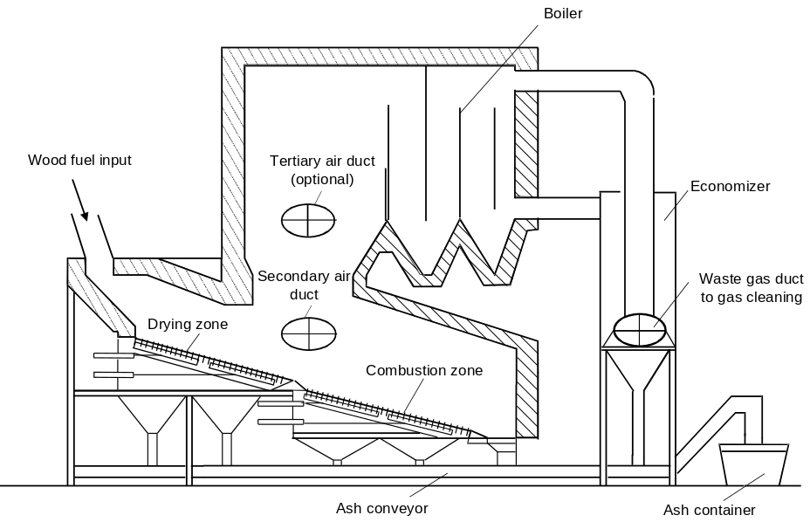

2.3 Fluidized bed combustion
Fluidized bed combustion is utilized for various types of solid fuels. In a typical fluidized bed combustion unit, the solid fuel is kept fluidized by injected air together with an inert bed material mainly consisting of limestone or sand and the fuel ash. Two basic fluidized bed combustion technologies are primarily used for wood combustion. These are atmospheric bubbling fluidized bed combustion and atmospheric circulating fluidized bed combustion (Figure 2). Fluidized bed combustion is suitable for even lowest fuel qualities and for a great variety of fuels. For wood combustion, nearly all types of wood residues and wood waste can be used. Water contents up to 60% are possible. Fluidized bed systems are adaptable even to low operation loads. A cycle between low and high loads is generally possible without support fuel and at a higher speed than other combustion technologies.
Chlorine-induced high-temperature corrosion can be suppressed by installing the last superheater unit in the bed. The low combustion temperature in fluidized bed systems, compared to many other combustion technologies, offers several operational advantages for emission control. The investment for fluidized bed combustion plants is mainly influenced by the technology used and the type of flue gas cleaning installed. Circulating fluidized bed combustion entails a considerably higher specific investment than bubbling fluidized bed combustion for plant sizes below 30 MWth (CSTB 2000).

2.4 Further combustion technologies for wood
Further combustion technologies for wood include underfeed stoker furnaces, cyclone suspension furnaces (muffle suspension furnaces), rotary furnaces, turbulent bottom furnaces, fan blower furnaces and dust burners. Underfeed furnaces or underfeed stoker furnaces are particularly suitable for the combustion of dry and not too coarse wood particles with a low ash content. This technique is used for total heat inputs up to 5 MW. Compared to normal grate furnaces the specific investment is generally lower. As cyclone suspension furnaces require a dust content of at least 50% their application is limited mainly to the wood processing industry. Dust burners are used for wood dust with a particle size of up to 1 mm. Applications of this burner type include woodchip dryers and the injection of wood dust in cement furnaces (CSTB 2000).
Figure 2. General scheme of furnace using circulating fluidized bed combustion
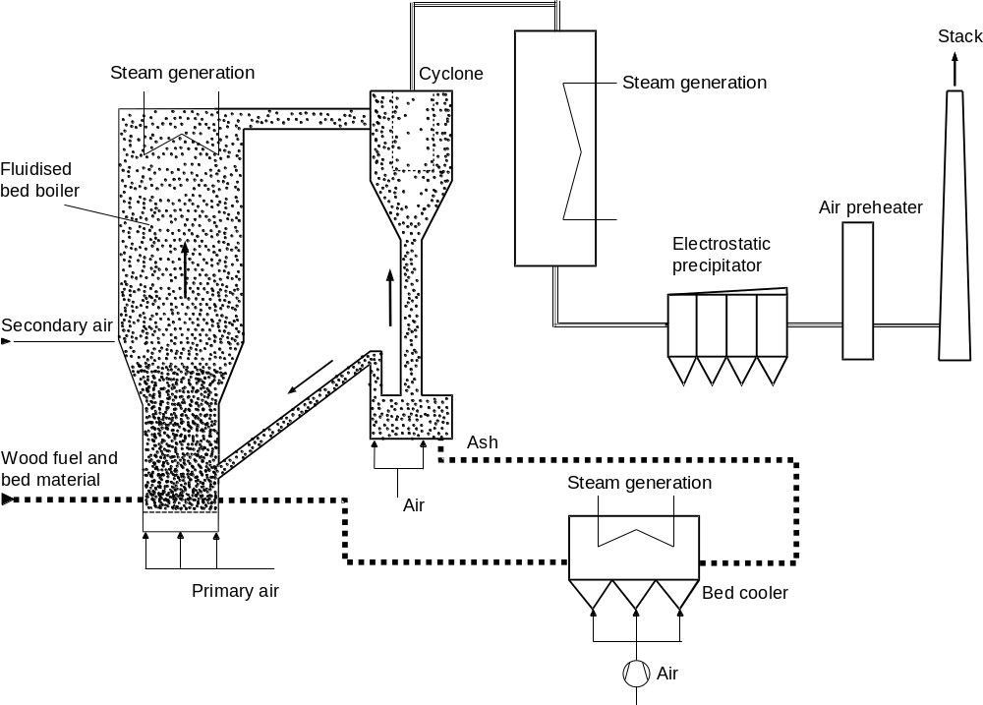

2.5 Energy conversion techniques
For energy conversion downstream of wood combustion furnaces, heat exchanger systems (boilers) and subsequent systems for combined heat and power production (e.g. steam turbines, steam engines) have to be distinguished. The type of boiler used depends on the heat transfer medium, the plant size and the energy quality required. Firetube boilers are used for hot water or steam production downstream of small-scale and medium-scale wood furnaces. Heat transfer only takes place by convection. Watertube boilers are used for large-scale and medium-scale wood waste combustion plants. The water to be evaporated flows through tubes surrounded by the hot flue gases. Heat transfer takes place predominantly by radiation. Compared to firetube boilers, considerably higher operating pressures are possible – up to 100 bar. Downstream of wood furnaces only heat or combined heat and power are generally produced. For this reason condensing power generation can be neglected. Nevertheless, combined heat and power plants may also need condensing capacities in case the heat generated is not used (CSTB 2000).

2.6 Co-combustion of (untreated) wood and wood-related biomass
Co-combustion means the burning of wood wastes and wood residues together with other waste materials or together with fossil fuels. The objective is to realize synergy effects between two combustion processes. Benefits include savings in operating costs through the use of cheaper secondary fuels, and the greater combustion efficiency of the combined process compared to the two processes operated separately. For wood waste and wood residues, relevant practices include co-combustion in cement furnaces, co-combustion in coal-fired power plants, co-gasification with fossil fuels and waste and co-incineration in waste incineration plants (CSTB 2000). For further information see sections V.A, V.B, and VI.D of these guidelines.

2.7 Wood gasification
Gasification of wood and wood waste is the conversion of solid and liquid residues derived from the thermochemical decomposition of the organic matter in the wood at high temperatures in a gaseous fuel by adding oxidizing reactants. The main objective of wood gasification is to transfer as much as possible of the chemical energy of the wood feedstock into a gaseous fraction (producer gas) consisting mainly of combustible gaseous products with a low molecular weight.
The gasification technique is in general related to the reactor type. The two basic gasification techniques available are fixed bed gasification and fluidized bed gasification. For wood gasification the utilization of fixed bed gasifiers is in general preferred for smaller total heat inputs below 5 MW. For larger capacities fluidized bed gasifiers are mainly used.
The energy content of the producer gas from gasification can be used either thermally for the firing of a boiler or for another thermal process (either separately or using co-combustion, for example in an existing utility boiler or in a cement furnace) or mechanically for power generation in gas engines or gas turbines. Further possibilities are the utilization of the producer gas for methanol synthesis or in fuel cells.
The system needed for producer gas cleaning is determined by the concentration of impurities and by the requirements of the gas utilization technique used. Depending on the gas utilization technique, gas cleaning is required to avoid erosion, corrosion and unwanted deposits, and to ensure fulfilment of emission limits. Two different gas cleaning concepts, cold (or wet) gas cleaning and hot gas cleaning, can be distinguished. Hot gas cleaning is considered advantageous for advanced highly efficient systems due to the higher achievable electrical and overall efficiencies and due to the non-generation of contaminated wastewater or condensate. Even though gasification can be seen as a proven and reliable technique, for all plants with electricity generation, either in gas turbines or gas motors, gas cleaning is still a crucial restriction. Problems associated with the gas cleaning process include process control, the cost of gasification residue disposal, and the high investment and operating costs of the gas cleaning unit itself (CSTB 2000).

2.8 Combustion of other biomass
Other biomass fuels include other solid biofuels, such as straw and crops, and liquid fuels, such as canola oil. Straw combustion increases fouling of surfaces and requires combustion techniques that are not sensitive to the slagging of ashes. Due to the greater input of mineral matter and chlorine compared to wood combustion, there is also an increase in emissions of dust, hydrogen chloride (HCl), polychlorinated dibenzo-p-dioxins (PCDD) and polychlorinated dibenzofurans (PCDF) (LfU 2002). Exemplary results from emission tests are given in subsection 4 below.

2.9 Recovery boilers in the pulp and paper industry
The manufacture of pulp utilizes mechanical, thermomechanical, chemimechanical and chemical methods (see section V.C of these guidelines). In chemical pulping, the fibres are broken down chemically. Chemicals are used in a cooking process to enter the fibre lumen and dissolve lignin in the cell walls to gain access to the compound middle lamella. Lignin has to be removed from the lamella to free the fibres. The lignin and many other organic substances are thus put into solution. The chemicals used in sulphate (kraft) and sulphite pulping are recovered from this solution through combustion in boilers, which also allows for energy recovery.
Recovery boilers in sulphate (kraft) pulping operate in a first step under reducing conditions, leading to the formation of sodium sulphide. A molten residue consists of sodium sulphide and sodium carbonate. In the second and third steps of the combustion process, a staged supply of combustion air occurs in order to assure complete burnout. Here, collected odorous gases can be supplied.
Recovery boilers in sulphite pulping do not operate with staged combustion. The lye is burnt in oxidizing conditions with a low air excess.

2.10 Combustion of peat
Within the European Union, peat is a significant fuel (regarded as a fossil fuel) in Ireland and Finland. Combustion technologies for peat are similar to coal combustion (section VI.D of the present guidelines). Today, peat is mainly burnt in fluidized bed boilers (bubbling and circulating fluidized bed combustion). These boilers typically have a fuel input of less than 200 MW, and they produce either electricity, or electricity and heat to local industry or the district heating system. Peat-fired boilers are usually also designed to combust other low-calorific fuels and sometimes coal. Heavy oil is commonly used as an auxiliary start-up fuel.
Due to its characteristics, peat is applicable for co-firing with wood. Technically it would be more difficult to use only wood fuel in existing plants because of corrosion and fouling problems. The ability to burn peat also assures continuous fuel supply in areas where the availability of wood is insufficient for the fuel demand (European Commission 2006).

3. Emission control measures

3.1 Relevant primary and secondary measures
Reduction of PCDD/PCDF emissions includes the primary and secondary measures summarized in Table 3 (Baumbach and Zuberbühler 2002; CSTB 2000; LfU 2002).
Relevant primary measures are similar to those used in the waste incineration sector. In the case of untreated biomass, secondary measures are restricted to dust abatement. Smaller furnaces may use multicyclones to achieve dust concentrations in the cleaned flue gas of 100–150 mg/Nm³. Fabric filters or electrostatic precipitators achieve dust concentrations in the range of < 5 to 25 mg/Nm³ (see section III.C (iv) of the present guidelines for general guidance on flue gas cleaning).
Downstream of wood waste combustion, additional flue gas cleaning can be carried out with absorption or adsorption processes. Generally only adsorption processes are used, due to their lower costs. Dry sorbent injection (entrained flow reactor) has gained major importance downstream of wood combustion due to its technical simplicity and its low costs. A mixture of calciferous substance and activated carbon or lignite activated carbon (activated carbon produced from lignite) is generally used as an adsorption agent. Possible calciferous agents are limestone (CaCO₃), lime (CaO) and hydrated lime (Ca(OH)₂). While the calciferous agents remove sulphur dioxide (SO₂), hydrogen chloride (HCl) and hydrogen fluoride (HF), the various types of activated carbon minimize heavy metal emissions (mercury, cadmium and arsenic), PCDD/PCDF emissions and emissions of polycyclic aromatic hydrocarbons. A typical mixture used in an entrained flow reactor consists of 85–95% calciferous agent and 5–15% activated carbon. As a secondary measure for reduction of emissions of nitrogen oxides (NO_{x}), particularly downstream of large-scale wood waste combustion installations, selective non-catalytic reduction can be used, but selective catalytic reduction may also apply. The selective catalytic reduction has been applied to biomass fired fluidized bed combustors. One problem with this technique is the deactivation of the catalyst which is faster when firing biomass, compared with coal, especially in the case of grate furnaces and the case of straw.
Table 3. PCDD/PCDF emission control measures for biomass firing installations
Management options | Emission level (%) | Estimated costs | Management risks
Primary measures
Control of fuel quality (e.g. calorific value, water content, contaminants) | Resulting emission level not quantified | Higher fuel price | High water content increases PCDD/PCDF formation
Optimized burnout (e.g. reduction of excess air) |  | No additional cost for new installations
Sufficient residence time of flue gases in the hot zone of the furnace
Secondary measures
Efficient dust abatement | Medium efficiency |  | Filter temperature  < 200 °C
Dry sorbent injection  Selective catalytic reduction | High efficiency | Additional investmentª:  selective catalytic reduction 110–180% | Disposal of used sorbents necessary, not common in combustion plants firing virgin biomass
a. Percentage related to investment for furnace, boiler and dust collector of wood combustion plants with
1–10 MW thermal capacity.

3.2 Fuel characteristics
Fuel quality plays a major role in PCDD/PCDF formation during biomass combustion. PCDD/PCDF are always formed during wood combustion via precursors such as phenols and lignin, or via de novo reactions in the presence of particulate carbon and chlorine. High emission levels can be expected from burning treated wood (wood waste). Wood residues (waste and industrial) often contain various types of contaminants (chromated copper arsenate, pentachlorophenol, creosote, adhesives, resins, paint and other surface coatings). Another major source of PCDD can be salt-laden wood waste burnt in power boilers at pulp and paper mills (Lavric, Konnov and De Ruyck 2004).
Combustion of contaminated wood, such as urban wood waste and demolition wood, should be strictly limited to installations with efficient emission control systems such as waste incineration plants (see section V.A of these guidelines) (Nussbaumer 2003).
The moisture content of biomass can be high. Therefore, dryers may be used prior to combustion. Steam dryers are considered to be safe, with low environmental impact. Another method is based on drying with flue gas, which is subsequently fed to the stack. In this case emissions of organic compounds such as waxes or aromatic compounds are possible (European Commission 2006).

4. Process outputs

4.1 Formation of PCDD and PCDF in combustion processes
The dominant reaction resulting in the formation of PCDD/PCDF in combustion processes is de novo synthesis. Section III.C (i) of these guidelines provides general information on PCDD/PCDF formation mechanisms. Specific considerations for biomass combustion are given below.
PCDD can be formed in the absence of organic chlorinated compounds. The presence of particulate carbon and a chlorine source is sufficient. Investigations at a stationary grate combustor have shown that the total amount of PCDD/PCDF and coplanar polychlorinated biphenyls (PCB) formed was proportional to the chlorine content of the combustion samples when the temperature of the combustion chamber was lower than 700 °C. On the other hand, when the grate temperature of the combustion chamber was higher than 800 °C, there was only slight formation of PCDD/PCDF and coplanar PCB, regardless of the chlorine content of the fuel (Yasuhara, Katami and Shibamoto 2003).
The better combustion conditions in larger facilities tend to have an influence on PCDD/PCDF concentration. Tests have shown that even when processing materials containing high halogen quantities, the concentrations remained below those obtained from small facilities using natural wood. When halogenated input materials were added, a very clear relationship between carbon monoxide (CO) and PCDD/PCDF concentrations was observed. The dominant influence of combustion quality on PCDD/PCDF emission concentrations could be seen from the increasing CO concentrations and simultaneously decreasing flue gas temperature (Lavric, Konnov and De Ruyck 2004).

4.2 Emissions of PCDD/PCDF

4.2.1 Combustion of wood or wood waste
The influence of fuel quality and combustion conditions on PCDD/PCDF emissions is illustrated in Table 4.
Table 4. PCDD/PCDF concentrations for different types of wood fuels
Type of wood | PCDD/PCDF min.  ng I-TEQ/m³ (at 11% O₂)ª | PCDD/PCDF max.  ng I-TEQ/m³ (at 11% O₂)
Lump wood (natural) | 0.02 | 0.13
Woodchips (natural) | 0.004 | 0.88
Wood waste | 0.03 | 18.00
Chlorine/heavy metal-free particle board | 0.03 | 0.10
Particle board with PVC or ammonium chloride (NH₄Cl) | 0.05 | 12.28
Particle board with pentachlorophenol | 0.21 | 5.14
a. 1 ng (nanogram) = 1 × 10⁻¹² kilogram (1 × 10⁻⁹ gram). For information on toxicity measurement see section I.C, subsection 3 of the present guidelines.
Source: Nussbaumer 2004.

A comprehensive review of PCDD/PCDF test results from wood-fired installations can be found in Lavric, Konnov and De Ruyck 2004.

4.2.2 Combustion of other biomass
Launhardt and Thoma tested various herbaceous biofuels (straw, whole plant cereals and set-aside hay) and spruce wood for their potential to form PCDD/PCDF, polychlorinated phenols, polychlorinated benzenes and polycyclic aromatic hydrocarbons during combustion. The trials were conducted in an automatically charged multifuel furnace for domestic applications of 50 kW. Relatively uniform combustion conditions were indicated by the CO emission results. Flue gas and different ash fractions were analysed. The concentration of PCDD was in the range of 0.052–0.891 ng I-TEQ/Nm³ at 13% O₂ (Table 5). All the emissions from wood were at a relatively low level. Increased emissions, between 10 and 25 times higher, of PCDD/PCDF, polychlorinated phenols and polychlorinated benzenes were detected when herbaceous fuels were used (Lavric, Konnov and De Ruyck 2004).
Table 5. PCDD/PCDF emissions from different types of biomass
Fuel type | PCDD/PCDF  ng I-TEQ/m³
Wood (spruce) | 0.052
Straw (wheat) | 0.656
Hay | 0.891
Triticale | 0.052
Canola pellets | 0.245
Source: LfU 2002.
PCDD/PCDF emission data for liquid biomass combustion are scarce. Tests at a canola oil motor for combined heat and power production (90 kW) showed PCDD/PCDF concentrations of 4–7 pg I-TEQ/m³. PCB concentrations amounted to 40–81 ng/m³ (LfU 2002).

4.2.3 Combustion of black liquor
Table 6 shows selected emission factors from kraft black liquor recovery boilers.
Table 6. PCDD/PCDF emissions from kraft black liquor recovery boilers
Fuel | Emission factor (I-TEQ) | Emission factor (WHO-TEQ) | Reference
Black liquor solidsª | 0.10–0.15 ng/kg | 0.10–0.16 ng/kg | EPA 2000
Black liquor solidsª | 0.029–0.065 ng/kg | 0.028–0.072 ng/kg | EPA 2000
Black liquor solidsª | 0.07 ng/kg |  | UNEP 2005
a. In general 1 kg black liquor (water content 70 %) corresponds to a flue gas volume of 5–8 m³ (oxygen content between 5 and 8%).

4.2.4 Combustion of peat
In European Commission 2006, PCDD emissions are reported from an atmospheric fluidized bed boiler equipped with a fabric filter firing 50% peat and 50% bark. PCDD/PCDF emissions amounted to 0.008 ng I-TEQ/Nm³ (dust emission level: 10 mg/Nm³).

4.2.5 Other releases of PCDD/PCDF from biomass combustion
PCDD/PCDF are discharged with solid combustion residues such as bottom ashes and fly ash. In general, PCDD/PCDF concentrations increase with decreasing particle size (LfU 2002). Therefore, pollutant concentrations in fly ash tend to be higher than in bottom ash.
Pohlandt and Marutzky analysed furnace, boiler and fly ash. The samples were collected at different plants in the wood working industry, from a smoke house and from combustion of wood impregnated with inorganic wood preservative consisting of boron, chromium and copper in a two-stage laboratory furnace. They found that the fly ashes exhibited the highest levels of PCDD/PCDF. The concentrations of PCDD/PCDF in the ashes originating from the impregnated wood were higher than those of the ashes from the combustion of the diluted impregnated wood, but below those determined for the fly ash of industrial wood firing plants. The concentration of PCDD in the fly ash was higher than in the bottom ash. This observation was confirmed by Wunderli et al. and Yamamura et al. (Lavric, Konnov and De Ruyck 2004).
Particularly in the case of wood waste combustion, captured fly ash has to be disposed of in an environmentally sound manner (see section III.C (iv), subsection 2.1 of the present guidelines).
The fly ash from straw combustion units should be disposed of to sanitary landfill, primarily due to its high content of cadmium. The bottom ash is normally brought back to the fields or used as a road construction material when certain requirements with regard to physical and chemical properties are met (European Commission 2006).
The finest fraction of fly ash has to be sent to landfills due to its high content of heavy metals and persistent organic pollutants. Used adsorbent also has to be landfilled.

5. Best available techniques and best environmental practices

5.1 Primary measures and process optimization to reduce PCDD/PCDF emissions
Best available techniques to reduce PCDD/PCDF emissions may include the following measures (Nussbaumer and Hasler 1998).
- Prevention of illegal incineration of waste;
- Combustion of contaminated wood, such as urban wood waste and demolition wood, should be strictly limited to installations with efficient emission control – it is preferable that this material is not used in boilers and is instead treated as waste;
- Control of fuel quality (e.g. calorific value, water content, contaminants);
- Optimized combustion technology: Improved burnout of gases and fly ash and reduction of dust content:
- Optimize excess air ratio to < 1.5–2, though care must be taken as any changes made to the air ratio can also affect the amount of other emissions;
- Good mixing quality of gas and air (high turbulence);
- Sufficient residence time in the hot zone;
- Minimal disturbance of the glow bed and homogeneous distribution of the primary air;
- Optional integration of selective non-catalytic reduction for NO_{x} reduction;
- Measures in the boiler:
- Minimal residence time in the temperature range 180 °C and 500 °C and minimal dust deposition ability;
- Optimized plant operation:
- Application of advanced combustion control technologies to ensure optimal burnout in practice;
- Stationary operation, no on/off operation and prevention of rapid changes of heat and demand;
- Cleaning of the hot zone of flue gases at regular intervals.

5.2 Secondary measures
Secondary control measures are pollution control techniques and include the following measures:
- Optimized gas cleaning:
- Rapid quench of combustion gases (< 200 °C) before passing through filters in order to avoid the de novo reformation (or synthesis) window;
- PCDD/PCDF separation in dust separators (electrostatic precipitators, fabric filters) in combination with sorbent injection (if necessary);
- Optional destruction of PCDD/PCDF by catalytic oxidation, i.e., in combination with selective catalytic reduction for NO_{x} reduction.

6. Performance levels associated with best available techniques
For biomass-fired plants, particularly wood-fired installations, emission levels associated with best available techniques are generally below 0.1 ng I-TEQ/m³.

7. Performance monitoring and reporting
PCDD/PCDF emissions should be monitored in accordance with international standard methods.
In order to ensure complete combustion, furnaces should be equipped with measuring instruments that continuously determine carbon monoxide emission mass concentrations.
In order to ensure the performance of emission control equipment, furnaces should be equipped with measuring instruments that continuously determine dust emission mass concentrations qualitatively and quantitatively (according to the requirements of different plant sizes). For further information on monitoring see Section III (vi) of these guidelines.
In addition, quality control procedures should be implemented with regard to fuel composition.

References
Baumbach G. and Zuberbühler U. 2002. Entwicklung eines Feuerungskonzeptes zur Verbesserung des Ausbrandes bei gleichzeitiger NO_{x}-Minderung bei der Holzverbrennung im gewerblichen Bereich. Report BWPLUS 3 96 007. Institut für Verfahrenstechnik und Dampfkesselwesen, University of Stuttgart.
CSTB (Centre Scientifique et Technique du Bâtiment). 2000. Energy-Efficient Technologies from Demolition, Packaging and Industrial Wood Waste. Final Report. Programme THERMIE, Type B Action (STR-1965-98-FR), Phase I. CSTB with Quasco, CTBA, La Calade and DFIU/IFARE.
EPA (United States Environmental Protection Agency). 2000. Exposure and Human Health Reassessment of 2,3,7,8-Tetrachlorodibenzo-p-dioxin (TCDD) and Related Compounds, Part I: Estimating Exposure to Dioxin-Like Compounds Vol. 2: Sources of Dioxin-Like Compounds in the United States. Draft Final Report. EPA, Washington, D.C. www.epa.gov/ncea/pdfs/dioxin/part1/volume2/volume2.pdf.
European Commission. 2006. Reference Document on Best Available Techniques for Large Combustion Plants. Formally adopted BAT Reference Document (BREF). European IPPC Bureau, Seville, Spain. http://eippcb.jrc.es/pages/FActivities.htm.
IEA Bioenergy. 2004. Biomass Combustion and Co-firing: An Overview. IEA Bioenergy Task 32. www.ieabioenergy-task32.com.
Lavric E.D., Konnov A.A. and De Ruyck J. 2004. “Dioxin Levels in Wood Combustion: A Review.” Biomass and Bioenergy 26:115–145.
LfU (Bayerisches Landesamt für Umweltschutz). 2002. Energetische Nutzung nachwachsender Rohstoffe. Zusammenfassender Bericht zu 15 Teilprojekten.
Nussbaumer T. 2003. “Combustion and Co-combustion of Biomass: Fundamentals, Technologies, and Primary Measures for Emission Reduction.” Energy and Fuels 17:1510–1521.
Nussbaumer T. 2004. Dioxin- und PAK-Emissionen der privaten Abfallverbrennung. Umwelt-Materialien Nr. 172. Bundesamt für Umwelt, Wald und Landschaft, Bern.
Nussbaumer T. and Hasler P. 1998. Emissions of PCDD/F from Biomass Combustion. Biomass for Energy and Industry, 10th European Conference and Technology Exhibition, 8–11 June 1998, Würzburg (Germany).
UNEP (United Nations Environment Programme). 2005. Standardized Toolkit for Identification and Quantification of Dioxin and Furan Releases. UNEP, Geneva. www.pops.int/documents/guidance/Toolkit_2005.pdf.
Yasuhara A., Katami T. and Shibamoto T. 2003. “Formation of PCDDs, PCDFs, and Coplanar PCBs from Incineration of Various Woods in the Presence of Chlorides.” Environ. Sci. Technol. 37:1563–1567.

